# INTRODUCTION

***Chapter 1***

* 1. **INTRODUCTION**

Ageing in society is a worldwide issue that especially impacts northern countries. In France, due to the high care cost [1] and to the limited number of rooms in care institution, the solution that has been chosen by care-givers, frail people and their family is to maintain elderly at home the longest and in the best conditions by giving them an adapted assistance. In an aging society it is extremely important to develop a devices, which can support and assist the elderly in their daily life, since their mobility degrades with age. This situation requires a great medical care, incurs large costs and can be fatal in some cases. The elderly tend to have cognitive impairments and experience more serious falls but there is strong evidence that daily exercise may result on fall prevention and postural stability [2]. So, it becomes more and more relevant to find ways and tools to compensate, to improve or to restore and to enhance this mobility.

According to the report of the year 2018 of WHO (World Health Organization), it is declared that more than 15% of world’s population is suffering from disability. Moreover, approximately the adults between 110 million till 190 million [3] are suffering from the complications and problems of lower limb disabilities of gait pattern. More than a billion people are suffering from some sort of problems related to the disabilities, this corresponds is about 15% of the total world population [3]. In the past 50 years there are several research related to the gait analysis is still going on.

It is stated by the ICF (International Classification of Functioning) that disability is define as the activity of limitation within the gait pattern. Problem related to the gait is increasing due to the major factor of chronic health problems, some major issues are Parkinson disease [4], hemiplegia, paraplegia, stroke and several others. Patients related to this disease need additional care and concern as they are not able to perform their gait

properly. Gait problems are also increasing in adults due to the issues related to the stress [5] and depression, in which most common are negative attitude, limited social interaction and anxiety. In the past years different types of chronic comparative analysis have been done by the researchers, one of the gait comparisons is between the young

[3] and elder subjects. Several researches work on the alignment of the foot angle [4] (as this is the most critical analysis data of the gait pattern which is done in 1996).

In the past research work, several very helpful new researches have been done to work on the gait pattern. From 2010 the wearable sensors [6] as well as particular objective methods have been used for the analysis of the gait pattern. All these work are very effective in their own way but the main problem is that, they are not portable [7] and every one of them is fully linked with the wearable sensors. So in this new method of gait pattern analysis of the chronic disease we use the portable device [7] which is the good achievement towards the problem solving situation of the disease.

# INTRODUCTION TO PROJECT

Rapid advances have occurred in the field of robotics in recent years. Direct interaction of humans and robots is now being realized in an important manner within

[8] the field of assistive robotics (AR). As robots are increasingly used to improve the independence and quality of life of persons with disabilities, there is a growing importance for the rehabilitation professional to be aware of available systems. An understanding of the direction that AR is taking is important for the clinician and researcher alike.

Gait has been the first discovery when the problems of disability were taken as a serious issue of mankind care [9]. The disability has variation of problems but the most major problems are related to the chronic diseases. Before moving towards the Gait disability, firstly we should know what is disability? So basically disability is the complex

and multidimensional disorder. This is usually occurring due to the heavy load bearing, accidents, stress, chronic disease and mostly neurological [3] problems.

There are two major physical barriers that patients usually have to be faced, the first one is social issue and the second is physical issue. Socially they are considered as unhandy and clumsy, while physically they are so disturb [10] and discomfort. Gait disability is the most dynamic interaction between the lower limb disorders with the health conditions both the personal and environmental conditions will affect the gait pattern of the patients. Many researchers have work on the gait pattern and identify the relationships between the lower extremity, foot progression, adduction of the limb and abduction of the limb with several other factor included [2] and their result shows the alignment of foot which will help to predict and solve the future problems. Main purpose of all these experiments are to identify the abnormal gait pattern to overcome these entire problems with the effective solutions

[11] without using markers.

Over the past years, technological advances allowed the incorporation of sensors and actuators in conventional walkers, providing the stability of four-legged walkers, without affecting the resultant naturalness of the users’ gait patterns. Besides, these devices enable to identify the movement intentions of the users and therefore control the mobility assistance accordingly. We will present an alternative device, which is used in case of total incapacity of mobility. This device is usually a rollator, a kind of wheelchair and walker or solutions based on autonomous especial vehicle, equipped with sensors, for spatiotemporal gait monitoring. The first objective is to provide physicians with the features they are used to when evaluating elderly frailty, while maintaining a low cost and ensuring a good ease of use and by embedding all the sensors on the rollator without equipping the patient. Subsequently, the intelligent rollator could deliver others relevant features that will enriched the existing feature set [1]. This is used to avoid, whenever possible, the inadequate use of alternative device, thus improving the physical and cognitive capabilities. This walker can be used as mobility- training devices, self-ported devices, such as prostheses or orthoses, or external, such as

crutches, canes and walkers. The sensor placed in the rollator would help to analyze the basic gait parameters which includes stride length, step length, cadence, stride time, step time and walking velocity.

# PROBLEM STATEMENT

For the completion of this project, following are the problem statements which need to be addressed. The objectives which need to be fulfilled by the end of this process are:

* + - Gait monitoring is crucial in patients with neuropathology (stroke, hemiplegia, ataxia, Parkinson, etc) to measure gait parameters as walking velocity or stride length [10] so to measure the gait, presented rollator is a useful support for Activities of Daily Living (ADL) in users with mobility challenges and they have a significant role in rehabilitation. It has double purpose that is support and monitoring.
    - It can support up to 64% of the vertical load [10]. Also, it is an effective walking aid for partial weight bearing, which is essential in the healing period of orthopaedic lower limb patients [7].
    - The panel of large amount of specialists was used to sit with a huge setup of system to perform gait analysis of the patients and the data was accessed by confining the patient in a room by help of peripherals which were given to the patients to wear.
    - Besides, monitoring with cameras or electronic walkways need to be performed in a controlled area (e.g indoors environments). Finally, wearable sensors are often not comfortable enough for long term use [10]. Also, since they need to be adapted for different users to be worn, testing with several users may take significantly longer.
    - Clinical evaluation of frailty in the elderly is the first step to decide the degree of assistance they require.

# PROJECT OBJECTIVES

The objectives which need to be fulfilled by the end of the process of creation of this rehabilitation related project are stated below:

* + - The first objective is to provide physicians with the features they are used to when evaluating elderly frailty, while maintaining a low cost and ensuring a good ease of use and by embedding all the sensors on the walker without equipping the patient[1].
    - To develop a software programming to create a compatibility of walker with the upcoming rehabilitation devices in such parameters of researches.
    - To design a comfort handling frame which can be used for measuring gait parameters and for walking aid as well.
    - To replace the heavy equipment with the simple comfortable and secure rollator.
    - Rollators can be equipped with force sensors mounted on the walker handles or under the forearm to passively derive some gait characteristics.
    - Analysis of applied force would be measured on both the sides with the help Pasco capstone load cell sensors.

# SCOPE OF WORK

* + - To make the people of society to be able to fulfill own necessities with Self- sufficiency. Rehabilitation may lead to skill recovery and allow people to remain autonomous or improve their quality of life.
    - Gait monitoring is very difficult process for the patient suffering from any kind of diseases usually for the patients of neuropathology and for amputed patients.
    - Gait analysis is a technique to treat the individuals with conditions affecting their ability to walk.
    - Measurement of forces and graphical representation will provide the information about the normal and disable patients.

# SIGNIFICANCE OF PROJECT

This project has multiple application some of its significances are as follow:

* + - It is very crucial to measure the gait pattern of a patient suffering from any kind of disability (stroke, hemiplegia, ataxia, Parkinson etc).
    - In older one patients were using treadmill, wearable cameras to measure gait but that was not so comfortable enough for long term use. This rollator will provide support plus monitoring that will help the patients with aid and support.
    - It is a new methodology to calculate the spatiotemporal gait parameters for the amputated and disabled persons.

# Major Contributions

Here are some of the contributions that should kept under consideration to represent the project:

* + - The rollator is user friendly and easy to operate.
    - Rollator is portable and monitoring can be performed on any unspecified place at any time.
    - This system has the procedure which is used in [10] to systemize the force, spatial, temporal parameters.
    - As compared to our previous system, which was a static walker equipped with force sensor, this is more comfortable and easy to operate.

# LITERATURE REVIEW

***Chapter 2***

* 1. **INTRODUCTION**

In the last two, three decades there is a tremendous change in the field of assistive technology and in the field of rehabilitation for the patients having any type of disabilities. Advancement and modifications in the medical equipments are increasing with every coming day. In the initial stage of rehabilitation approximately all patients were using the same type of equipments, for example if an adult person had an injury in a foot or leg, he will use the simple cane for his assistance and same thing will be for any senior citizen, but now if there is an injury with a senior citizen the doctor will recommend him a tripod cane which is same like cane but has 3 legs for extra support, so this is the modification in cane. Therefore scientists and engineers work together to make a mobility aid device for the patients with any kind of diseases they first design a standard walking frame which consist of almost four vertical aluminium tubes, by applying force on these pipes patient was moving forward, then a rollator was design for the assistance of patients with disabilities this is for those patients who are even not able to hold the walker perfectly it is consist of four wheels, front two wheels are rotatory and rear two wheels are fixed.

# TECHNIQUES

The techniques which were studied to obtain the gait are listed below:

* + - Limb Dominance, Foot Orientation and Functional Asymmetry during walking gait (Year 2017).
    - Gait analysis of Patients following total knee replacements. (Year 2007)
    - Gait Analysis in Lower-Limb Amputation and Prosthetic Rehabilitation (Year 2014)
    - Quantitative Human Gait analysis (Year 2000)

# RELIABILITY OF ROLLATOR

The rollator is a popular assistive walking device in most European and especially the Nordic countries. The exact number of rollator users is unknown but about 6.4% of Danish 56–84 year-old people use a rollator and in Sweden about 4% of the total population use a rollator [1]. The terms "wheeled walker", "rolling walker", "three wheeled walker", “four-wheeled walker" are frequently used synonymously with rollator, which can be defined as a frame with three or four wheels. For several years, researchers have been addressing the needs of persons with mobility disabilities through alternative or augmentative devices. These solutions are selected based on the degree of disability of the user.

Over the past years, technological advances allowed the incorporation of sensors and actuators in conventional walkers, providing the stability of four-legged walkers [2], without affecting the resultant naturalness of the users gait patterns. Besides, these devices enable to identify the movement intentions of the user and therefore control the mobility assistance accordingly.

# MOBILITY ASSISTIVE DEVICES

Providing physical assistance is one of the most direct ways that robots can help persons with disabilities, these systems allow for increased independence and function in physical tasks. Many commercially available robotic feeding systems are examples of simple and affordable AR. These feeders are important from a clinician’s perspective due to their relative low cost and the time they have been in clinical use [8]. They have

great capacity to improve the functional independence measure domain of eating, a common target in both inpatient and outpatient rehabilitation, and an important goal to a patient’s sense of autonomy. The devices are covered in part by medical insurance in some cases, although this varies by country and region. They allow self-feeding in persons with high tetraplegia or who are otherwise dependent in this activity of daily living.

Because of the many available devices and the importance of selecting the best for each individual patient, a formal evaluation should be carried out by an experienced physical therapist before deciding which device is appropriated for the injury. Once the device is indicated, the therapist can make the appropriate equipment adjustments to meet the specifications of each patient and can provide training in the proper use of the device [2]. Potential problems can be assessed by the physical therapist before the device is used. In case of total incapacity of mobility, considering both bipedestation and locomotion, the alternative devices, represented by the wheelchairs and the special vehicles, are the optimal solution.

These have been the targets of intensive research, especially considering Autonomous Robotic Wheelchairs (ARW). Beyond the manual wheelchairs, robotic solutions are able to provide for autonomous and assistive navigation to wheelchairs (Smart Wheelchairs) making use of human–machine interfaces, like BCI’s (Brain Computer Interfaces) and EMG (electromyography) signals.

Additionally, some smart wheelchairs also enable a bipedestation position. Nevertheless, the continuous use of this kind of devices can cause problems of health mainly since the user remains for a long time in a sitting position, these problems include loss of bone mass, osteoporosis, degradation of blood circulation and physiological functions, skin sores, among others. For these reasons considering the remaining locomotion capacities, it is interesting to encourage, whenever possible, the use of augmentative devices. The augmentative devices can help the patient with reduced

mobility to avoid the previously presented health problems and allow using the user’s patient remaining locomotion capability. In some cases, users can even relearn to walk safely and efficiently, in order to retrieve all the necessary movements for a normal gait. In other cases, these devices acts like a functional compensation elements that assist movements that the patient has lost. This means that the patient can learn new strategies to move, contributing to his independent locomotion on the daily life.

# GAIT ANALYSIS USING TREADMILL & OVER GROUND (1997)

During the year of 1997, H. Stolze with his team work on the research to use treadmills for the analysis of gait pattern within the children [5] and adults. In this they compare the normal gait walk and treadmill walk and noted that swing phase is increasing 5% in adults. This system was limited for the normal and healthy patients. Those patient who have any disability were not able to use this.

# QUANTITATIVE GAIT ANALYSIS (2000)

This paper is about the estimation and analysis of gait during the locomotion. They used 20 students for the analysis and applied basic kinematic concepts [13] for the recognition of gait, but one flaw in it was that force applied by the students were not measured therefore no force factor was involved in this research.

# GAIT ANALYSIS OF PATIENTS WITH TOTAL KNEE REPLACEMENT (2007)

In this research they took the patients who have total knee and ask them to perform the gait and monitor their pattern. They observe that the less total knee motion during gait and with less knee flexion during swing than controls [7]. They also identified the kinetic discrepancies between patients and controls.

# GAIT ANALYSIS IN LOWER-LIMB AMPUTATION (2014)

In this research work those patients were taken which have some sort of amputation [12] in their body and due to that amputee they are not able to perform their gait perfectly. They evaluate the characteristics of gait and diversion of normal disable person.

Wearable sensors & treadmill were used in this research which is not so comfortable enough for the patients with amputee or disabilities.

# OVERALL SUMMARY

In past years from 1995 to 2018 [12, 7] [13, 5] all work is done for the gait analysis, its recognition and in the advancement of the new methods to concise the procedure of recognizing gait and making it possible for the aged and disabled patients. In some papers they work on spatiotemporal gait parameters, some have work for stance phase and some papers for swing phase but approximately all papers have used the wearable sensors which are not so comfortable and convenient by patients. So to overcome this problem we are designing a rollator equipped with sensors to measure spatiotemporal gait parameters also it will measure the walking velocity and would be capable of fall prevention as well, this will not require any other sensor for the patients to wear, the patient just has to hold the rollator and walk.

# METHODOLOGY

***Chapter 3***

* 1. **METHODOLOGY**

Gait parameters are typically measured on treadmills, using cameras, electronic walkway, or wearable sensors. Besides, monitoring with cameras or electronic walkways need to be performed in a controlled area e.g indoors environments [11]. Wearable sensors are often not comfortable enough for long term use [13]. The rollator is a special aid device for the user’s support and monitoring.

This rollator contain two force sensors in the handle bar to measure the force and two more sensors which are interfaced with Arduino UNO, a rotary encoder and an ultrasonic sensor in a rear wheel to measure the gait parameters. In pre-phase of our project we work on load cells of 50kg (SEN-10245) with its amplifier (HX-711) to measure the force of the subjects, the amplifier was connected to a microcontroller Arduino UNO then we calibrated the cells by putting loads on the sensor, but unfortunately when we mounted these cells on a rollator they were not giving the desired values, then we move towards the next phase and uses Pasco load cells of 100N (PS- 2200), by testing these cells in a same manner we placed these sensor in handle bar of rollator by cutting the handles in equal size and calibrated the sensors by hanging load on the handles. Rotary encoder is placed on the rear part of rollator in a contact with right wheel to measure the walking velocity of the patient and the distance covered by the patient and ultrasonic sensor will detect the number of steps taken by the patient and at the end the result is seen on laptop. The parameters of gait will be shown on serial monitor of the Arduino software while the force applied by patient would be seen on Pasco Capstone software. The parameters shown in serial monitor includes Step Length, Step Time, Stride Length, Stride Time, Cadence, Number of steps and Total time. The measured force is shown in the form of graph or digits.

# BLOCK DIAGRAM OF PRE PHASE OF THIS PROJECT

Load Cell

(SEN-10245)

Amplifier

(HX-711)

Arduinio uno

USB Port

Results

Figure 3.2: Block Diagram of Pre-phase

# BLOCK DIAGRAM OF PHASE 1

Pasco Amplifier

Pasco Load Cell

Sensor 01

Pasco Load Cell

Sensor 02

Rollator

Results

Figure 3.3(a): Block Diagram of Phase 1

Pasco Capstone

Software

|  |  |  |  |  |
| --- | --- | --- | --- | --- |
| Ultrasonic Sensor  (Sr-104) | |  | Rotary Encoder  (ky-040) | |
|  |  | | |  |

Arduino UNO

Aduino Software

Results

Figure 3.3(b): Block Diagram of Phase 1

# Proposed Method:

In this project we have proposed a methodology to identify the spatiotemporal gait parameters by rollator equipped with force sensor and tested it on different people. These people were of two categories i:e Genomic aged patients and Osteoporotic patients. No external or wearable sensors were used to obtain the results.

This proposed method shown in above block diagrams are working in two ways. The block diagram in (figure 3.3(a)) is representing the force applied by the subject and its result while (figure 3.3(b)) is representing the sensors input to microcontroller these sensors include encoder and ultrasonic sensor. This system is free from wearable sensors. Force sensors placed in the rollator will help to measure the force applied by the upper limbs. When the patient start walking, two PASCO force sensors placed in the handle bar of rollator will measure the force applied by the patient from left or right side of the body. Using different type of spatiotemporal gait parameters we can characterize the osteoporotic and genomic conditions. Various types of forces sensors have been available in the market like Load cell, Load cell disk sensor, straight bar load cell, Pasco capstone force sensors and several others are available. So in the Pre-Phase the Load Bar sensors are used and Load cell sensors were tested on initial basis and analysis of its position. After that standard weights were applied for its calibration. Also generate the coding to connect load sensor with HX711 amplifier and Arduino. In pre- phase load cells were tested, but we did not get the desired result from them and secondly there was the issue of mounting these load cells on the rollator therefore we change the category of force sensors.

In phase-1 the PASCO Load cell sensors are used for measuring the force. A rollator has purchased and cleaved from different positions, for the placement ofsensors. In phase-1, PASCO Load cell 100N sensors are placed with in equal positions. These sensors are not permanently fixed they can be adjust by screws or can be changed in case of any electronic problem. The calibration of the PASCO load cell sensors were

tested by applying weights. After checking error within the load cell sensors, placement of sensors were corrected. Currently we have removed the error by placing sensors in correct position. An ultrasonic sensor is placed on the right side of rollator to measure the steps of the subject, it is placed on a wooden stick with a slippery pad to move or set it according to the patient. An encoder is also placed on the right side of the rear wheel to measure the distance covered by the patients.

# PICTURES OF PROJECT

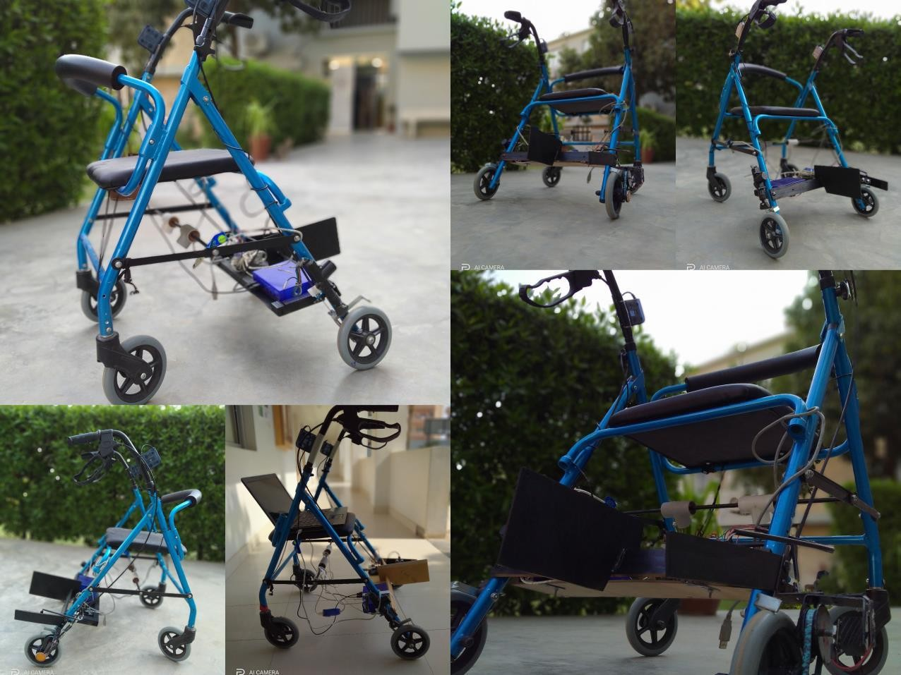

Figure 3.5: Pictures of Presented Model

# PROCESSING IN MICROCONTROLLER

The controller we have used in our project is an Arduino UNO. It is connected with encoder and ultrasonic sensor these sensors takes input from the patients. Encoder is fixed in a rear wheel to measure the rpm of the rollator and the parameters of distance and time while the ultrasonic is also placed in a rear side on a patch to measure the steps of the patient. The Vcc and ground for both sensors are made common in a breadboard. The trigger pin of ultrasonic is connected on 9th pin of Arduino (digital PWM), while the echo of ultrasonic is connected to 10th pin of Arduino (digital PWM). The encoder’s CLK is connected with 2nd pin of digital and the DT of encoder is connected with the 4th pin of digital PWM.

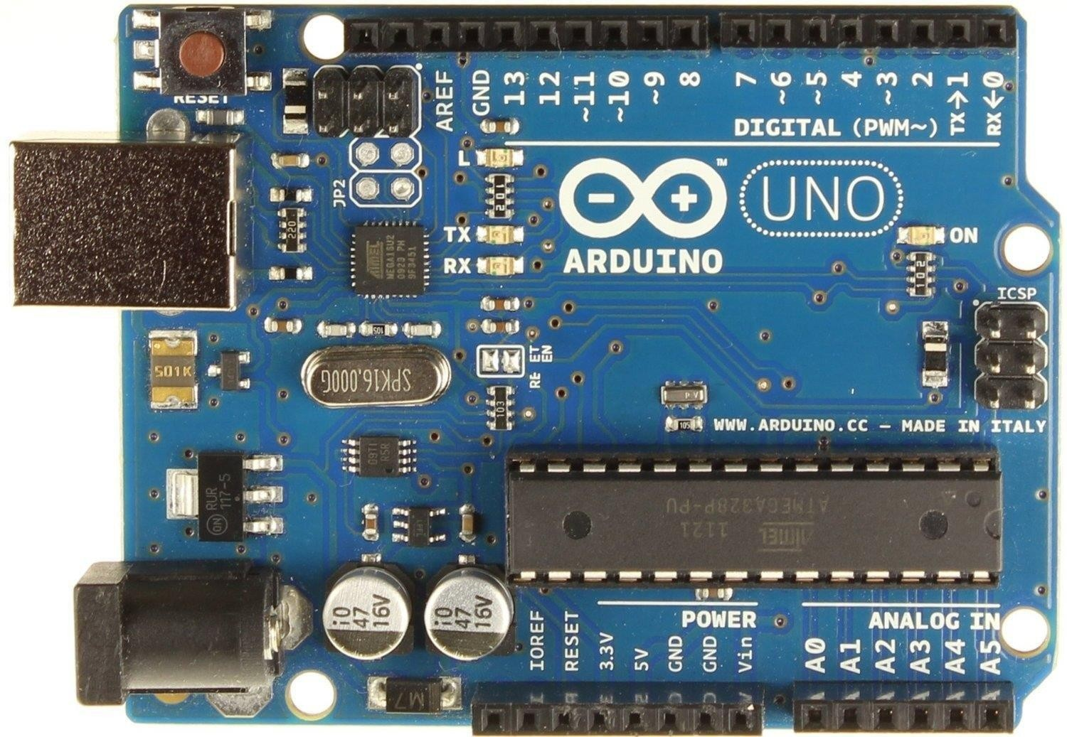

Figure 3.6: Arduino UNO

# PASCO CAPSTONE FORCE SENSORS:

Pasco capstone sensors (PS-2200) of 100N are used for taking the input data in the form of force from the patient’s upper limb these load cells are connected to the amplifier (PS-2198) as shown below in diagram. This amplifier has four ports and you can connect four force sensors at a time since we have used only two force sensors therefore we have just use port 1 & 2. As the force from the upper limb is applied by the patient for moving the rollator, sensors will give the output of applied force in the form of graphs or digits.

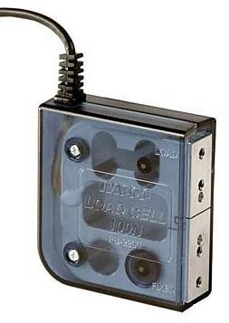

Figure 3.7(a): Force Sensor

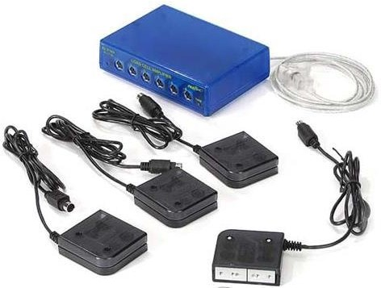

Figure 3.7(b): Force Sensor’s Amplifier of Four Channel

# Rotary Encoder

A rotary encoder is a type of position sensor which is used for determining the angular position of a rotating shaft. It generates an electrical signal, either analog or digital, according to the rotational movement. There are many different types of rotary encoders which are classified by either Output Signal or Sensing Technology. The particular rotary encoder that we have use in this project is an incremental rotary encoder and it’s the simplest position sensor to measure rotation of wheel which will help to calculate the spatiotemporal parameters. We have fixed the pulley system to make the connection between the wheel and encoder to make the result more accurate. In result encoder gives the spatiotemporal parameters such as time, distance etc.



Figure 3.8: Rotary Encoder

# Ultrasonic Sensor:

The HC-SR04 ultrasonic sensor uses SONAR to determine the distance of an object just like the bats do. It offers excellent non-contact range detection with high accuracy and stable readings in an easy-to-use package from 2 cm to 400 cm or 1” to 13 feet. We have used ultrasonic for the measurement of steps taken by the patients it is placed at the right side of patient’s leg and its range is set from 0 to20 cm it means that it will detect the object which is in the range of 20cm . It will calculate that how many

time the patient has taken the steps and at the end it will show with the sum up of all in serial monitor.

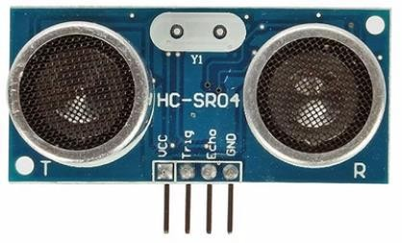

Figure 3.9: Ultrasonic Sensor

# Pasco Capstone Software:

PASCO Capstone is a feature-rich data acquisition, visualization, and analysis program designed by PASCO scientific for advanced science education. The process of rehabilitation is usually depending on the patient's conditions, diseases & several other problems like amputee are usually interconnected with slow gait. The results which are obtained are shown in the form of graphs and the value which fluctuate and shifts in the graphs shows the problem in the patient’s lower limb. Different outputs have been obtained by the adult and the elderly aged patients. One more thing which we have notice that, the patients those who suffer from lower limb amputee or different types of fractures have more different and difficult gait parameters, and these results has been taken in the form of graphs and digits. The Pasco software has been used for the interpretations and the analysis of the outputs.

# MECHANICAL STRUCTURE OF PRE-PHASE:

In the pre-phase of this project we have used the load cell (SEN-10245) which were interfaced with Arduino through its amplifier (HX-711). The purpose of doing this

work was to analyze that which type of load cell or force sensors are suitable for obtaining the force in rollator. Similarly the Arduino was connected to the laptop and we were monitoring the results in a serial monitor of the software.

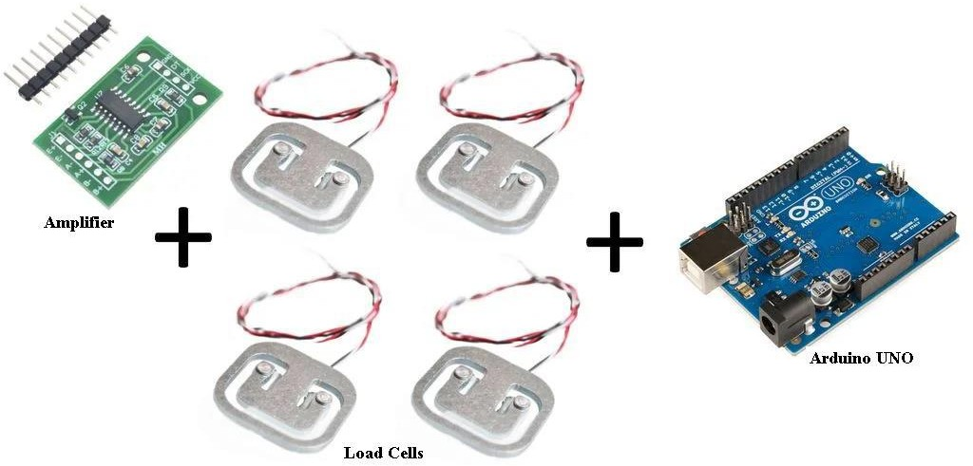

Figure 3.11: Pre-phase Model

# MECHANICAL STRUCTURE OF PHASE 1

Now for the development of the phase-1, a walking aid device i.e. smart rollator

[1] is used. This project is working in two ways, the force of the subject is measured separately by the PASCO capstone software through the PASCO load cells and the spatiotemporal gait parameters are obtained by the sensors we have placed in the rollator these sensors are rotary encoder and ultrasonic sensors. For the measurement of force we have placed two force sensors of 100N in its handle bar by cutting its rod with the same size of 5mm. When the patient grabs the handle they apply force on them and the sensor starts taking the reading of the upper limb extremity forces. After cutting the handles we make drill in a rods for the placement of screws of sensors this make it easy to change the sensor in case of any sensor is not working, these sensors are linked with its amplifier and amplifier is connected to the laptop which gives the output of force in Pasco Capstone software in the form of graphs and digits.

For the placement of encoder we have designed two wooden plates which work as a pulley system, the small plate which is fixed with the wheel is of 21cm and the second plate is of 42cm in which encoder is fixed and they both are in contact with the help of a rubber belt. It means that 2 rotations of wheel will complete the one rotation of the encoder, the reason of making the pulley system was to increase the accuracy of results. Encoder was not detecting the correct rpm when the patient move the rollator fastly, therefore we make the pulley system to minimize the effect of missing rotation. When we were not using pulley system, we used the plastic and metallic module for the encoder placement but we did not get desired results from them because of their unstable structure.

Ultrasonic sensor is placed on the right side of the patient’s leg it will calculate the steps taken by the patient. It is placed on a wood and can be adjusted according to the patient’s condition. If the patient is taking long or short steps it could be placed at the position where patient’s right foot will in contact with the ground because it is calculating how many time the leg cross the sensor.

# CALCULATION OF PARAMETERS

The gait parameters which we have observed in this project are:

* + - Total distance covered by subject
    - Total time taken by the subject
    - Number of steps
    - Number of strides
    - Step time
    - Step length
    - Stride time
    - Stride length
    - Cadence
    - Walking velocity

And the calculation of these parameters has been done with the given formulae, we have applied these formulae in Arduino’s code through which we have observed the values of gait parameters.

## FORMULAE

Here are the given formulae which we have applied in our coding.

* + - * Step Time = Total time / No. of steps
      * Step Length = Total distance / No. of steps
      * Stride Time = Total time / No. of strides
      * Stride Length = Total distance / No. of strides
      * Cadence = ( Steps / Total time ) * 60

# FLOW CHART

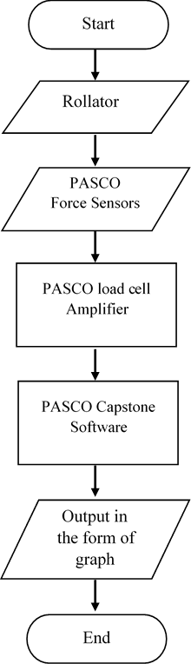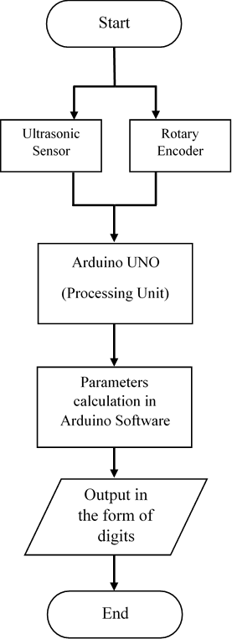

Figure 3.14(a): Flow Chart of Figure 3.14(b): Flow Chart

Force Representation of Measuring Gait Parameters

# RESULTS AND DISCUSSION

***Chapter 4***

* 1. **INTRODUCTION**

The procedure of taking results of the force applied on each sensor is through the Pasco Capstone software while steps of the patients and other spatiotemporal parameters are observed by Ultrasonic sensor and Rotary Encoder linked with Arduino. Breaking system is also controlled by another Arduino. The testing of force sensors was done by hanging weights on the handle and the testing of other sensors were checked manually, distance by the measuring tape and steps by counting the subject’s walk manually. All spatiotemporal parameters are observed on a serial monitor at the end when subject complete his practice. All parts of the systems are working perfectly with the accurate results.

# EXPERIMENT

The experiment is conducted on total 45 subjects in which we have taken three types of subjects. One of the group is of normal and adult subjects which are total 20 subjects and have ages between 20 to 30 years, the second group is of elderly aged subjects which are also 20 subjects and have ages between 60 to 90 years and third group is of subjects with amputated left leg which are total 5 subjects and have ages between 25 to 35.

## Experimental Setup

For the collection of data we take two types of people young and aged which were approached from a few towns of city Karachi. For the collection of healthy and normal persons we took 20 volunteers from our university (ZUFEST), from North campus and Link Road campus, while for the collection of aged and abnormal patient we visited an old age home ( Anmol Zindagi ), located in North Nazimbabad, Karachi.

In this old age home we get the results from 10 subjects while other 10 subjects are the grand parents of our friends and relatives.

A rehabilitation room with plain smooth tiled floor was selected to ask the subject for walking on the rollator. The adults and aged both were asked to walk at least six meters.

# Data Representation

The data of the subject is represented in different forms for achieving the desired results. Following are the types of data representation of force and spatiotemporal parameters:

* The data of forces of subject is collected in the form of graphs in Pasco Capstone Software installed in laptop.
* The data of gait parameters of subject is collected in the form of digits shown in the window of serial monitor of Arduino Software. The screen shots of both force and serial monitor are attached with each of the subject’s data.
* The details of subjects were written manually during the time of data collection which was later converted into a complete table after taking out some necessary readings by using formulas.
* Since we are collecting data on two software at a time so after every walk of subject, the data of Pasco and Arduino was saved in a separate folder with his name.

The data of forces applied by the subjects is collected in the form of graphs which show the peaks. Force measured by the load cell sensor is represented on two individual graphs of four sensors. When a subject start to take a step then the force is applied on both the handles of the rollator which generates the peak on each graph. At

the end of walking when person ends taking steps then the force is decreased to minimum or may goes to negative value. The x-axis contains the time while y-axis presents the force. The graph with blue color represents the force of left hand while the graph with red color is representing the force of right hand of the subject.

The value of gait parameters are shown on serial monitor of the software which shows the values in digit form whose screen shot is saved to the subject’s data folder and later exported these values in table form.

# DATA AND ANALYSIS OF HEALTHY ADULT SUBJECTS

The 20 figures with two parts (a) and (b) contain the graphs of healthy and adult subjects ages from 20 to 30 years, the first part is the graphical representation of the two forces applied from right or left hand on each side of rollator and the second part is the value of observed spatiotemporal parameters on Arduino software which are written in tabular form.

The analysis of data of all healthy subjects is performed individually which is mentioned with details along with the table of data collected of each subject.

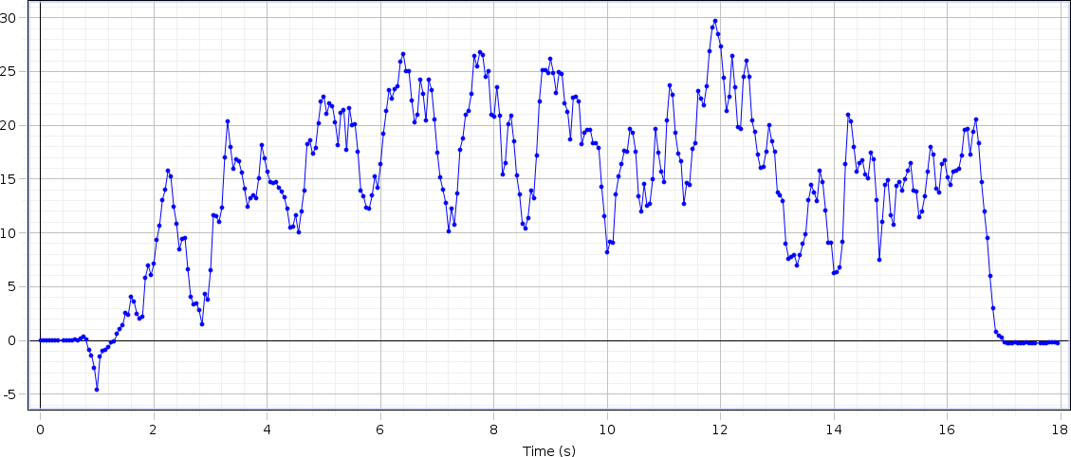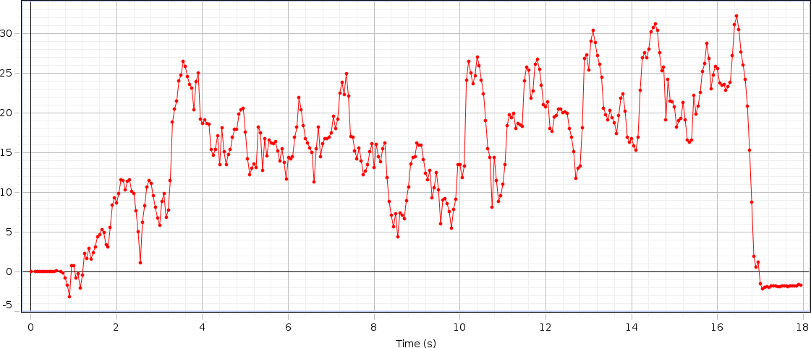

# DATA OF SUBJECT-I

## Left Hand Force

Figure 4.4.1(a): Graph of Left Hand Force of Adult Subject I

## Right Hand Force

Figure 4.4.1(b): Graph of Right Hand Force of Adult Subject I

Table 4.4.1: Data of Adult Subject I

|  |  |  |  |  |  |  |  |  |  |
| --- | --- | --- | --- | --- | --- | --- | --- | --- | --- |
| S.no | Steps | Time (sec) | Distance (meter) | Step Time | Step Length | Stride Time | Stride Length | Cadence | Velocity |
| 01 | 14 | 10 | 5.875 | 0.71 | 0.4196 | 1.43 | 0.8393 | 84 | 0.587 |

## Analysis

The rise and drop of strengths in the graph appears upper limb strengths amid taking care of inactive rollator utilized for gait by healthy person. The maximum rise up at F1 is 29.5N (this force is applied from left hand of the subject), at F2 the maximum rise up is of 35N (this force is applied from right hand of the subject). The change of both forces are different for every single individual according to their age, muscle strength and walking abilities of the subject, the force result comes from the subject. Because of the design of our rollator the force is bit different from abnormal subject (who are affected from any disease or disability) but not showing a major difference in the graph because their wheels help them to move easily without applying force on the handle bars. Subsequently, it is demonstrated that time inversely proportional to velocity.

## Parameters

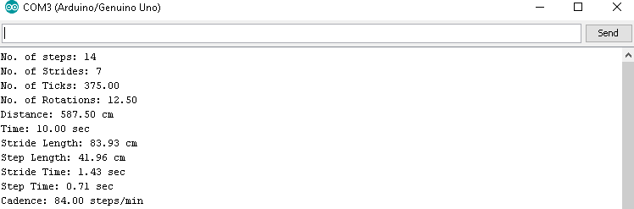

Figure 4.4.1(c): Observed Gait Parameters of Adult Subject I

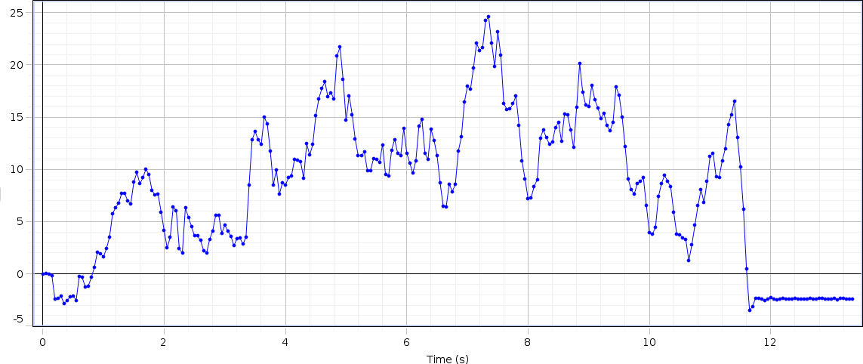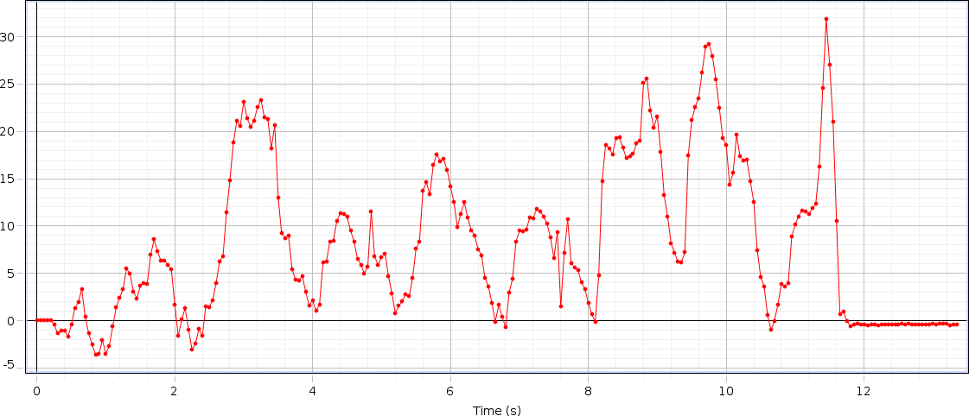

# DATA OF SUBJECT-II

## Left Hand Force

Figure 4.4.2(a): Graph of Left Hand Force of Adult Subject II

## Right Hand Force

Figure 4.4.2(b): Graph of Right Hand Force of Adult Subject II

Table 4.4.2: Data of Adult Subject II

|  |  |  |  |  |  |  |  |  |  |
| --- | --- | --- | --- | --- | --- | --- | --- | --- | --- |
| S.no | Steps | Time  (sec) | Distance  (meter) | Step  Time | Step  Length | Stride  Time | Stride  Length | Cadence | Velocity |
| 02 | 18 | 10 | 6.11 | 0.56 | 0.3394 | 1.11 | 0.6789 | 108 | 0.611 |

## Analysis

The rise and drop of strengths in the graph appears upper limb strengths amid taking care of inactive rollator utilized for gait by healthy person. The maximum rise up at F1 is 29N (this force is applied from left hand of the subject), at F2 the maximum rise up is of 33N (this force is applied from right hand of the subject). The change of both forces are different for every single individual according to their age, muscle strength and walking abilities of the subject, the force result comes from the subject. Because of the design of our rollator the force is bit different from abnormal subject (who are affected from any disease or disability) but not showing a major difference in the graph because their wheels help them to move easily without applying force on the handle bars. Subsequently, it is demonstrated that time inversely proportional to velocity.

## Parameters

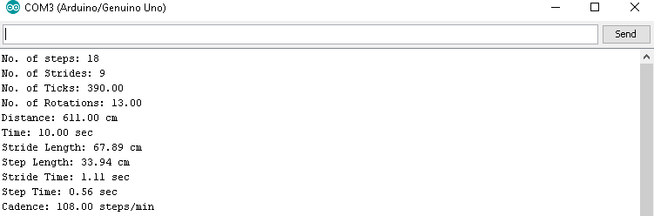

Figure 4.4.2(c): Observed Gait Parameters of Adult Subject II

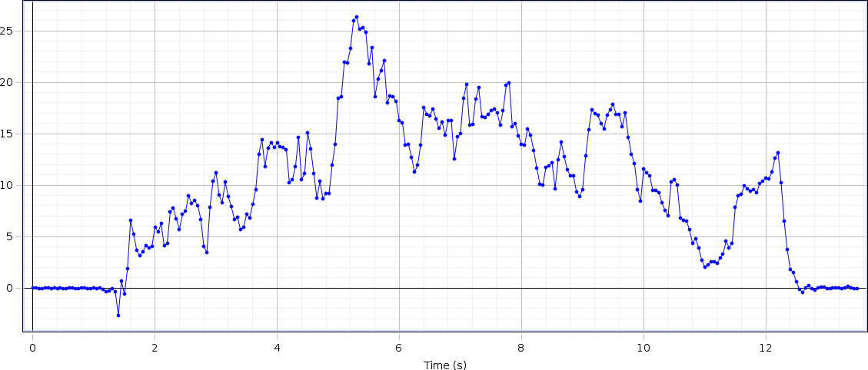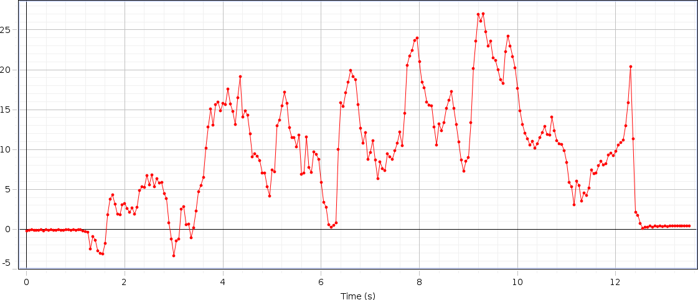

# DATA OF SUBJECT-III

## Left Hand Force

Figure 4.4.3(a): Graph of Left Hand Force of Adult Subject III

## Right Hand Force

Figure 4.4.3(b): Graph of Right Hand Force of Adult Subject III

Table 4.4.3: Data of Adult Subject III

|  |  |  |  |  |  |  |  |  |  |
| --- | --- | --- | --- | --- | --- | --- | --- | --- | --- |
| S.no | Steps | Time  (sec) | Distance  (meter) | Step  Time | Step  Length | Stride  Time | Stride  Length | Cadence | Velocity |
| 03 | 16 | 11 | 5.835 | 0.69 | 0.3647 | 1.37 | 0.7295 | 87.27 | 0.53 |

## Analysis

The rise and drop of strengths in the graph appears upper limb strengths amid taking care of inactive rollator utilized for gait by healthy person. The maximum rise up at F1 is 26.5N (this force is applied from left hand of the subject), at F2 the maximum rise up is of 27N (this force is applied from right hand of the subject). The change of both forces are different for every single individual according to their age, muscle strength and walking abilities of the subject, the force result comes from the subject. Because of the design of our rollator the force is bit different from abnormal subject (who are affected from any disease or disability) but not showing a major difference in the graph because their wheels help them to move easily without applying force on the handle bars. Subsequently, it is demonstrated that time inversely proportional to velocity.

## Parameters

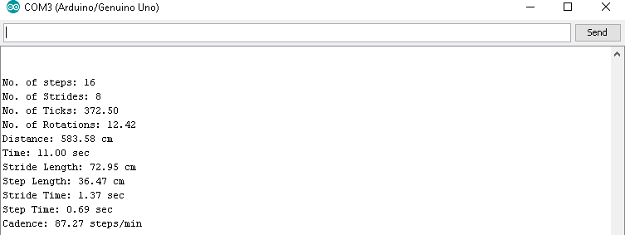

Figure 4.4.3(c): Observed Gait Parameters of Adult Subject III

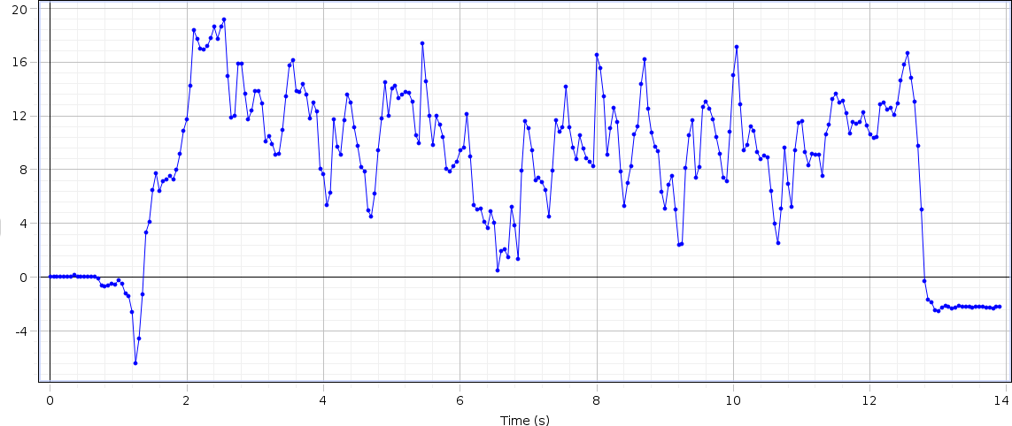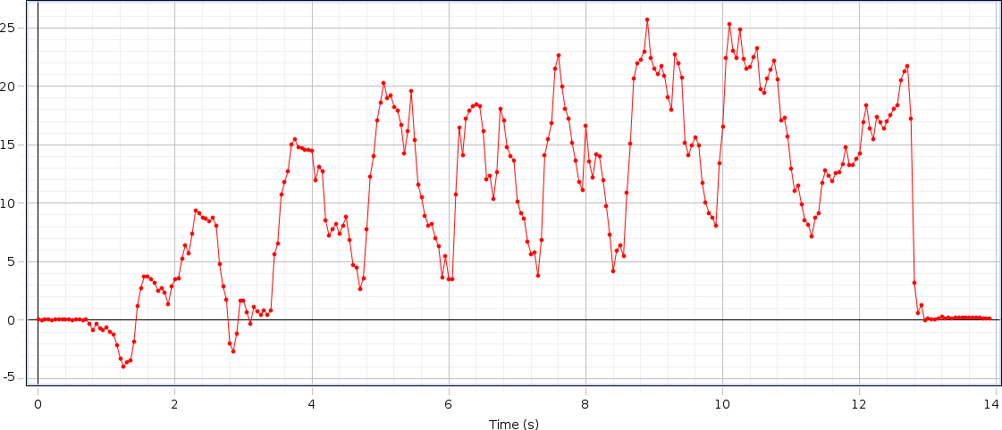

# DATA OF SUBJECT-IV

## Left Hand Force

Figure 4.4.4(a): Graph of Left Hand Force of Adult Subject IV

## Right Hand Force

Figure 4.4.4(b): Graph of Right Hand Force of Adult Subject IV

Table 4.4.4: Data of Adult Subject IV

|  |  |  |  |  |  |  |  |  |  |
| --- | --- | --- | --- | --- | --- | --- | --- | --- | --- |
| S.no | Steps | Time  (sec) | Distance  (meter) | Step  Time | Step  Length | Stride  Time | Stride  Length | Cadence | Velocity |
| 04 | 18 | 11 | 6.227 | 0.61 | 0.3460 | 1.22 | 0.6919 | 98.18 | 0.565 |

## Analysis

The rise and drop of strengths in the graph appears upper limb strengths amid taking care of inactive rollator utilized for gait by healthy person. The maximum rise up at F1 is 19N (this force is applied from left hand of the subject), at F2 the maximum rise up is of 26N (this force is applied from right hand of the subject). The change of both forces are different for every single individual according to their age, muscle strength and walking abilities of the subject, the force result comes from the subject. Because of the design of our rollator the force is bit different from abnormal subject (who are affected from any disease or disability) but not showing a major difference in the graph because their wheels help them to move easily without applying force on the handle bars. Subsequently, it is demonstrated that time inversely proportional to velocity.

## Parameters

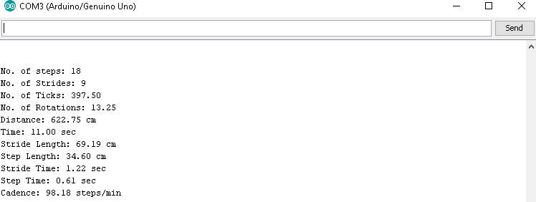

Figure 4.4.4(c): Observed Gait Parameters of Adult Subject IV

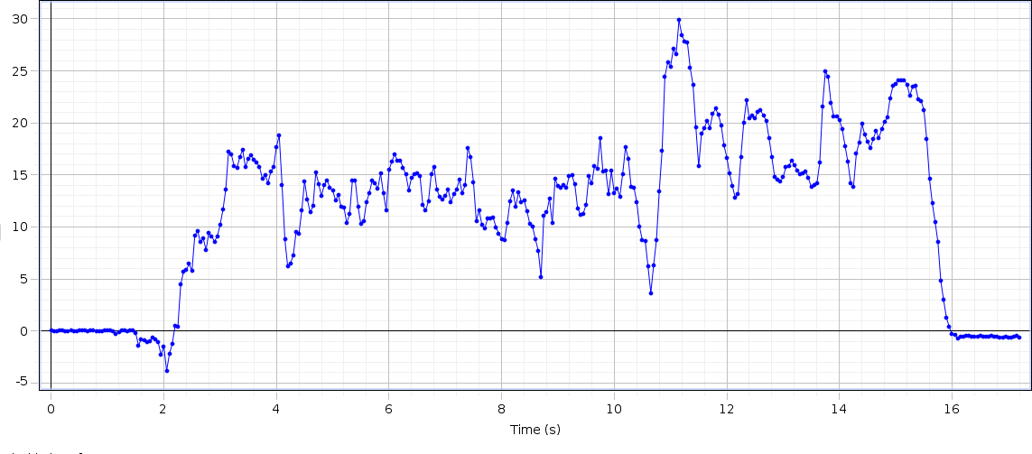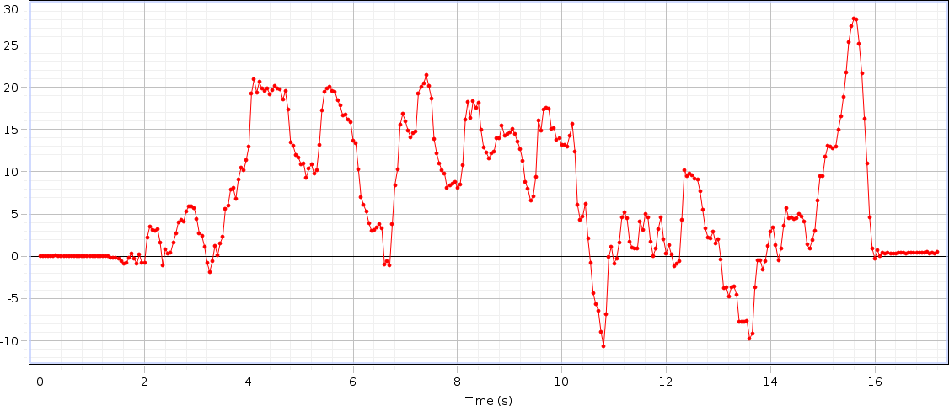

# DATA OF SUBJECT–V

## Left Hand Force

Figure 4.4.5(a): Graph of Left Hand Force of Adult Subject V

## Right Hand Force

Figure 4.4.5(b): Graph of Right Hand Force of Adult Subject V

Table 4.4.5: Data of Adult Subject V

|  |  |  |  |  |  |  |  |  |  |
| --- | --- | --- | --- | --- | --- | --- | --- | --- | --- |
| S.no | Steps | Time  (sec) | Distance  (meter) | Step  Time | Step  Length | Stride  Time | Stride  Length | Cadence | Velocity |
| 05 | 20 | 12 | 6.38 | 0.60 | 0.3192 | 1.20 | 0.6384 | 100 | 0.531 |

## Analysis

The rise and drop of strengths in the graph appears upper limb strengths amid taking care of inactive rollator utilized for gait by healthy person. The maximum rise up at F1 is 30N (this force is applied from left hand of the subject), at F2 the maximum rise up is of 28N (this force is applied from right hand of the subject). The change of both forces are different for every single individual according to their age, muscle strength and walking abilities of the subject, the force result comes from the subject. Because of the design of our rollator the force is bit different from abnormal subject (who are affected from any disease or disability) but not showing a major difference in the graph because their wheels help them to move easily without applying force on the handle bars. Subsequently, it is demonstrated that time inversely proportional to velocity.

## Parameter

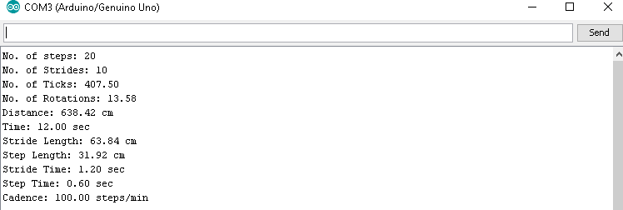

Figure 4.4.5(c): Observed Gait Parameters of Adult Subject V

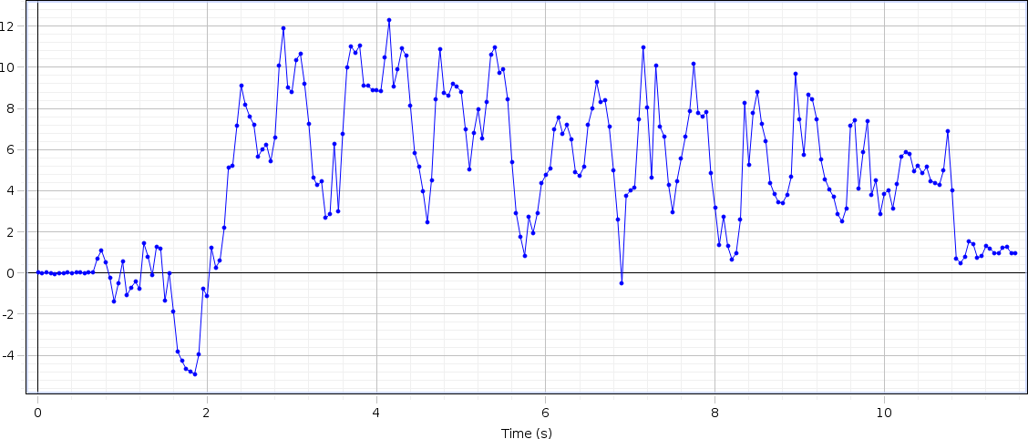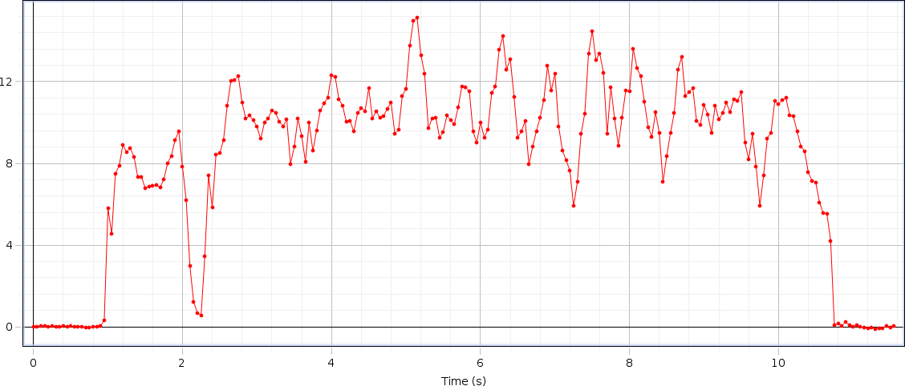

# DATA OF SUBJECT-VI

## Left Hand Force

Figure 4.4.6(a): Graph of Left Hand Force of Adult Subject VI

## Right Hand Force

Figure 4.4.6(b): Graph of Right Hand Force of Adult Subject VI

Table 4.4.6: Data of Adult Subject VI

|  |  |  |  |  |  |  |  |  |  |
| --- | --- | --- | --- | --- | --- | --- | --- | --- | --- |
| S.no | Steps | Time  (sec) | Distance  (meter) | Step  Time | Step  Length | Stride  Time | Stride  Length | Cadence | Velocity |
| 06 | 14 | 09 | 6.07 | 0.64 | 0.4336 | 1.29 | 0.8673 | 93.33 | 0.674 |

## Analysis

The rise and drop of strengths in the graph appears upper limb strengths amid taking care of inactive rollator utilized for gait by healthy person. The maximum rise up at F1 is 14N (this force is applied from left hand of the subject), at F2 the maximum rise up is of 13N (this force is applied from right hand of the subject). The change of both forces are different for every single individual according to their age, muscle strength and walking abilities of the subject, the force result comes from the subject. Because of the design of our rollator the force is bit different from abnormal subject (who are affected from any disease or disability) but not showing a major difference in the graph because their wheels help them to move easily without applying force on the handle bars. Subsequently, it is demonstrated that time inversely proportional to velocity.

## Parameters

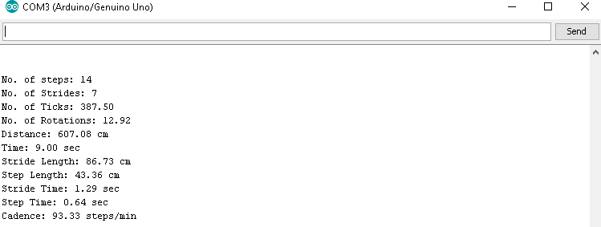

Figure 4.4.6(c): Observed Gait Parameters of Adult Subject VI

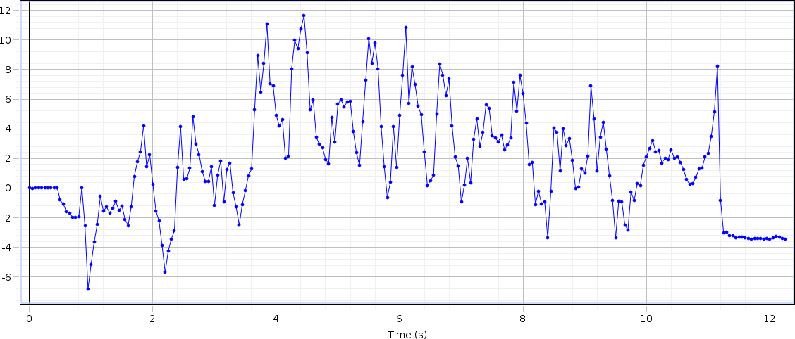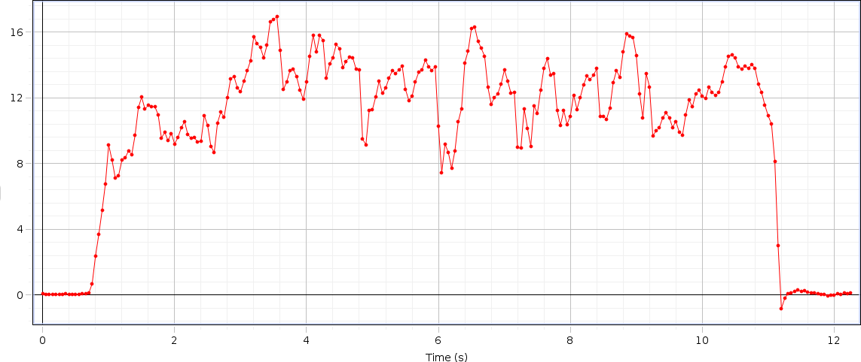

# DATA OF SUBJECT-VII

## Left Hand Force

Figure 4.4.7(a): Graph of Left Hand Force of Adult Subject VII

## Right Hand Force

Figure 4.4.7(b): Graph of Right Hand Force of Adult Subject VII

Table 4.4.7: Data of Adult Subject VII

|  |  |  |  |  |  |  |  |  |  |
| --- | --- | --- | --- | --- | --- | --- | --- | --- | --- |
| S.no | Steps | Time  (sec) | Distance  (meter) | Step  Time | Step  Length | Stride  Time | Stride  Length | Cadence | Velocity |
| 07 | 16 | 10 | 6.61 | 0.63 | 0.4137 | 1.25 | 0.8274 | 96 | 0.661 |

## Analysis

The rise and drop of strengths in the graph appears upper limb strengths amid taking care of inactive rollator utilized for gait by healthy person. The maximum rise up at F1 is 11N (this force is applied from left hand of the subject), at F2 the maximum rise up is of 17N (this force is applied from right hand of the subject). The change of both forces are different for every single individual according to their age, muscle strength and walking abilities of the subject, the force result comes from the subject. Because of the design of our rollator the force is bit different from abnormal subject (who are affected from any disease or disability) but not showing a major difference in the graph because their wheels help them to move easily without applying force on the handle bars. Subsequently, it is demonstrated that time inversely proportional to velocity.

## Parameters

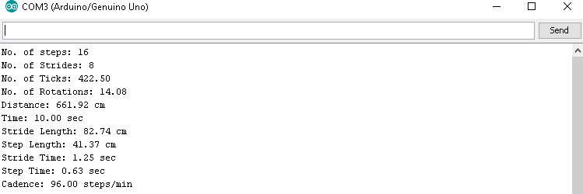

Figure 4.4.7(c): Observed Gait Parameters of Adult Subject VII

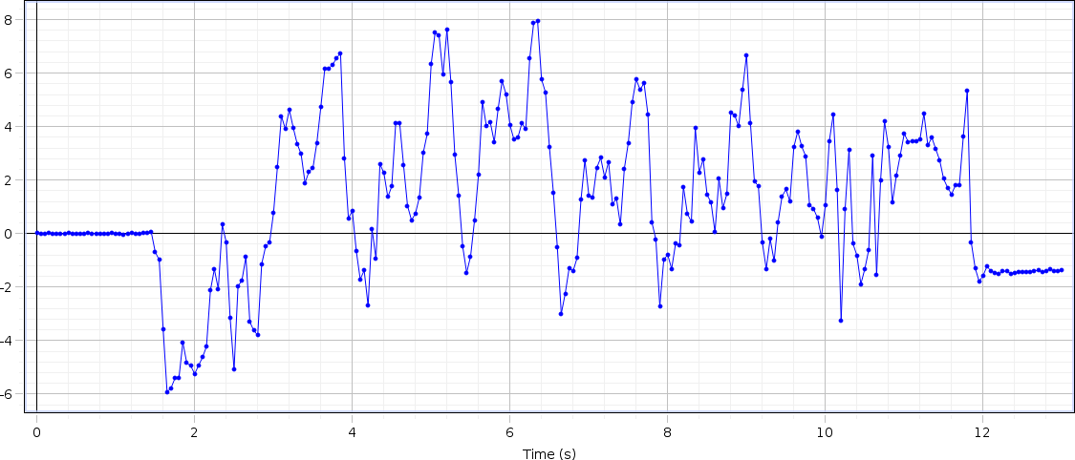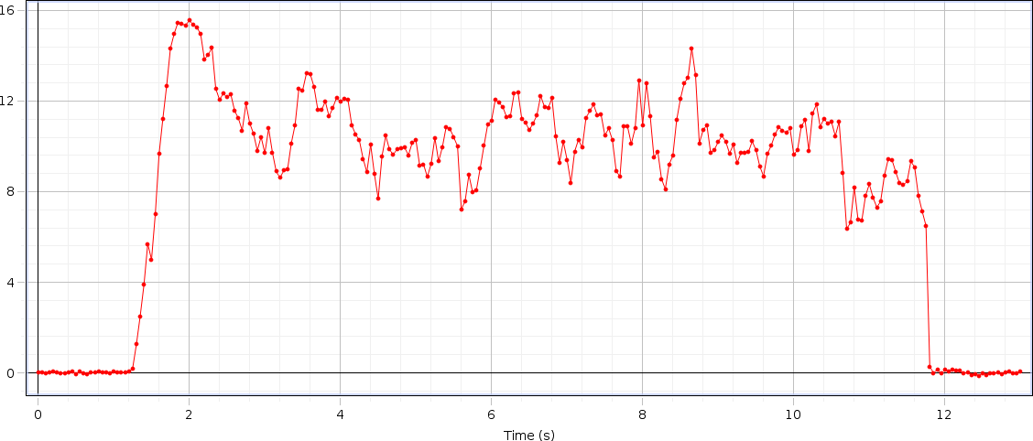

# DATA OF SUBJECT-VIII

## Left Hand Force

Figure 4.4.8(a): Graph of Left Hand Force of Adult Subject VIII

## Right Hand Force

Figure 4.4.8(b): Graph of Right Hand Force of Adult Subject VIII

Table 4.4.8: Data of Adult Subject VIII

|  |  |  |  |  |  |  |  |  |  |
| --- | --- | --- | --- | --- | --- | --- | --- | --- | --- |
| S.no | Steps | Time  (sec) | Distance  (meter) | Step  Time | Step  Length | Stride  Time | Stride  Length | Cadence | Velocity |
| 08 | 14 | 10 | 5.82 | 0.71 | 0.4161 | 1.43 | 0.8321 | 84 | 0.582 |

## Analysis

The rise and drop of strengths in the graph appears upper limb strengths amid taking care of inactive rollator utilized for gait by healthy person. The maximum rise up at F1 is 8N (this force is applied from left hand of the subject), at F2 the maximum rise up is of 15N (this force is applied from right hand of the subject). The change of both forces are different for every single individual according to their age, muscle strength and walking abilities of the subject, the force result comes from the subject. Because of the design of our rollator the force is bit different from abnormal subject (who are affected from any disease or disability) but not showing a major difference in the graph because their wheels help them to move easily without applying force on the handle bars. Subsequently, it is demonstrated that time inversely proportional to velocity.

## Parameters

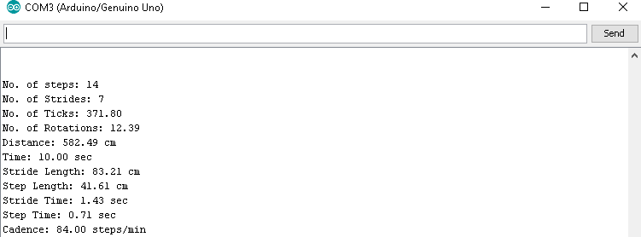

Figure 4.4.8(c): Observed Gait Parameters of Adult Subject VIII

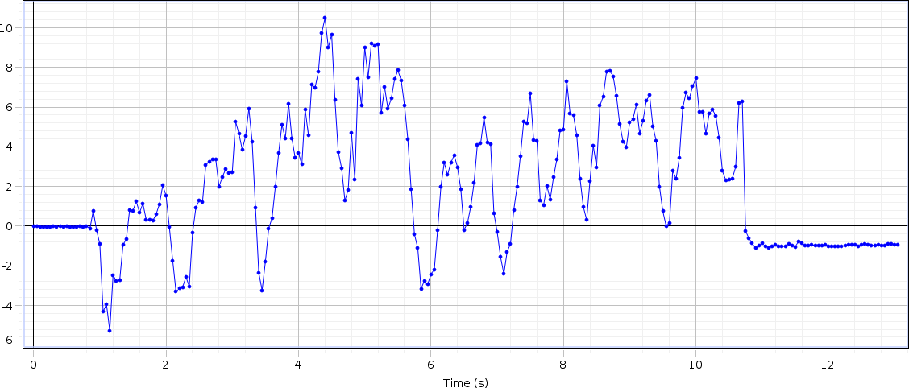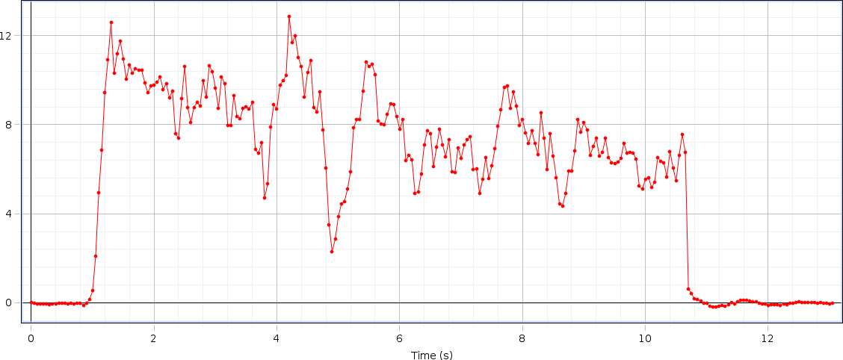

# DATA OF SUBJECT-IX

## Left Hand Force

Figure 4.4.9(a): Graph of Left Hand Force of Adult Subject IX

## Right Hand Force

Figure 4.4.9(b): Graph of Right Hand Force of Adult Subject IX

Table 4.4.9: Data of Adult Subject XI

|  |  |  |  |  |  |  |  |  |  |
| --- | --- | --- | --- | --- | --- | --- | --- | --- | --- |
| S.no | Steps | Time  (sec) | Distance  (meter) | Step  Time | Step  Length | Stride  Time | Stride  Length | Cadence | Velocity |
| 09 | 16 | 09 | 5.58 | 0.56 | 0.3490 | 1.12 | 0.6979 | 106.67 | 0.62 |

## Analysis

The rise and drop of strengths in the graph appears upper limb strengths amid taking care of inactive rollator utilized for gait by healthy person. The maximum rise up at F1 is 11N (this force is applied from left hand of the subject), at F2 the maximum rise up is of 14N (this force is applied from right hand of the subject). The change of both forces are different for every single individual according to their age, muscle strength and walking abilities of the subject, the force result comes from the subject. Because of the design of our rollator the force is bit different from abnormal subject (who are affected from any disease or disability) but not showing a major difference in the graph because their wheels help them to move easily without applying force on the handle bars. Subsequently, it is demonstrated that time inversely proportional to velocity.

## Parameters

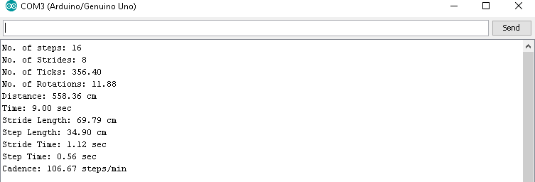

Figure 4.4.9(c): Observed Gait Parameters of Adult Subject IX

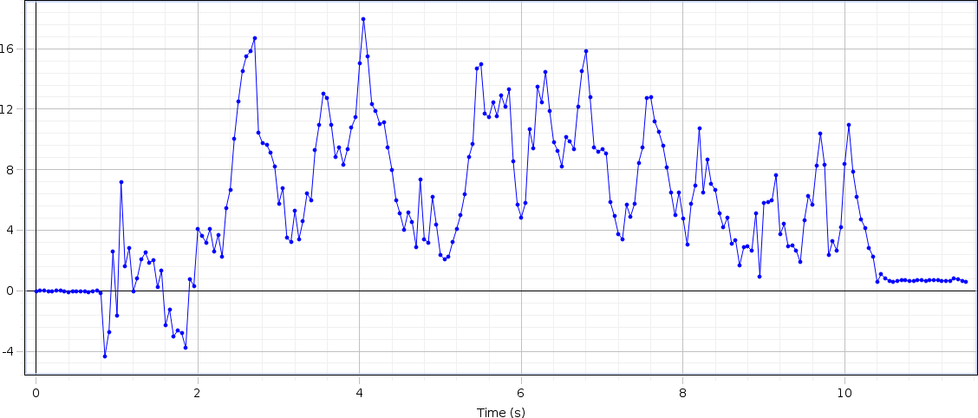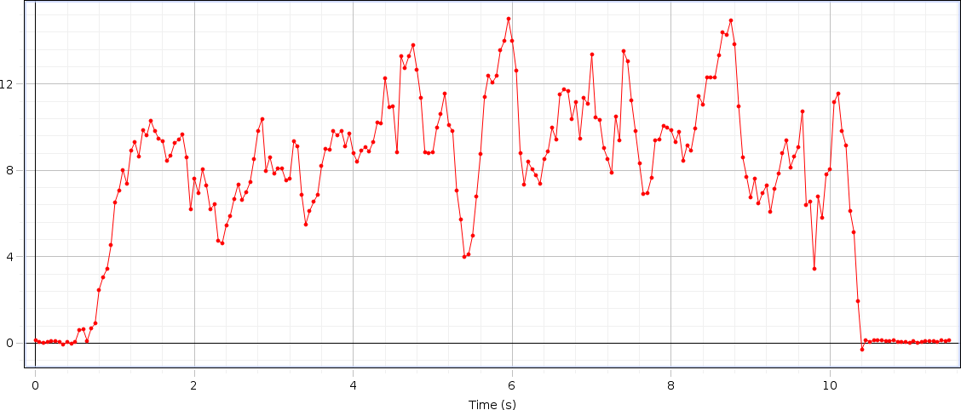

# DATA OF SUBJECT -X

## Left Hand Force

Figure 4.4.10(a): Graph of Left Hand Force of Adult Subject X

## Right Hand Force

Figure 4.4.10(b): Graph of Right Hand Force of Adult Subject X

Table 4.4.10: Data of Adult Subject X

|  |  |  |  |  |  |  |  |  |  |
| --- | --- | --- | --- | --- | --- | --- | --- | --- | --- |
| S.no | Steps | Time  (sec) | Distance  (meter) | Step  Time | Step  Length | Stride  Time | Stride  Length | Cadence | Velocity |
| 10 | 14 | 09 | 6.58 | 0.64 | 0.47 | 1.29 | 0.94 | 93.33 | 0.731 |

## Analysis

The rise and drop of strengths in the graph appears upper limb strengths amid taking care of inactive rollator utilized for gait by healthy person. The maximum rise up at F1 is 18N (this force is applied from left hand of the subject), at F2 the maximum rise up is of 13N (this force is applied from right hand of the subject). The change of both forces are different for every single individual according to their age, muscle strength and walking abilities of the subject, the force result comes from the subject. Because of the design of our rollator the force is bit different from abnormal subject (who are affected from any disease or disability) but not showing a major difference in the graph because their wheels help them to move easily without applying force on the handle bars. Subsequently, it is demonstrated that time inversely proportional to velocity.

## Parameters

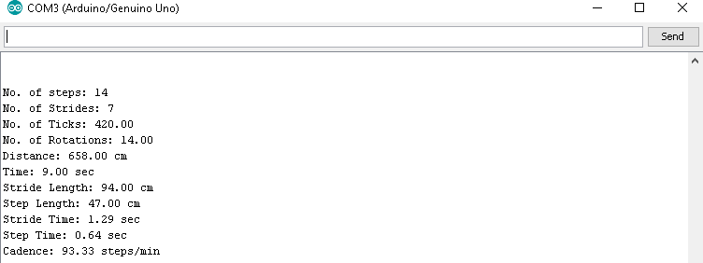

Figure 4.4.10(c): Observed Gait Parameters of Adult Subject X

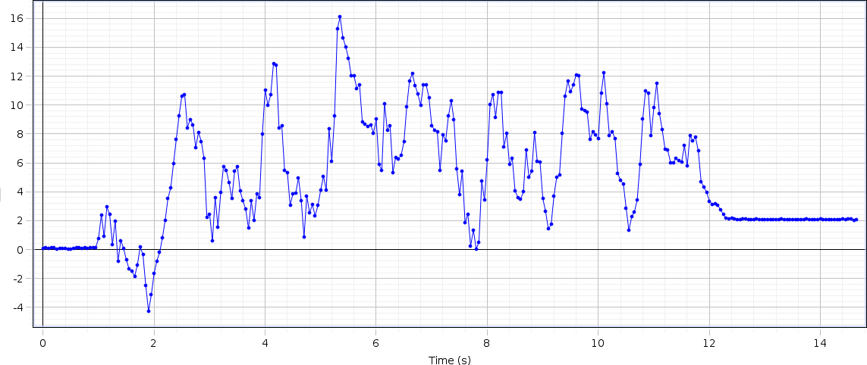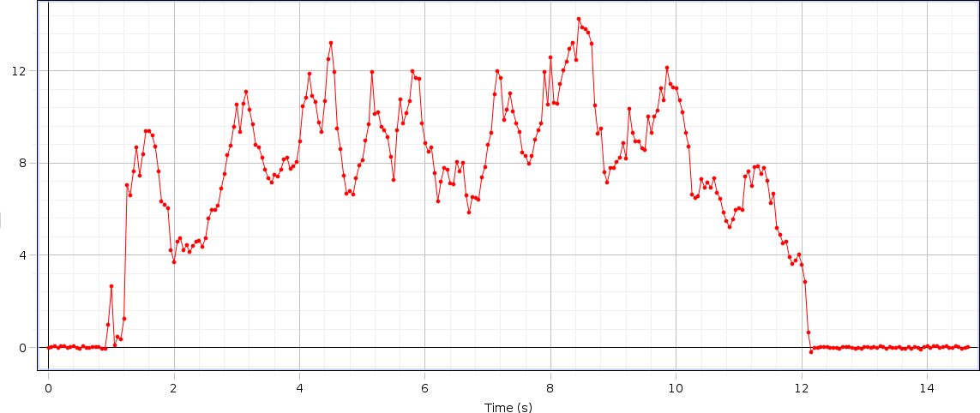

# DATA OF SUBJECT -XI

## Left Hand Force

Figure 4.4.11(a): Graph of Left Hand Force of Adult Subject XI

## Right Hand Force

Figure 4.4.11(b): Graph of Right Hand Force of Adult Subject XI

Table 4.4.11: Data of Adult Subject XI

|  |  |  |  |  |  |  |  |  |  |
| --- | --- | --- | --- | --- | --- | --- | --- | --- | --- |
| S.no | Steps | Time  (sec) | Distance  (meter) | Step  Time | Step  Length | Stride  Time | Stride  Length | Cadence | Velocity |
| 11 | 16 | 10 | 5.87 | 0.63 | 0.3672 | 1.25 | 0.7344 | 96 | 0.587 |

## Analysis

The rise and drop of strengths in the graph appears upper limb strengths amid taking care of inactive rollator utilized for gait by healthy person. The maximum rise up at F1 is 16.5N (this force is applied from left hand of the subject), at F2 the maximum rise up is of 15N (this force is applied from right hand of the subject). The change of both forces are different for every single individual according to their age, muscle strength and walking abilities of the subject, the force result comes from the subject. Because of the design of our rollator the force is bit different from abnormal subject (who are affected from any disease or disability) but not showing a major difference in the graph because their wheels help them to move easily without applying force on the handle bars. Subsequently, it is demonstrated that time inversely proportional to velocity.

## Parameters

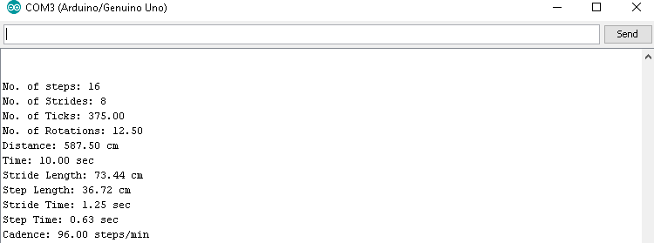

Figure 4.4.11(c): Observed Gait Parameters of Adult Subject XI

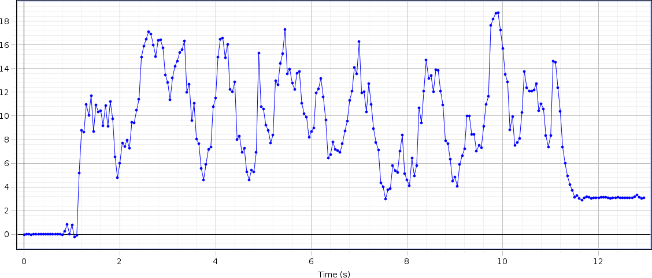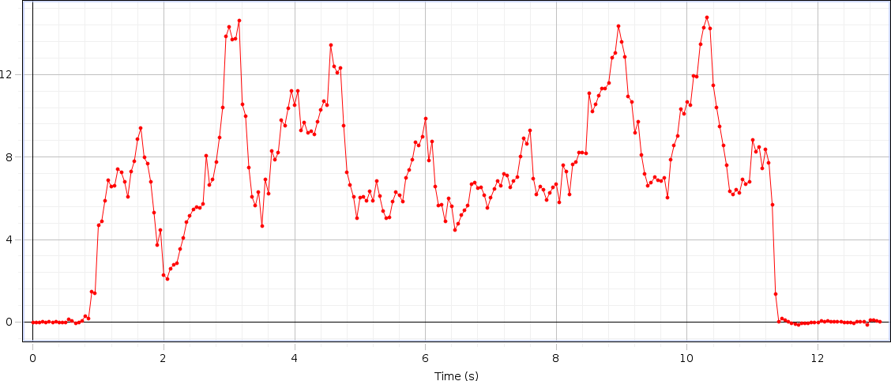

# DATA OF SUBJECT -XII

## Left Hand Force

Figure 4.4.12(a): Graph of Left Hand Force of Adult Subject XII

## Right Hand Force

Figure 4.4.12(b): Graph of Right Hand Force of Adult Subject XII

Table 4.4.12: Data of Adult Subject XII

|  |  |  |  |  |  |  |  |  |  |
| --- | --- | --- | --- | --- | --- | --- | --- | --- | --- |
| S.no | Steps | Time  (sec) | Distance  (meter) | Step  Time | Step  Length | Stride  Time | Stride  Length | Cadence | Velocity |
| 12 | 14 | 10 | 6.38 | 0.71 | 0.4560 | 1.43 | 0.9120 | 84 | 0.638 |

## Analysis

The rise and drop of strengths in the graph appears upper limb strengths amid taking care of inactive rollator utilized for gait by healthy person. The maximum rise up at F1 is 19N (this force is applied from left hand of the subject), at F2 the maximum rise up is of 14N (this force is applied from right hand of the subject). The change of both forces are different for every single individual according to their age, muscle strength and walking abilities of the subject, the force result comes from the subject. Because of the design of our rollator the force is bit different from abnormal subject (who are affected from any disease or disability) but not showing a major difference in the graph because their wheels help them to move easily without applying force on the handle bars. Subsequently, it is demonstrated that time inversely proportional to velocity.

## Parameters

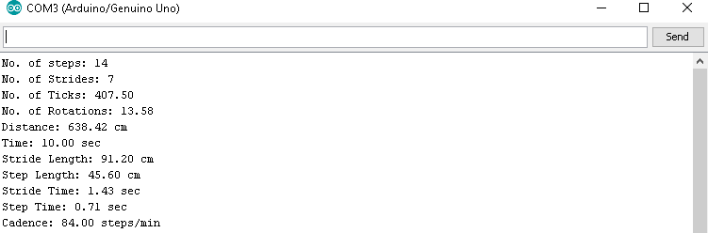

Figure 4.4.12(c): Observed Gait Parameters of Adult Subject XII

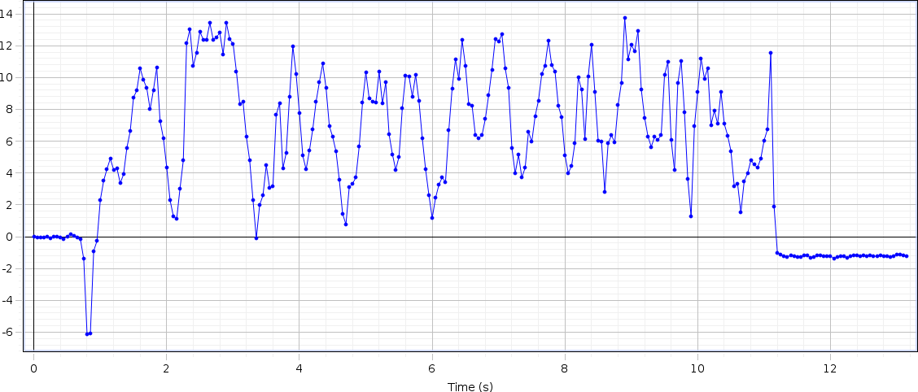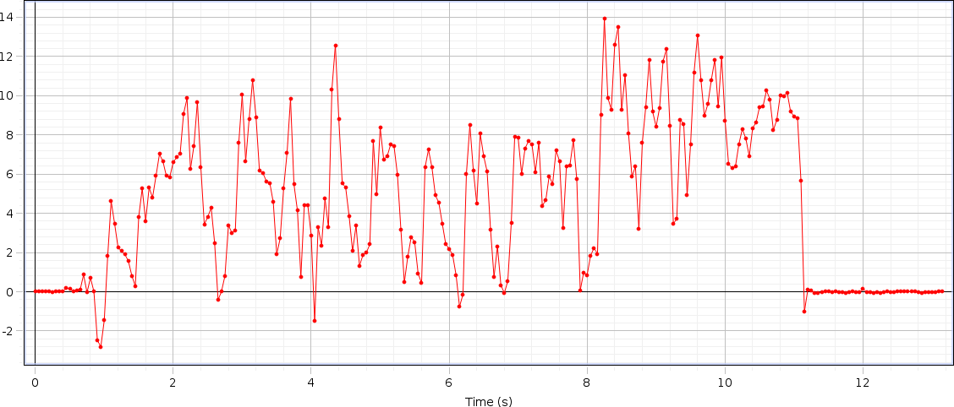

# DATA OF SUBJECT -XIII

## Left Hand Force

Figure 4.4.13(a): Graph of Left Hand Force of Adult Subject XIII

## Right Hand Force

Figure 4.4.13(b): Graph of Right Hand Force of Adult Subject XIII

Table 4.4.13: Data of Adult Subject XIII

|  |  |  |  |  |  |  |  |  |  |
| --- | --- | --- | --- | --- | --- | --- | --- | --- | --- |
| S.no | Steps | Time  (sec) | Distance  (meter) | Step  Time | Step  Length | Stride  Time | Stride  Length | Cadence | Velocity |
| 13 | 14 | 10 | 6.50 | 0.71 | 0.4644 | 1.43 | 0.9288 | 84 | 0.65 |

## Analysis

The rise and drop of strengths in the graph appears upper limb strengths amid taking care of inactive rollator utilized for gait by healthy person. The maximum rise up at F1 is 14N (this force is applied from left hand of the subject), at F2 the maximum rise up is of 14N (this force is applied from right hand of the subject). The change of both forces are different for every single individual according to their age, muscle strength and walking abilities of the subject, the force result comes from the subject. Because of the design of our rollator the force is bit different from abnormal subject (who are affected from any disease or disability) but not showing a major difference in the graph because their wheels help them to move easily without applying force on the handle bars. Subsequently, it is demonstrated that time inversely proportional to velocity.

## Parameters

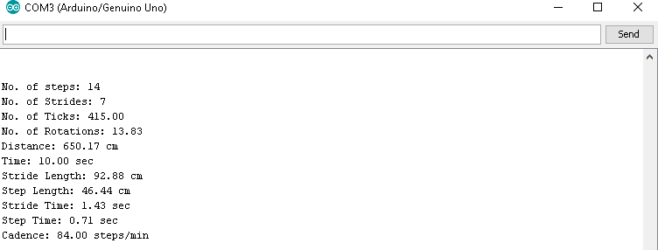

Figure 4.4.13(c): Observed Gait Parameters of Adult Subject XIII

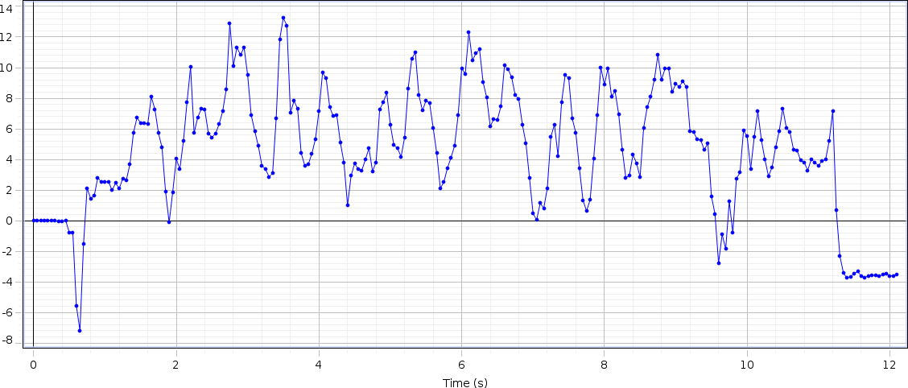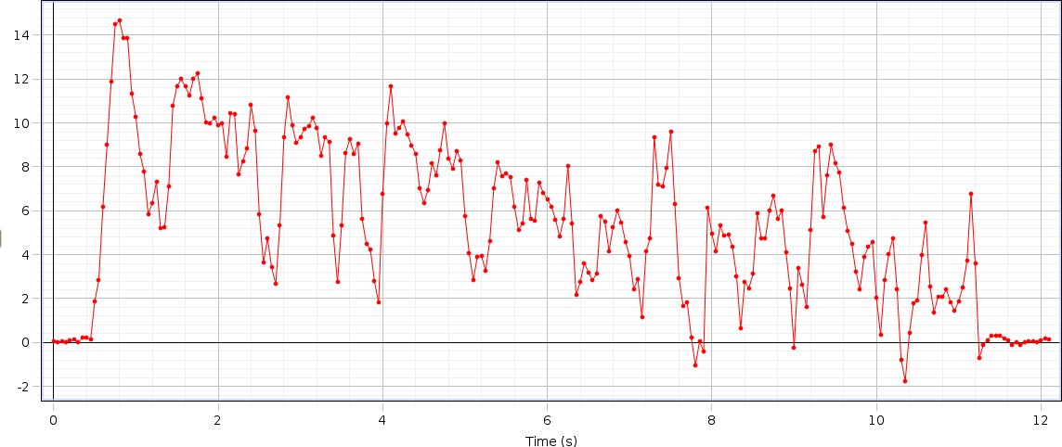

# DATA OF SUBJECT -XIV

## Left Hand Force

Figure 4.4.14(a): Graph of Left Hand Force of Adult Subject XIV

## Right Hand Force

Figure 4.4.14(b): Graph of Right Hand Force of Adult Subject XIV

Table 4.4.14: Data of Adult Subject XIV

|  |  |  |  |  |  |  |  |  |  |
| --- | --- | --- | --- | --- | --- | --- | --- | --- | --- |
| S.no | Steps | Time  (sec) | Distance  (meter) | Step  Time | Step  Length | Stride  Time | Stride  Length | Cadence | Velocity |
| 14 | 16 | 11 | 6.02 | 0.69 | 0.3763 | 1.37 | 0.7525 | 87.27 | 0.547 |

## Analysis

The rise and drop of strengths in the graph appears upper limb strengths amid taking care of inactive rollator utilized for gait by healthy person. The maximum rise up at F1 is 13.8N (this force is applied from left hand of the subject), at F2 the maximum rise up is of 14.5N (this force is applied from right hand of the subject). The change of both forces are different for every single individual according to their age, muscle strength and walking abilities of the subject, the force result comes from the subject. Because of the design of our rollator the force is bit different from abnormal subject (who are affected from any disease or disability) but not showing a major difference in the graph because their wheels help them to move easily without applying force on the handle bars. Subsequently, it is demonstrated that time inversely proportional to velocity.

## Parameters

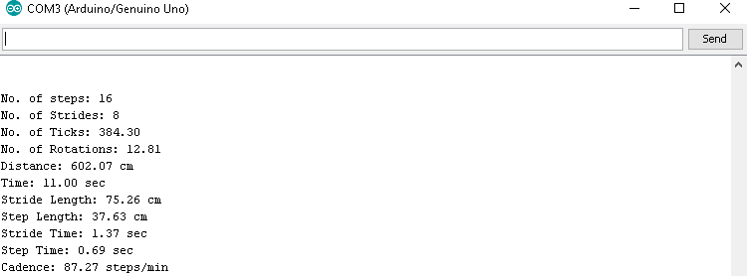

Figure 4.4.14(c): Observed Gait Parameters of Adult Subject XIV

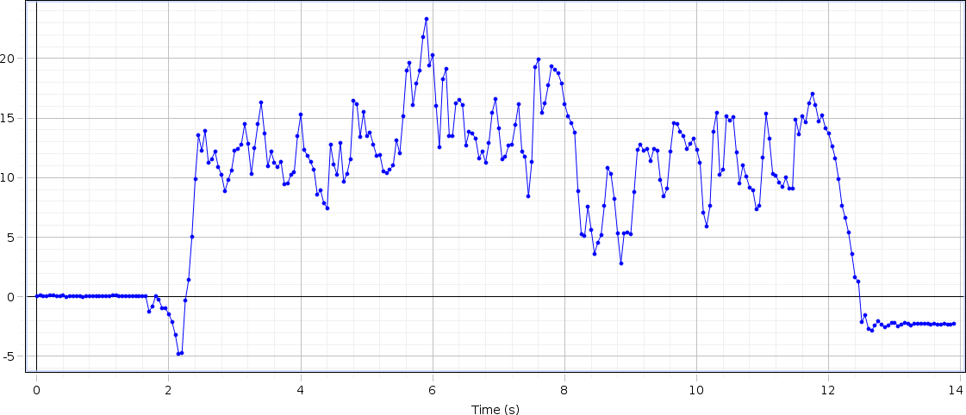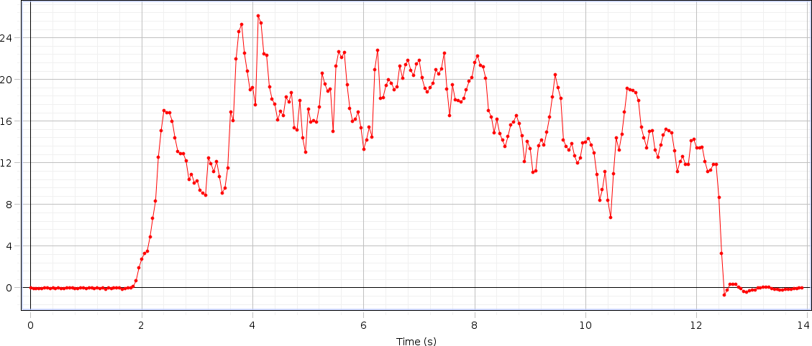

# DATA OF SUBJECT -XV

## Left Hand Force

Figure 4.4.15(a): Graph of Left Hand Force of Adult Subject XV

## Right Hand Force

Figure 4.4.15(b): Graph of Right Hand Force of Adult Subject XV

Table 4.4.15: Data of Adult Subject XV

|  |  |  |  |  |  |  |  |  |  |
| --- | --- | --- | --- | --- | --- | --- | --- | --- | --- |
| S.no | Steps | Time  (sec) | Distance  (meter) | Step  Time | Step  Length | Stride  Time | Stride  Length | Cadence | Velocity |
| 15 | 16 | 10 | 5.79 | 0.63 | 0.3623 | 1.25 | 0.7246 | 96 | 0.579 |

## Analysis

The rise and drop of strengths in the graph appears upper limb strengths amid taking care of inactive rollator utilized for gait by healthy person. The maximum rise up at F1 is 23N (this force is applied from left hand of the subject), at F2 the maximum rise up is of 24N (this force is applied from right hand of the subject). The change of both forces are different for every single individual according to their age, muscle strength and walking abilities of the subject, the force result comes from the subject. Because of the design of our rollator the force is bit different from abnormal subject (who are affected from any disease or disability) but not showing a major difference in the graph because their wheels help them to move easily without applying force on the handle bars. Subsequently, it is demonstrated that time inversely proportional to velocity.

## Parameters

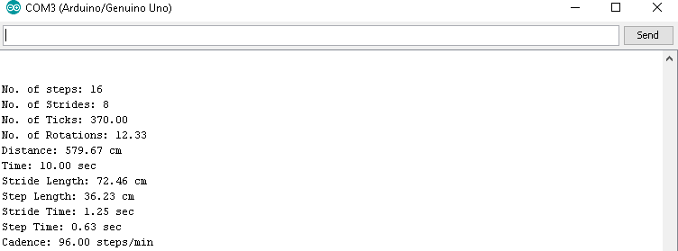

Figure 4.4.15(c): Observed Gait Parameters of Adult Subject XV

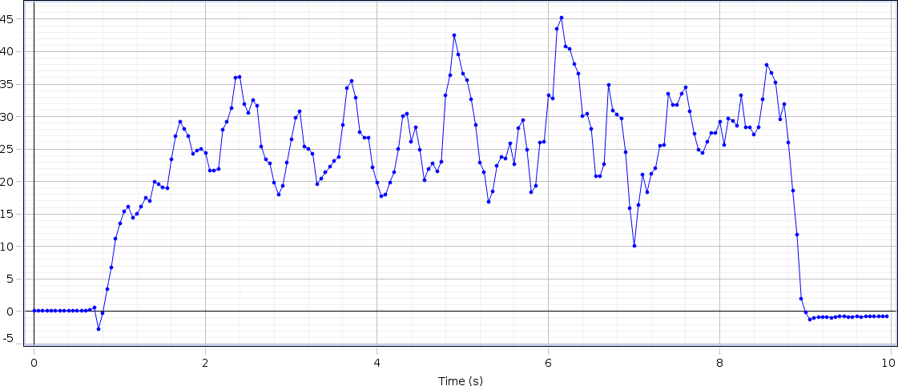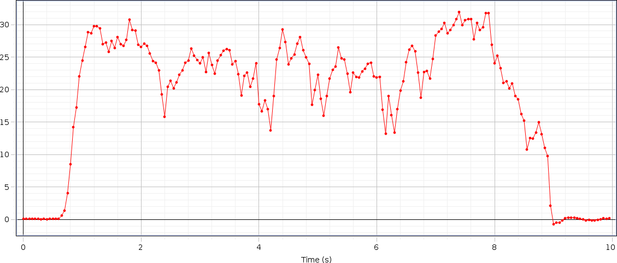

# DATA OF SUBJECT -XVI

## Left Hand Force

Figure 4.4.16(a): Graph of Left Hand Force of Adult Subject XVI

## Right Hand Force

Figure 4.4.16(b): Graph of Right Hand Force of Adult Subject XVI

Table 4.4.16: Data of Adult Subject XVI

|  |  |  |  |  |  |  |  |  |  |
| --- | --- | --- | --- | --- | --- | --- | --- | --- | --- |
| S.no | Steps | Time  (sec) | Distance  (meter) | Step  Time | Step  Length | Stride  Time | Stride  Length | Cadence | Velocity |
| 16 | 12 | 08 | 5.91 | 0.67 | 0.4928 | 1.33 | 0.9857 | 90 | 0.738 |

## Analysis

The rise and drop of strengths in the graph appears upper limb strengths amid taking care of inactive rollator utilized for gait by healthy person. The maximum rise up at F1 is 45N (this force is applied from left hand of the subject), at F2 the maximum rise up is of 33N (this force is applied from right hand of the subject). The change of both forces are different for every single individual according to their age, muscle strength and walking abilities of the subject, the force result comes from the subject. Because of the design of our rollator the force is bit different from abnormal subject (who are affected from any disease or disability) but not showing a major difference in the graph because their wheels help them to move easily without applying force on the handle bars. Subsequently, it is demonstrated that time inversely proportional to velocity.

## Parameters

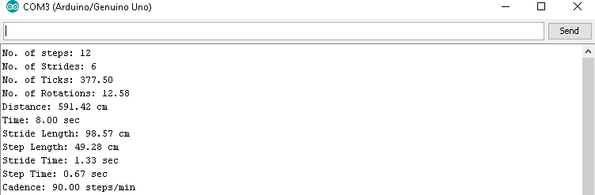

Figure 4.4.16(c): Observed Gait Parameters of Adult Subject XVI

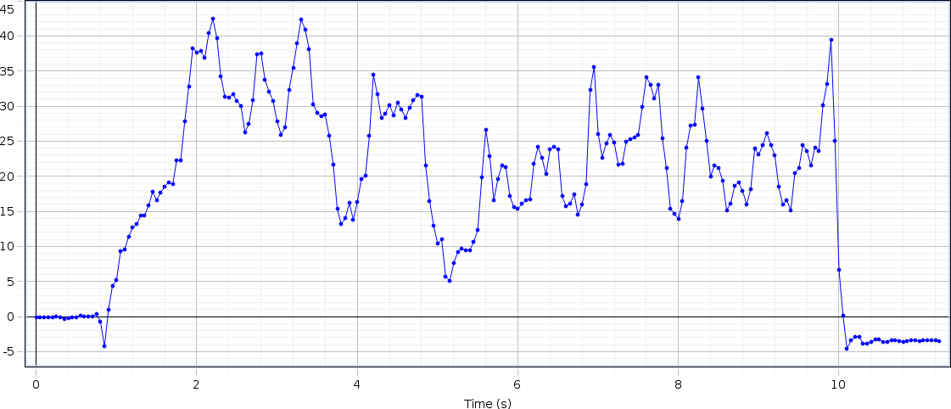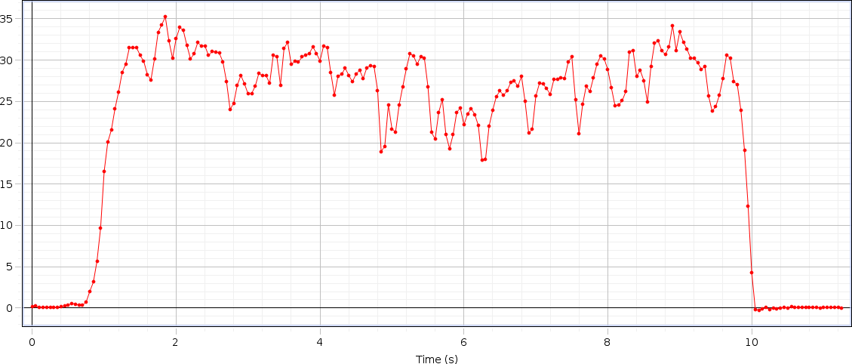

# DATA OF SUBJECT -XVII

## Left Hand Force

Figure 4.4.17(a): Graph of Left Hand Force of Adult Subject XVII

## Right Hand Force

Figure 4.4.17(b): Graph of Right Hand Force of Adult Subject XVII

Table 4.4.17: Data of Adult Subject XVII

|  |  |  |  |  |  |  |  |  |  |
| --- | --- | --- | --- | --- | --- | --- | --- | --- | --- |
| S.no | Steps | Time  (sec) | Distance  (meter) | Step  Time | Step  Length | Stride  Time | Stride  Length | Cadence | Velocity |
| 17 | 16 | 09 | 6.42 | 0.56 | 0.4015 | 1.12 | 0.8029 | 106.67 | 0.713 |

## Analysis

The rise and drop of strengths in the graph appears upper limb strengths amid taking care of inactive rollator utilized for gait by healthy person. The maximum rise up at F1 is 43N (this force is applied from left hand of the subject), at F2 the maximum rise up is of 35N (this force is applied from right hand of the subject). The change of both forces are different for every single individual according to their age, muscle strength and walking abilities of the subject, the force result comes from the subject. Because of the design of our rollator the force is bit different from abnormal subject (who are affected from any disease or disability) but not showing a major difference in the graph because their wheels help them to move easily without applying force on the handle bars. Subsequently, it is demonstrated that time inversely proportional to velocity.

## Parameters

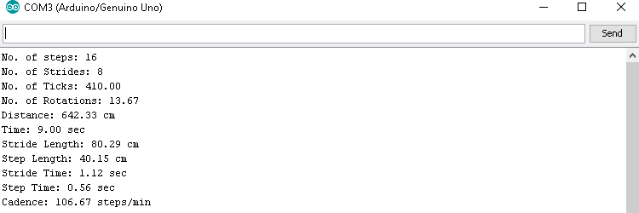

Figure 4.4.17(c): Observed Gait Parameters of Adult Subject XVII

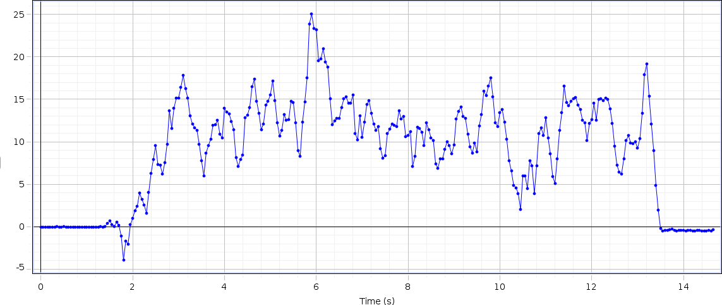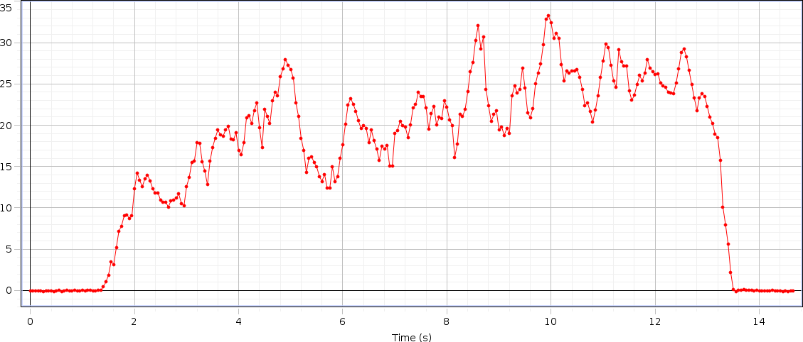

# DATA OF SUBJECT -XVIII

## Left Hand Force

Figure 4.4.18(a): Graph of Left Hand Force of Adult Subject XVIII

## Right Hand Force

Figure 4.4.18(b): Graph of Right Hand Force of Adult Subject XVIII

Table 4.4.18: Data of Adult Subject XVIII

|  |  |  |  |  |  |  |  |  |  |
| --- | --- | --- | --- | --- | --- | --- | --- | --- | --- |
| S.no | Steps | Time  (sec) | Distance  (meter) | Step  Time | Step  Length | Stride  Time | Stride  Length | Cadence | Velocity |
| 18 | 18 | 11 | 6.26 | 0.61 | 0.3481 | 1.22 | 0.6963 | 98.18 | 0.569 |

## Analysis

The rise and drop of strengths in the graph appears upper limb strengths amid taking care of inactive rollator utilized for gait by healthy person. The maximum rise up at F1 is 25N (this force is applied from left hand of the subject), at F2 the maximum rise up is of 34N (this force is applied from right hand of the subject). The change of both forces are different for every single individual according to their age, muscle strength and walking abilities of the subject, the force result comes from the subject. Because of the design of our rollator the force is bit different from abnormal subject (who are affected from any disease or disability) but not showing a major difference in the graph because their wheels help them to move easily without applying force on the handle bars. Subsequently, it is demonstrated that time inversely proportional to velocity.

## Parameters

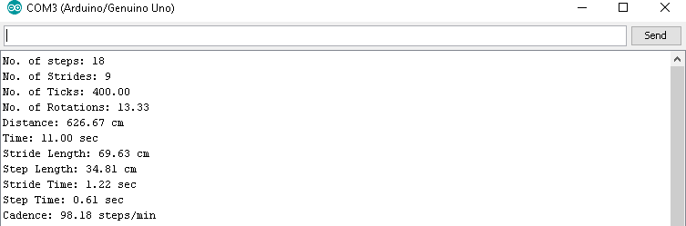

Figure 4.4.18(c): Observed Gait Parameters of Subject Adult XVIII

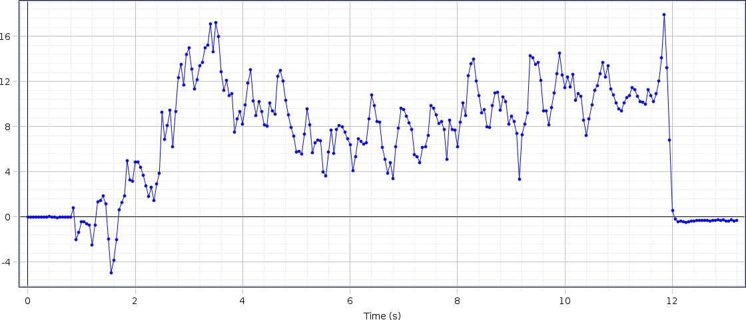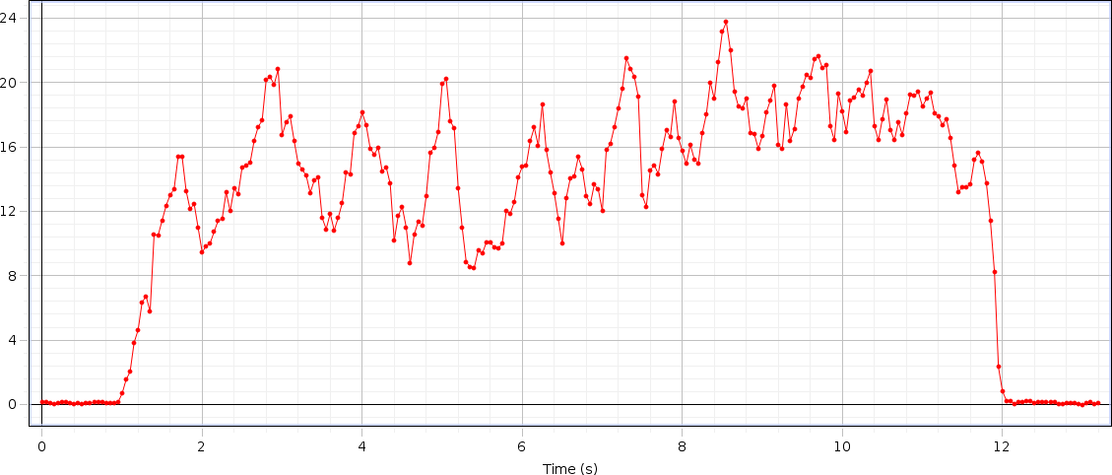

# DATA OF SUBJECT -XIX

## Left Hand Force

Figure 4.4.19(a): Graph of Left Hand Force of Adult Subject XIX

## Right Hand Force

Figure 4.4.19(b): Graph of Right Hand Force of Adult Subject XIX

Table 4.4.19: Data of Adult Subject XIX

|  |  |  |  |  |  |  |  |  |  |
| --- | --- | --- | --- | --- | --- | --- | --- | --- | --- |
| S.no | Steps | Time  (sec) | Distance  (meter) | Step  Time | Step  Length | Stride  Time | Stride  Length | Cadence | Velocity |
| 19 | 18 | 10 | 5.97 | 0.56 | 0.3321 | 1.11 | 0.6643 | 108 | 0.597 |

## Analysis

The rise and drop of strengths in the graph appears upper limb strengths amid taking care of inactive rollator utilized for gait by healthy person. The maximum rise up at F1 is 17N (this force is applied from left hand of the subject), at F2 the maximum rise up is of 24N (this force is applied from right hand of the subject). The change of both forces are different for every single individual according to their age, muscle strength and walking abilities of the subject, the force result comes from the subject. Because of the design of our rollator the force is bit different from abnormal subject (who are affected from any disease or disability) but not showing a major difference in the graph because their wheels help them to move easily without applying force on the handle bars. Subsequently, it is demonstrated that time inversely proportional to velocity.

## Parameters

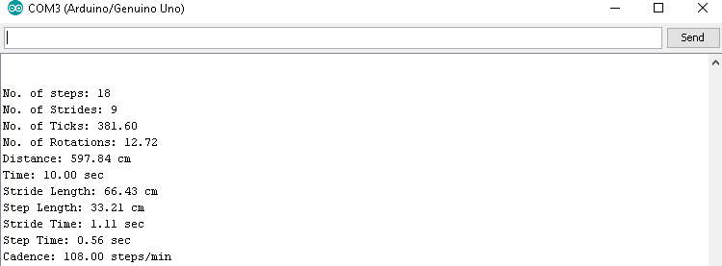

Figure 4.4.19(c): Observed Gait Parameters of Adult Subject XIX

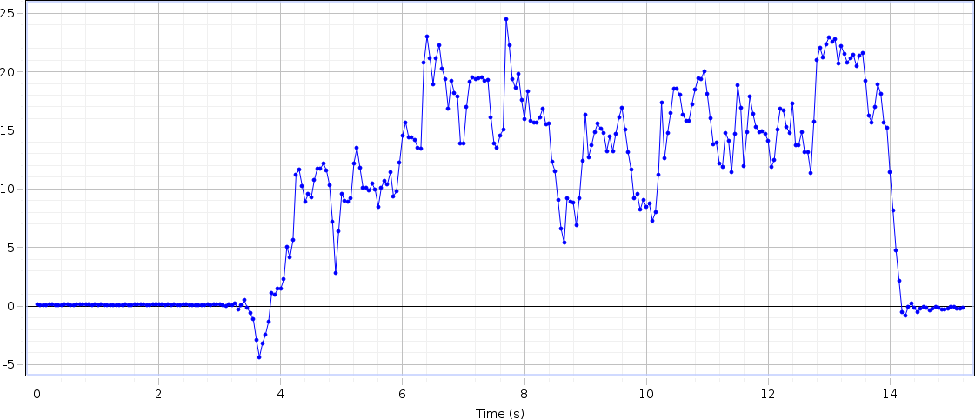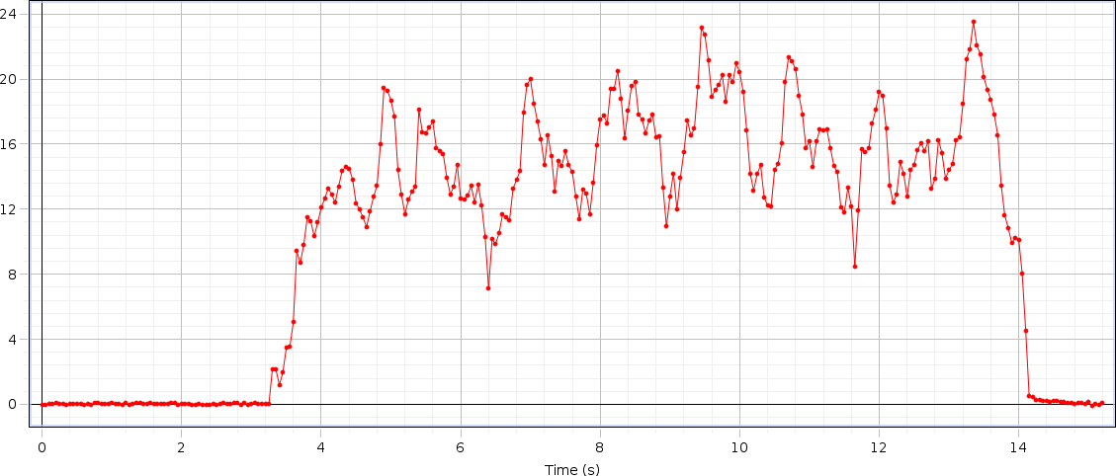

# DATA OF SUBJECT -XX

## Left Hand Force

Figure 4.4.20(a): Graph of Left Hand Force of Adult Subject XX

## Right Hand Force

Figure 4.4.20(b): Graph of Right Hand Force of Adult Subject XX

Table 4.4.20: Data of Adult Subject XX

|  |  |  |  |  |  |  |  |  |  |
| --- | --- | --- | --- | --- | --- | --- | --- | --- | --- |
| S.no | Steps | Time (sec) | Distance (meter) | Step Time | Step Length | Stride Time | Stride Length | Cadence | Velocity |
| 20 | 14 | 10 | 6.05 | 0.71 | 0.4324 | 1.43 | 0.8648 | 84 | 0.605 |

## Analysis

The rise and drop of strengths in the graph appears upper limb strengths amid taking care of inactive rollator utilized for gait by healthy person. The maximum rise up at F1 is 24N (this force is applied from left hand of the subject), at F2 the maximum rise up is of 23N (this force is applied from right hand of the subject). The change of both forces are different for every single individual according to their age, muscle strength and walking abilities of the subject, the force result comes from the subject. Because of the design of our rollator the force is bit different from abnormal subject (who are affected from any disease or disability) but not showing a major difference in the graph because their wheels help them to move easily without applying force on the handle bars. Subsequently, it is demonstrated that time inversely proportional to velocity.

## Parameters

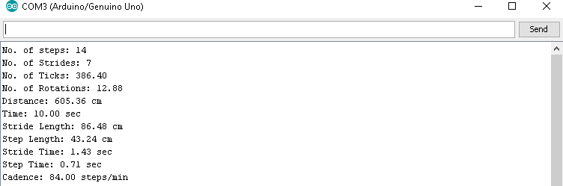

Figure 4.4.20(c): Observed Gait Parameters of Adult Subject XX

# DATA AND ANALYSIS OF ELDERLY AGED SUBJECTS

The 20 figures with two parts (a) and (b) contain the graphs of aged and diseased subjects whose ages are in 60 to 90 years, the first part is the graphical representation of the two forces applied from right or left hand on each side of rollator and the second part is the value of observed spatiotemporal parameters on Arduino software which are written in tabular form.

The analysis of data of all subjects are performed individually which is mentioned with details along with the table of data collected of each subject.

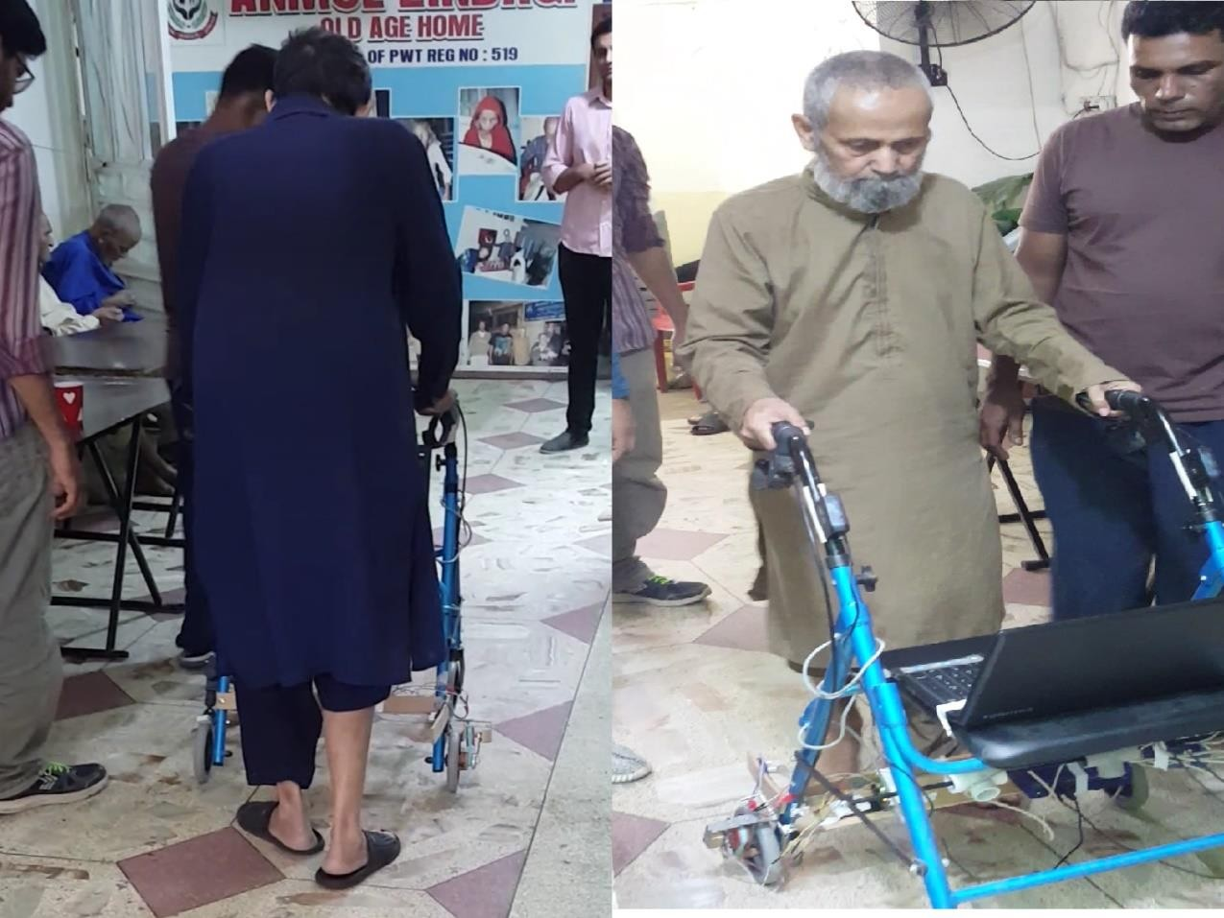

Figure 4.5: Elderly Aged Subjects

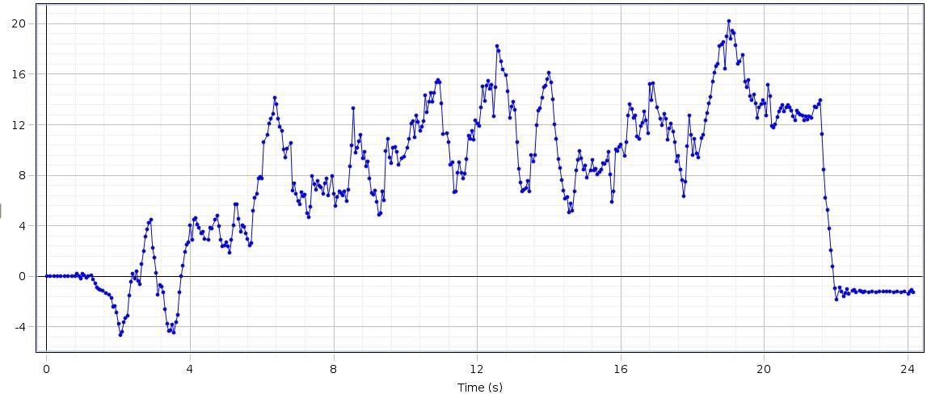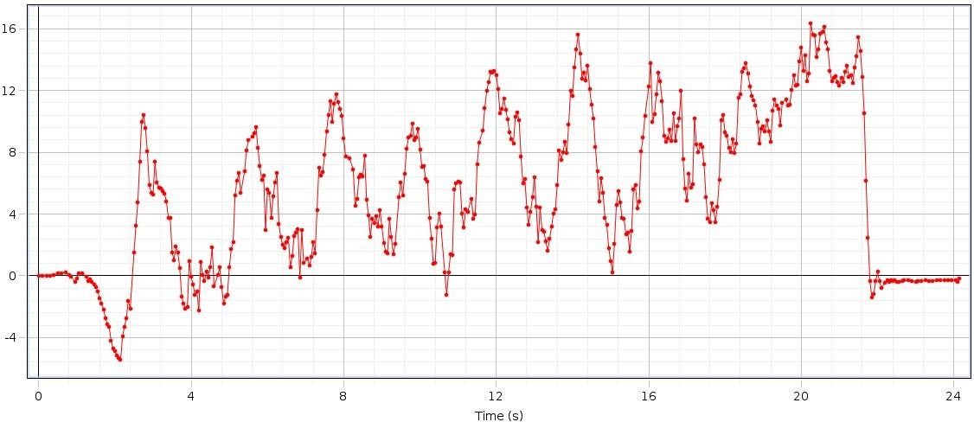

# DATA OF SUBJECT -I

## Left Hand Force

Figure 4.5.1(a): Graph of Left Hand Force of Aged Subject I

## Right Hand Force

Figure 4.5.1(b): Graph of Right Hand Force of Aged Subject I

Table 4.5.1: Data of Aged Subject I

|  |  |  |  |  |  |  |  |  |  |
| --- | --- | --- | --- | --- | --- | --- | --- | --- | --- |
| S.no | Steps | Time  (sec) | Distance  (meter) | Step  Time | Step  Length | Stride  Time | Stride  Length | Cadence | Velocity |
| 01 | 20 | 17 | 5.79 | 0.85 | 0.2895 | 1.70 | 0.5790 | 70.59 | 0.340 |

## Analysis

The rise and drop of strengths in the graph appears upper limb strengths amid taking care of inactive rollator utilized for gait by healthy genomic person. The maximum rise up at F1 is 20N (this force is applied from left hand of the subject), at F2 the maximum rise up is of 17N (this force is applied from right hand of the subject). The change of both forces are different for every single individual according to their age, muscle strength and walking abilities of the subject. The force result comes from the patients who are suffering from diseases like Osteoporosis, Parkinson’s etc. are diverse. Because of the design of our rollator the force is bit different from normal subject (who are not affected from any disease or disability) but not showing a major difference in the graph because their wheels help them to move easily without applying force on the handle bars. Subsequently, it is demonstrated that time inversely proportional to velocity.

## Parameters

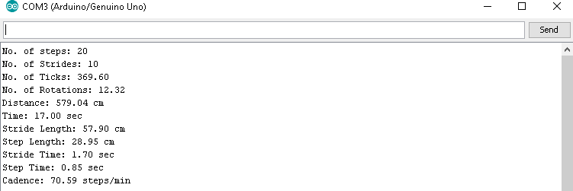

Figure 4.5.1(c): Observed Gait Parameters of Aged Subject I

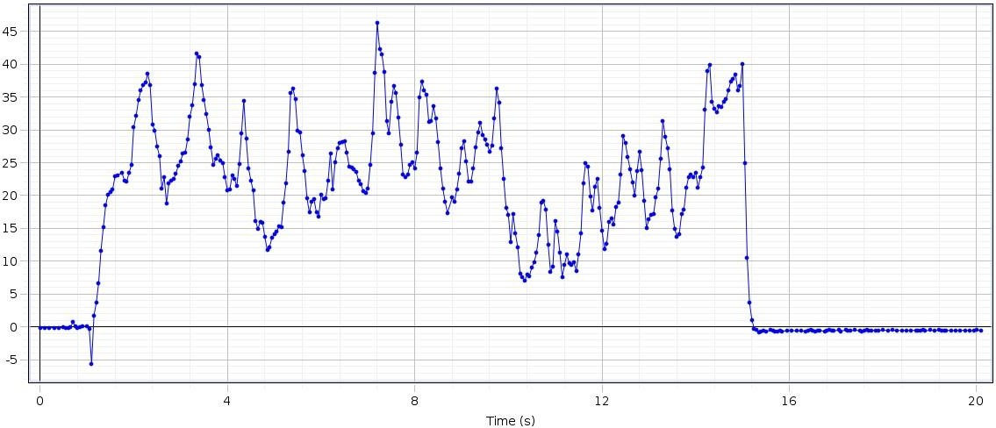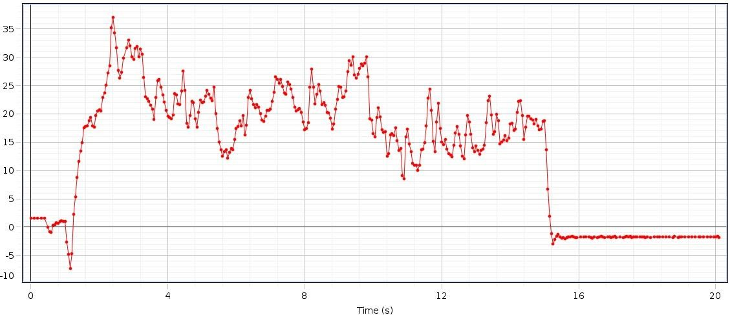

# DATA OF SUBJECT -II

## Left Hand Force

Figure 4.5.2(a): Graph of Left Hand Force of Aged Subject II

## Right Hand Force

Figure 4.5.2(b): Graph of Right Hand Force of Aged Subject II

Table 4.5.2: Data of Aged Subject II

|  |  |  |  |  |  |  |  |  |  |
| --- | --- | --- | --- | --- | --- | --- | --- | --- | --- |
| S.no | Steps | Time  (sec) | Distance  (meter) | Step  Time | Step  Length | Stride  Time | Stride  Length | Cadence | Velocity |
| 02 | 14 | 13 | 6.02 | 1.65 | 0.4301 | 3.31 | 0.8601 | 64.62 | 0.4630 |

## Analysis

The rise and drop of strengths in the graph appears upper limb strengths amid taking care of inactive rollator utilized for gait by healthy genomic person. The maximum rise up at F1 is 46N (this force is applied from left hand of the subject), at F2 the maximum rise up is of 33N (this force is applied from right hand of the subject). The change of both forces are different for every single individual according to their age, muscle strength and walking abilities of the subject. The force result comes from the patients who are suffering from diseases like Osteoporosis, Parkinson’s etc. are diverse. Because of the design of our rollator the force is bit different from normal subject (who are not affected from any disease or disability) but not showing a major difference in the graph because their wheels help them to move easily without applying force on the handle bars. Subsequently, it is demonstrated that time inversely proportional to velocity.

## Parameters

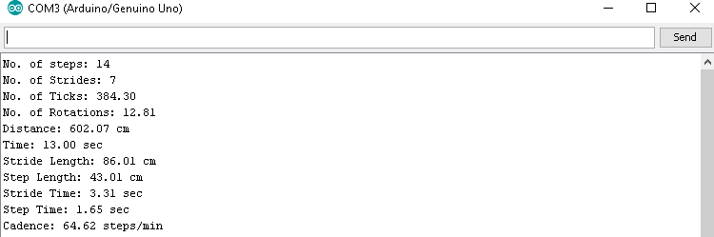

Figure 4.5.2(c): Observed Gait Parameters of Aged Subject I

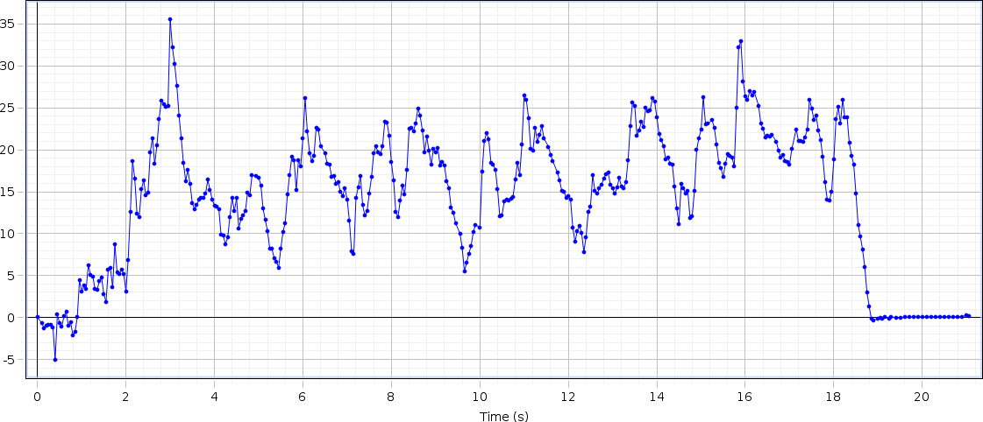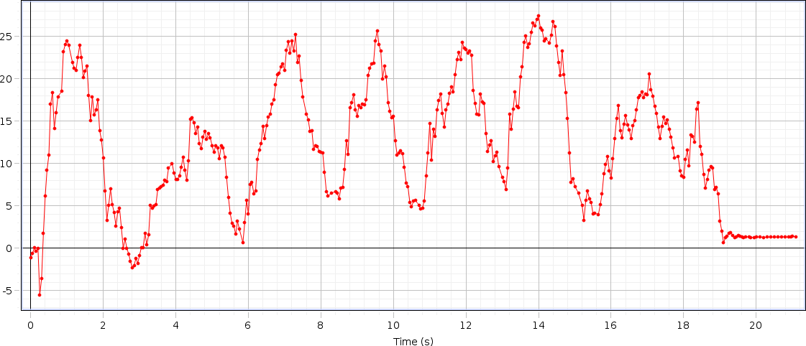

# DATA OF SUBJECT -III

## Left Hand Force

Figure 4.5.3(a): Graph of Left Hand Force of Aged Subject III

## Right Hand Force

Figure 4.5.3(b): Graph of Right Hand Force of Aged Subject III

Table 4.5.3: Data of Aged Subject III

|  |  |  |  |  |  |  |  |  |  |
| --- | --- | --- | --- | --- | --- | --- | --- | --- | --- |
| S.no | Steps | Time  (sec) | Distance  (meter) | Step  Time | Step  Length | Stride  Time | Stride  Length | Cadence | Velocity |
| 03 | 20 | 17 | 6.15 | 0.90 | 0.3076 | 1.81 | 0.6152 | 70.59 | 0.3617 |

## Analysis

The rise and drop of strengths in the graph appears upper limb strengths amid taking care of inactive rollator utilized for gait by healthy genomic person. The maximum rise up at F1 is 36N (this force is applied from left hand of the subject), at F2 the maximum rise up is of 27N (this force is applied from right hand of the subject). The change of both forces are different for every single individual according to their age, muscle strength and walking abilities of the subject. The force result comes from the patients who are suffering from diseases like Osteoporosis, Parkinson’s etc. are diverse. Because of the design of our rollator the force is bit different from normal subject (who are not affected from any disease or disability) but not showing a major difference in the graph because their wheels help them to move easily without applying force on the handle bars. Subsequently, it is demonstrated that time inversely proportional to velocity.

## Parameters

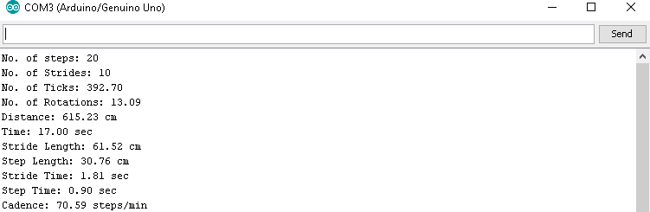

Figure 4.5.3(c): Observed Gait Parameters of Aged Subject III

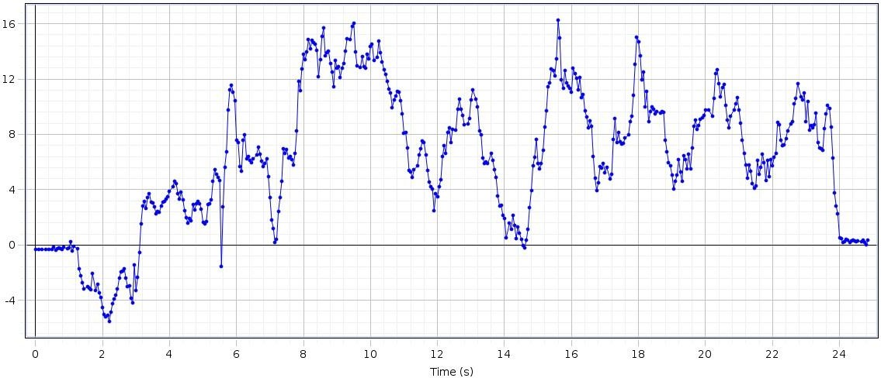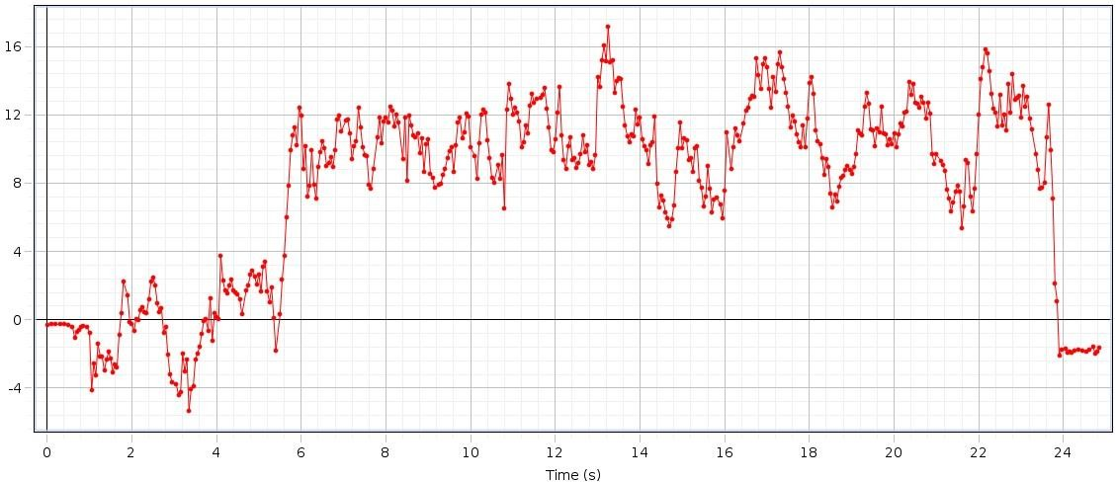

# DATA OF SUBJECT -IV

## Left Hand Force

Figure 4.5.4(a): Graph of Left Hand Force of Aged Subject IV

## Right Hand Force

Figure 4.5.4(b): Graph of Right Hand Force of Aged Subject IV

Table 4.5.4: Data of Aged Subject IV

|  |  |  |  |  |  |  |  |  |  |
| --- | --- | --- | --- | --- | --- | --- | --- | --- | --- |
| S.no | Steps | Time  (sec) | Distance  (meter) | Step  Time | Step  Length | Stride  Time | Stride  Length | Cadence | Velocity |
| 04 | 24 | 21 | 5.82 | 0.58 | 0.2426 | 1.16 | 0.4853 | 68.57 | 0.2771 |

## Analysis

The rise and drop of strengths in the graph appears upper limb strengths amid taking care of inactive rollator utilized for gait by healthy genomic person. The maximum rise up at F1 is 17N (this force is applied from left hand of the subject), at F2 the maximum rise up is of 18.5N (this force is applied from right hand of the subject). The change of both forces are different for every single individual according to their age, muscle strength and walking abilities of the subject. The force result comes from the patients who are suffering from diseases like Osteoporosis, Parkinson’s etc. are diverse. Because of the design of our rollator the force is bit different from normal subject (who are not affected from any disease or disability) but not showing a major difference in the graph because their wheels help them to move easily without applying force on the handle bars. Subsequently, it is demonstrated that time inversely proportional to velocity.

## Parameters

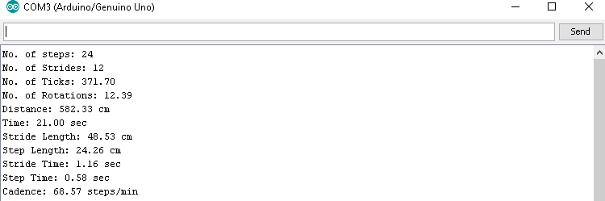

Figure 4.5.4(c): Observed Gait Parameters of Aged Subject IV

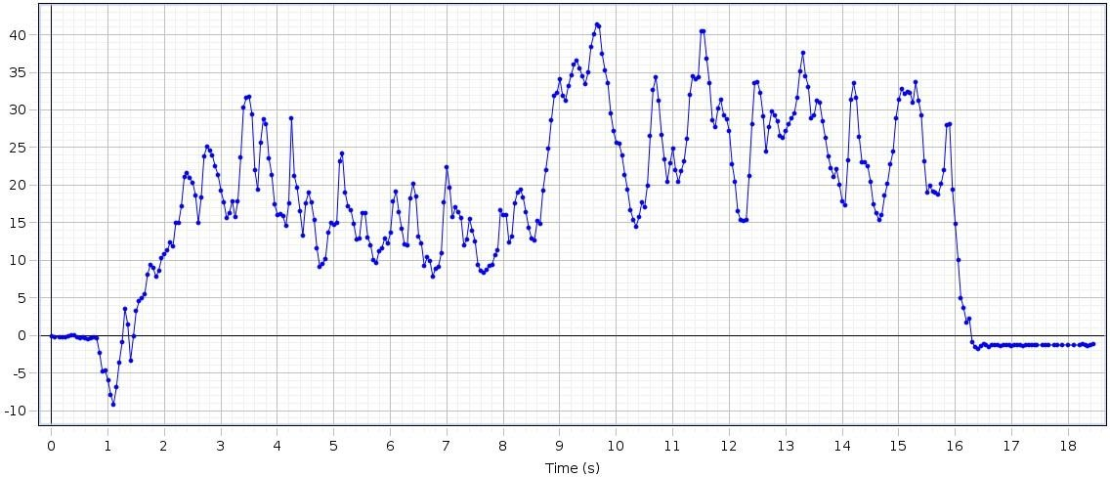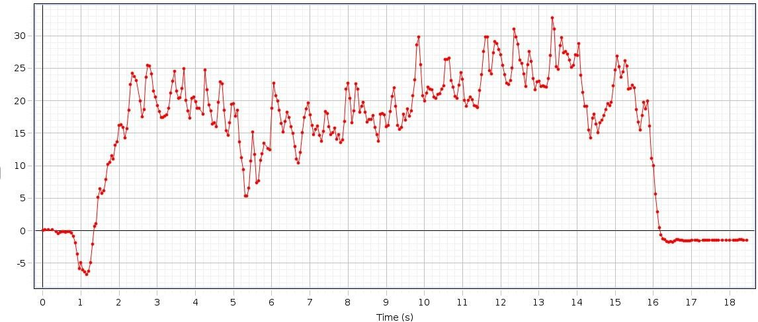

# DATA OF SUBJECT -V

## Left Hand Force

Figure 4.5.5(a): Graph of Left Hand Force of Aged Subject V

## Right Hand Force

Figure 4.5.5(b): Graph of Right Hand Force of Aged Subject V

Table 4.5.5: Data of Aged Subject V

|  |  |  |  |  |  |  |  |  |  |
| --- | --- | --- | --- | --- | --- | --- | --- | --- | --- |
| S.no | Steps | Time  (sec) | Distance  (meter) | Step  Time | Step  Length | Stride  Time | Stride  Length | Cadence | Velocity |
| 05 | 16 | 14 | 6.11 | 1.37 | 0.3825 | 2.73 | 0.7649 | 68.57 | 0.4364 |

## Analysis

The rise and drop of strengths in the graph appears upper limb strengths amid taking care of inactive rollator utilized for gait by healthy genomic person. The maximum rise up at F1 is 41N (this force is applied from left hand of the subject), at F2 the maximum rise up is of 35N (this force is applied from right hand of the subject). The change of both forces are different for every single individual according to their age, muscle strength and walking abilities of the subject. The force result comes from the patients who are suffering from diseases like Osteoporosis, Parkinson’s etc. are diverse. Because of the design of our rollator the force is bit different from normal subject (who are not affected from any disease or disability) but not showing a major difference in the graph because their wheels help them to move easily without applying force on the handle bars. Subsequently, it is demonstrated that time inversely proportional to velocity.

## Parameters

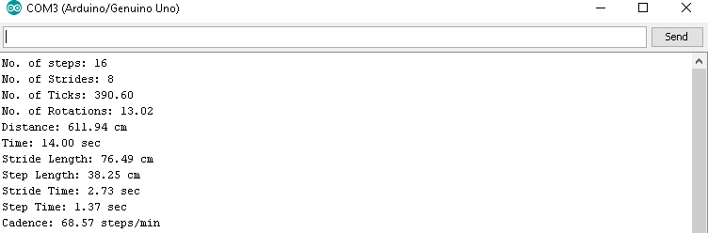

Figure 4.5.5(c): Observed Gait Parameters of Aged Subject V

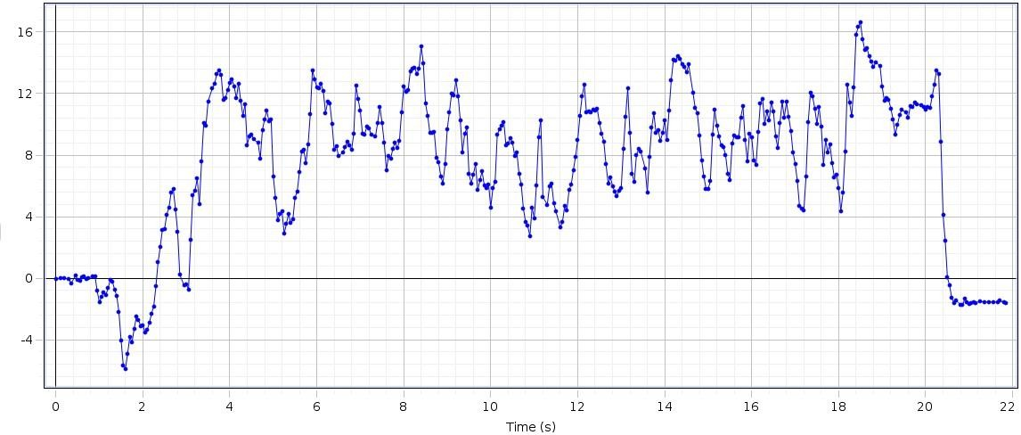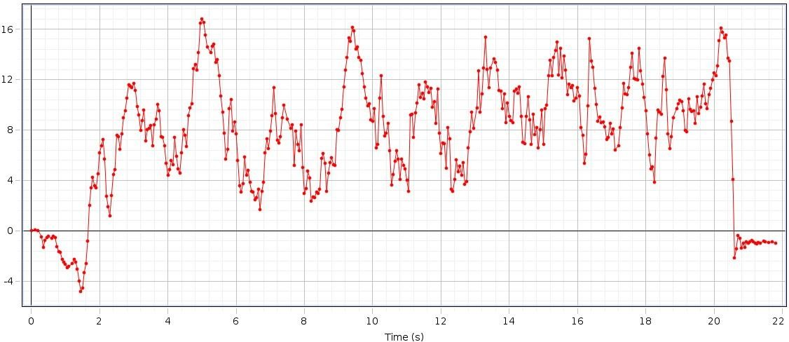

# DATA OF SUBJECT -VI

## Left Hand Force

Figure 4.5.6(a): Graph of Left Hand Force of Aged Subject VI

## Right Hand Force

Figure 4.5.6(b): Graph of Right Hand Force of Aged Subject VI

Table 4.5.6: Data of Aged Subject VI

|  |  |  |  |  |  |  |  |  |  |
| --- | --- | --- | --- | --- | --- | --- | --- | --- | --- |
| S.no | Steps | Time  (sec) | Distance  (meter) | Step  Time | Step  Length | Stride  Time | Stride  Length | Cadence | Velocity |
| 06 | 16 | 18 | 5.82 | 1.01 | 0.3640 | 2.02 | 0.7279 | 53.33 | 0.3233 |

## Analysis

The rise and drop of strengths in the graph appears upper limb strengths amid taking care of inactive rollator utilized for gait by healthy genomic person. The maximum rise up at F1 is 17.5N (this force is applied from left hand of the subject), at F2 the maximum rise up is of 17N (this force is applied from right hand of the subject). The change of both forces are different for every single individual according to their age, muscle strength and walking abilities of the subject. The force result comes from the patients who are suffering from diseases like Osteoporosis, Parkinson’s etc. are diverse. Because of the design of our rollator the force is bit different from normal subject (who are not affected from any disease or disability) but not showing a major difference in the graph because their wheels help them to move easily without applying force on the handle bars. Subsequently, it is demonstrated that time inversely proportional to velocity.

## Parameters

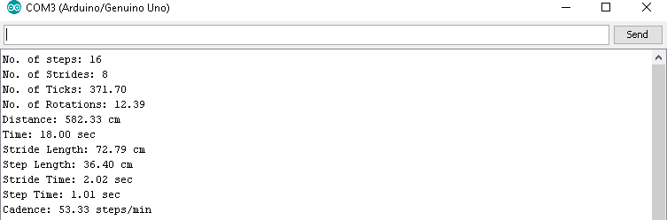

Figure 4.5.6(c): Observed Gait Parameters of Aged Subject VI

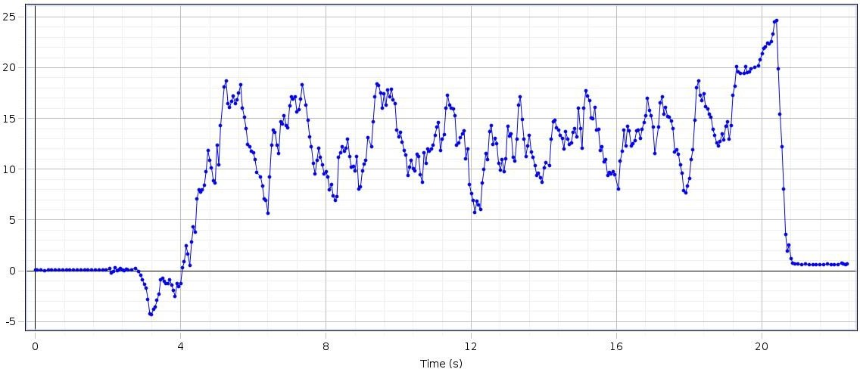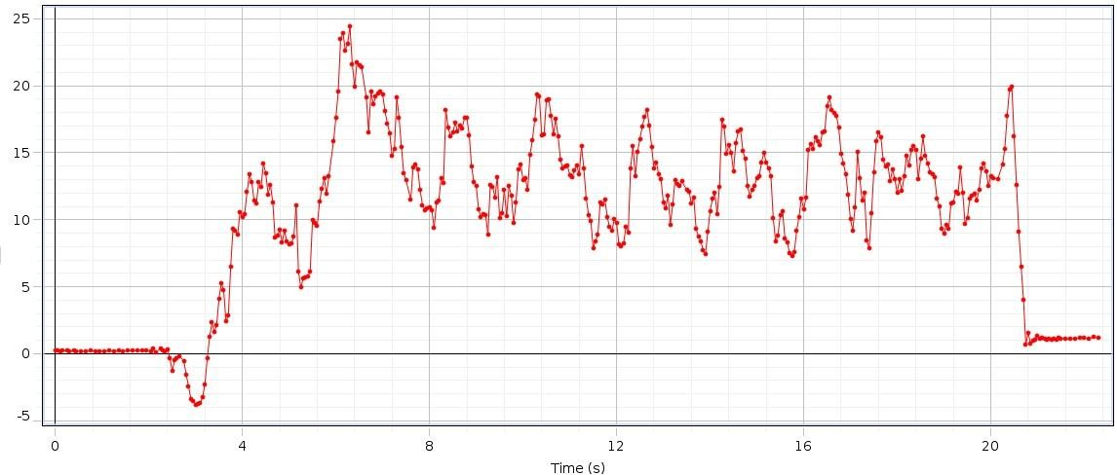

# DATA OF SUBJECT -VII

## Left Hand Force

Figure 4.5.7(a): Graph of Left Hand Force of Aged Subject VII

## Right Hand Force

Figure 4.5.7(b): Graph of Right Hand Force of Aged Subject VII

Table 4.5.7: Data of Aged Subject VII

|  |  |  |  |  |  |  |  |  |  |
| --- | --- | --- | --- | --- | --- | --- | --- | --- | --- |
| S.no | Steps | Time  (sec) | Distance  (meter) | Step  Time | Step  Length | Stride  Time | Stride  Length | Cadence | Velocity |
| 07 | 18 | 16 | 5.85 | 1.02 | 0.3253 | 2.03 | 0.6507 | 67.50 | 0.3656 |

## Analysis

The rise and drop of strengths in the graph appears upper limb strengths amid taking care of inactive rollator utilized for gait by healthy genomic person. The maximum rise up at F1 is 24N (this force is applied from left hand of the subject), at F2 the maximum rise up is of 24.5N (this force is applied from right hand of the subject). The change of both forces are different for every single individual according to their age, muscle strength and walking abilities of the subject. The force result comes from the patients who are suffering from diseases like Osteoporosis, Parkinson’s etc. are diverse. Because of the design of our rollator the force is bit different from normal subject (who are not affected from any disease or disability) but not showing a major difference in the graph because their wheels help them to move easily without applying force on the handle bars. Subsequently, it is demonstrated that time inversely proportional to velocity.

## Parameters

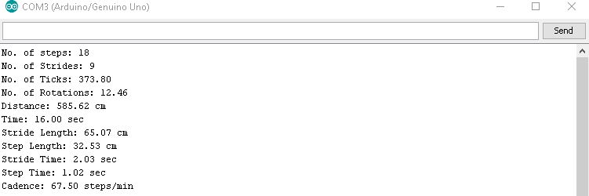

Figure 4.5.7(c): Observed Gait Parameters of Aged Subject VII

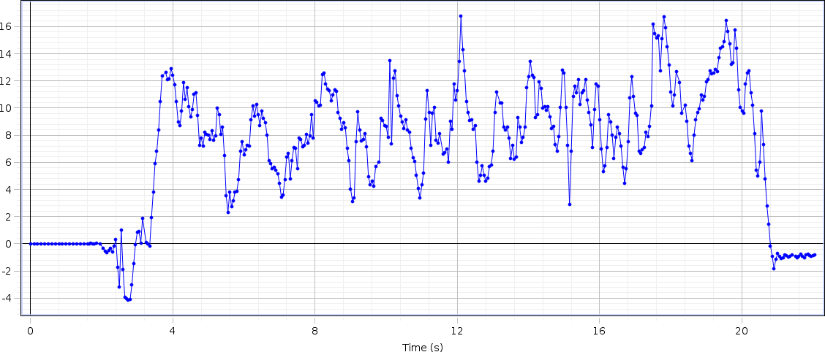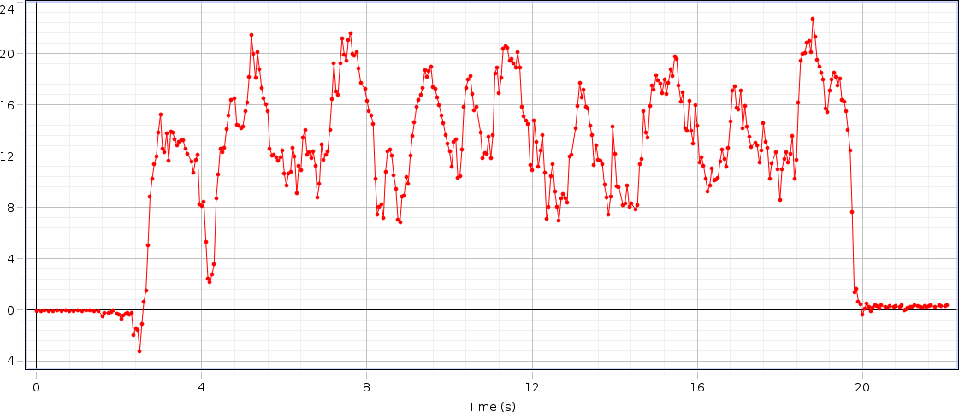

# DATA OF SUBJECT -VIII

## Left Hand Force

Figure 4.5.8(a): Graph of Left Hand Force of Aged Subject VIII

## Right Hand Force

Figure 4.5.8(b): Graph of Right Hand Force of Aged Subject VIII

Table 4.5.8: Data of Aged Subject VIII

|  |  |  |  |  |  |  |  |  |  |
| --- | --- | --- | --- | --- | --- | --- | --- | --- | --- |
| S.no | Steps | Time  (sec) | Distance  (meter) | Step  Time | Step  Length | Stride  Time | Stride  Length | Cadence | Velocity |
| 08 | 20 | 16 | 6.29 | 0.98 | 0.3149 | 1.97 | 0.6298 | 75 | 0.3931 |

## Analysis

The rise and drop of strengths in the graph appears upper limb strengths amid taking care of inactive rollator utilized for gait by healthy genomic person. The maximum rise up at F1 is 17N (this force is applied from left hand of the subject), at F2 the maximum rise up is of 23N (this force is applied from right hand of the subject). The change of both forces are different for every single individual according to their age, muscle strength and walking abilities of the subject. The force result comes from the patients who are suffering from diseases like Osteoporosis, Parkinson’s etc. are diverse. Because of the design of our rollator the force is bit different from normal subject (who are not affected from any disease or disability) but not showing a major difference in the graph because their wheels help them to move easily without applying force on the handle bars. Subsequently, it is demonstrated that time inversely proportional to velocity.

## Parameters

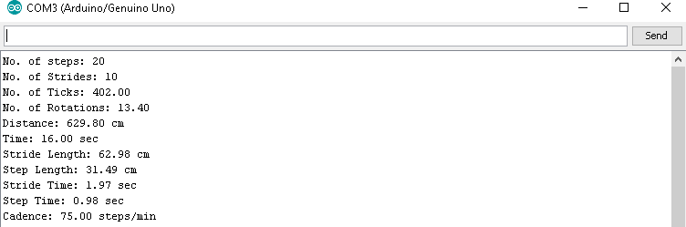

Figure 4.6.8(c): Observed Gait Parameters of Aged Subject VIII

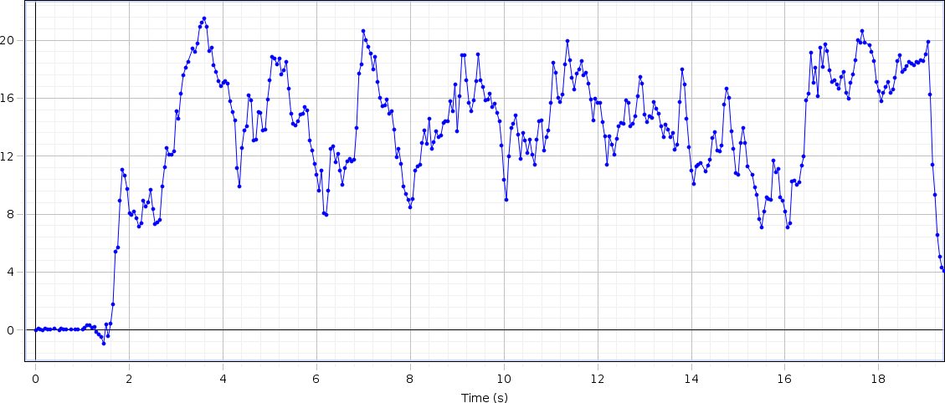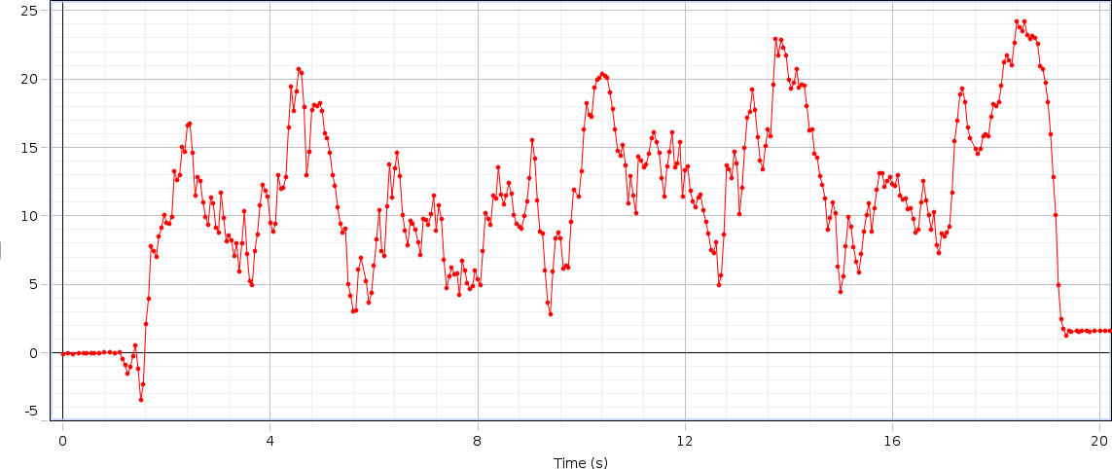

# DATA OF SUBJECT -IX

## Left Hand Force

Figure 4.5.9(a): Graph of Left Hand Force of Aged Subject IX

## Right Hand Force

Figure 4.5.9(b): Graph of Right Hand Force of Aged Subject IX

Table 4.5.9: Data of Aged Subject IX

|  |  |  |  |  |  |  |  |  |  |
| --- | --- | --- | --- | --- | --- | --- | --- | --- | --- |
| S.no | Steps | Time  (sec) | Distance  (meter) | Step  Time | Step  Length | Stride  Time | Stride  Length | Cadence | Velocity |
| 09 | 20 | 16 | 5.70 | 0.89 | 0.2851 | 1.78 | 0.5703 | 75 | 0.3562 |

## Analysis

The rise and drop of strengths in the graph appears upper limb strengths amid taking care of inactive rollator utilized for gait by healthy genomic person. The maximum rise up at F1 is 22N (this force is applied from left hand of the subject), at F2 the maximum rise up is of 21N (this force is applied from right hand of the subject). The change of both forces are different for every single individual according to their age, muscle strength and walking abilities of the subject. The force result comes from the patients who are suffering from diseases like Osteoporosis, Parkinson’s etc. are diverse. Because of the design of our rollator the force is bit different from normal subject (who are not affected from any disease or disability) but not showing a major difference in the graph because their wheels help them to move easily without applying force on the handle bars. Subsequently, it is demonstrated that time inversely proportional to velocity.

## Parameters

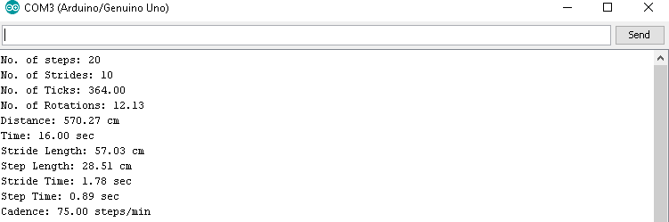

Figure 4.5.9(c): Observed Gait Parameters of Aged Subject IX

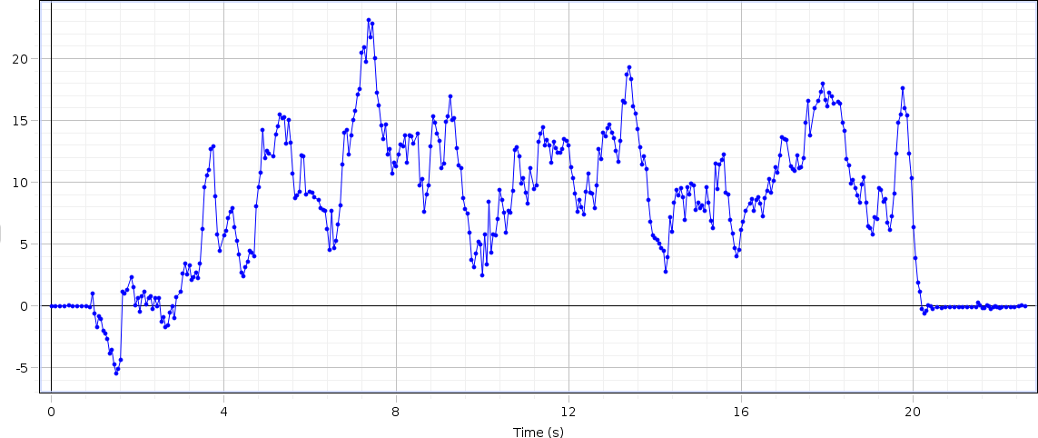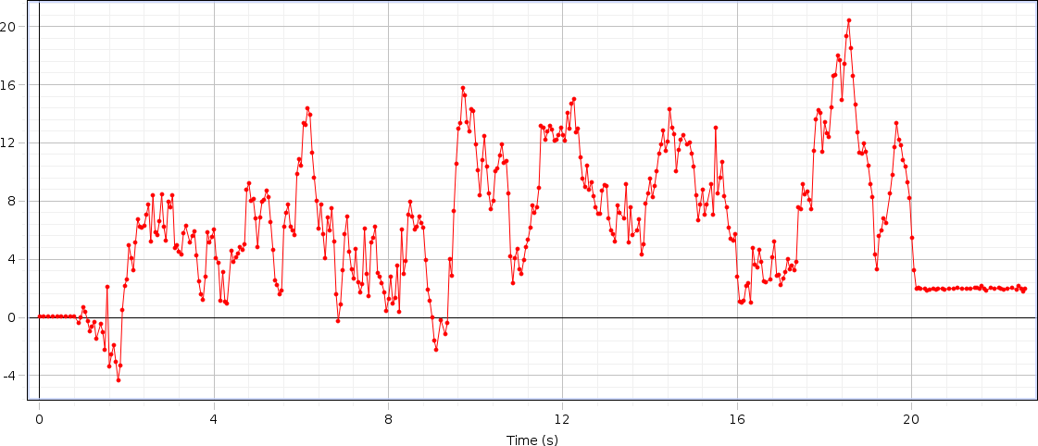

# DATA OF SUBJECT -X

## Left Hand Force

Figure 4.5.10(a): Graph of Left Hand Force of Aged Subject X

## Right Hand Force

Figure 4.5.10(b): Graph of Right Hand Force of Aged Subject X

Table 4.5.10: Data of Aged Subject X

|  |  |  |  |  |  |  |  |  |  |
| --- | --- | --- | --- | --- | --- | --- | --- | --- | --- |
| S.no | Steps | Time (sec) | Distance (meter) | Step Time | Step Length | Stride Time | Stride Length | Cadence | Velocity |
| 10 | 18 | 17 | 6.15 | 1.01 | 0.3418 | 2.01 | 0.6836 | 63.53 | 0.3617 |

## Analysis

The rise and drop of strengths in the graph appears upper limb strengths amid taking care of inactive rollator utilized for gait by healthy genomic person. The maximum rise up at F1 is 24N (this force is applied from left hand of the subject), at F2 the maximum rise up is of 21N (this force is applied from right hand of the subject). The change of both forces are different for every single individual according to their age, muscle strength and walking abilities of the subject. The force result comes from the patients who are suffering from diseases like Osteoporosis, Parkinson’s etc. are diverse. Because of the design of our rollator the force is bit different from normal subject (who are not affected from any disease or disability) but not showing a major difference in the graph because their wheels help them to move easily without applying force on the handle bars. Subsequently, it is demonstrated that time inversely proportional to velocity.

## Parameters

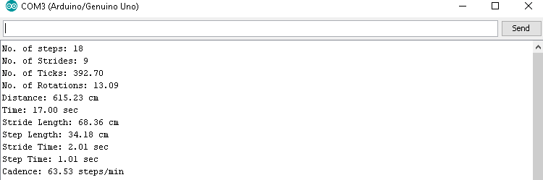

Figure 4.6.10(c): Observed Gait Parameters of Aged Subject X

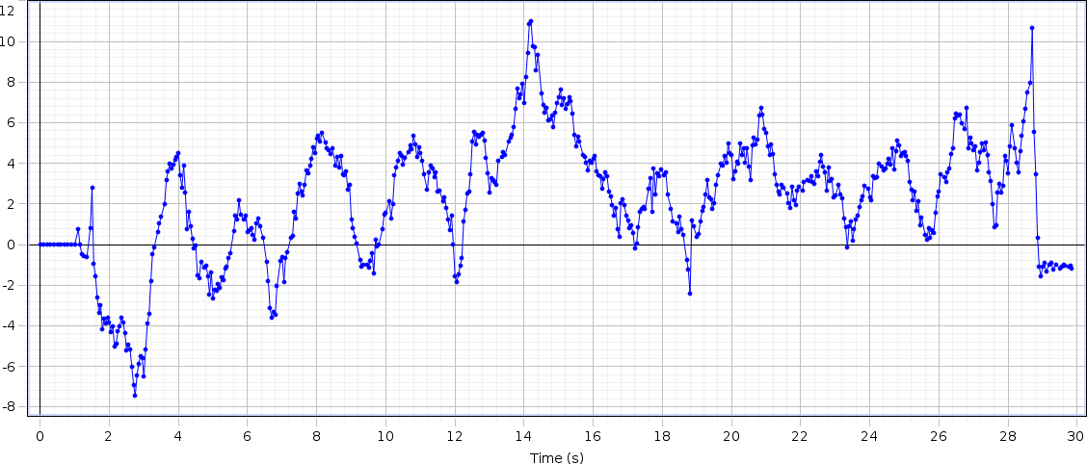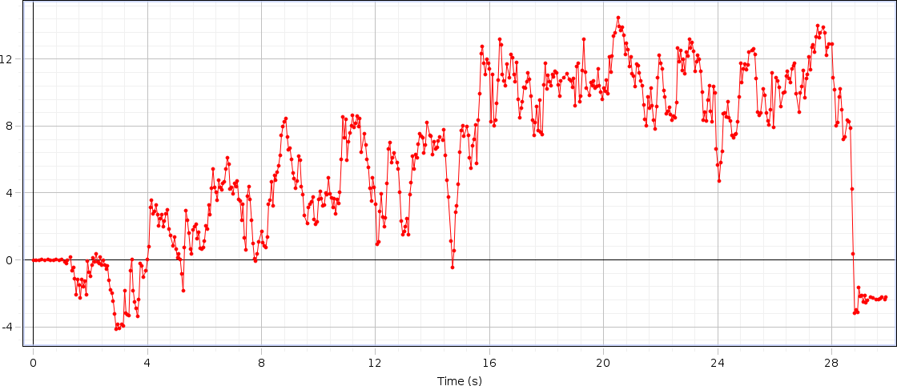

# DATA OF SUBJECT -XI

## Left Hand Force

Figure 4.5.11(a): Graph of Left Hand Force of Aged Subject XI

## Right Hand Force

Figure 4.5.11(b): Graph of Right Hand Force of Aged Subject XI

Table 4.5.11: Data of Aged Subject XI

|  |  |  |  |  |  |  |  |  |  |
| --- | --- | --- | --- | --- | --- | --- | --- | --- | --- |
| S.no | Steps | Time  (sec) | Distance  (meter) | Step  Time | Step  Length | Stride  Time | Stride  Length | Cadence | Velocity |
| 11 | 28 | 26 | 6.25 | 0.43 | 0.2232 | 0.86 | 0.4465 | 64.62 | 0.2403 |

## Analysis

The rise and drop of strengths in the graph appears upper limb strengths amid taking care of inactive rollator utilized for gait by healthy genomic person. The maximum rise up at F1 is 11.5N (this force is applied from left hand of the subject), at F2 the maximum rise up is of 14N (this force is applied from right hand of the subject). The change of both forces are different for every single individual according to their age, muscle strength and walking abilities of the subject. The force result comes from the patients who are suffering from diseases like Osteoporosis, Parkinson’s etc. are diverse. Because of the design of our rollator the force is bit different from normal subject (who are not affected from any disease or disability) but not showing a major difference in the graph because their wheels help them to move easily without applying force on the handle bars. Subsequently, it is demonstrated that time inversely proportional to velocity.

## Parameters

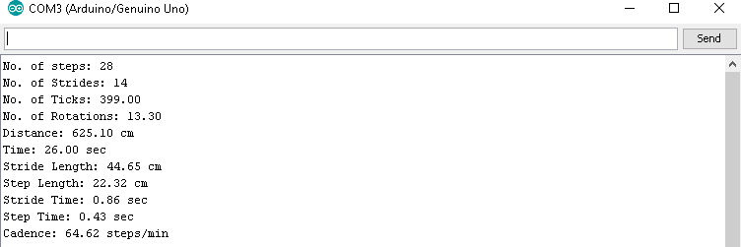

Figure 4.6.11(c): Observed Gait Parameters of Aged Subject XI

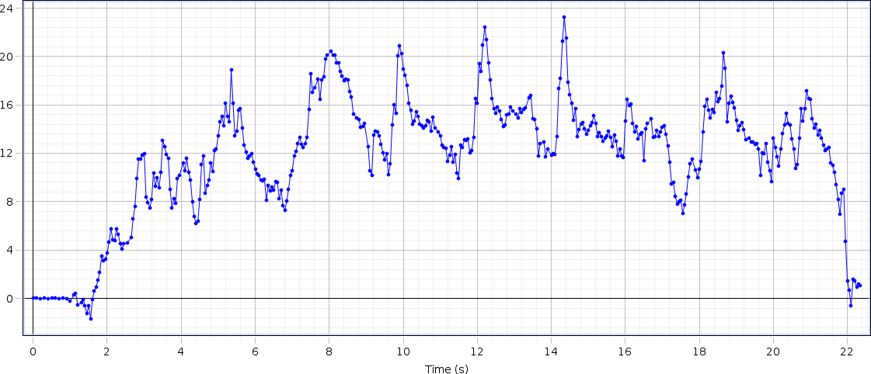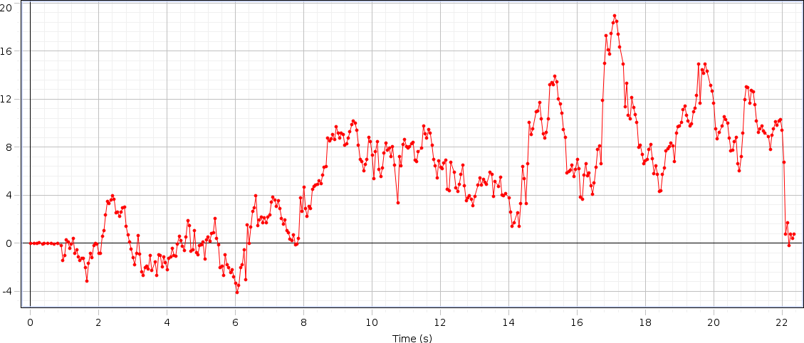

# DATA OF SUBJECT -XII

## Left Hand Force

Figure 4.5.12(a): Graph of Left Hand Force of Aged Subject XII

## Right Hand Force

Figure 4.5.12(b): Graph of Right Hand Force of Aged Subject XII

Table 4.5.12: Data of Aged Subject XII

|  |  |  |  |  |  |  |  |  |  |
| --- | --- | --- | --- | --- | --- | --- | --- | --- | --- |
| S.no | Steps | Time  (sec) | Distance  (meter) | Step  Time | Step  Length | Stride  Time | Stride  Length | Cadence | Velocity |
| 12 | 22 | 20 | 5.69 | 0.65 | 0.2587 | 1.29 | 0.5176 | 66 | 0.2845 |

## Analysis

The rise and drop of strengths in the graph appears upper limb strengths amid taking care of inactive rollator utilized for gait by healthy genomic person. The maximum rise up at F1 is 23N (this force is applied from left hand of the subject), at F2 the maximum rise up is of 19N (this force is applied from right hand of the subject). The change of both forces are different for every single individual according to their age, muscle strength and walking abilities of the subject. The force result comes from the patients who are suffering from diseases like Osteoporosis, Parkinson’s etc. are diverse. Because of the design of our rollator the force is bit different from normal subject (who are not affected from any disease or disability) but not showing a major difference in the graph because their wheels help them to move easily without applying force on the handle bars. Subsequently, it is demonstrated that time inversely proportional to velocity.

## Parameters

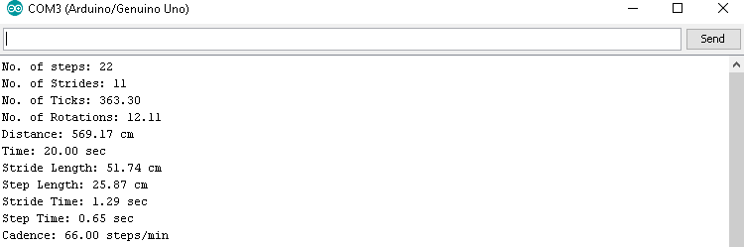

Figure 4.5.12(c): Observed Gait Parameters of Aged Subject XII

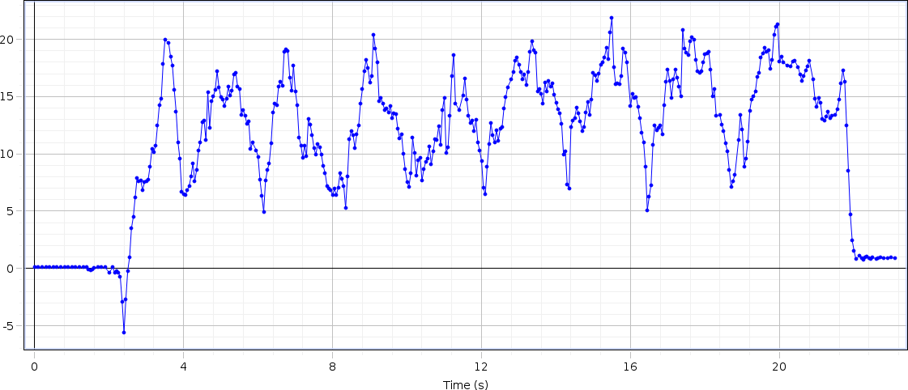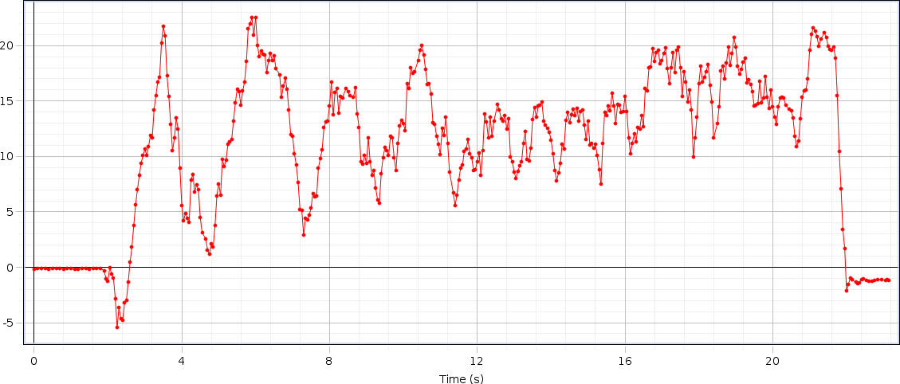

# DATA OF SUBJECT -XIII

## Left Hand Force

Figure 4.5.13(a): Graph of Left Hand Force of Aged Subject XIII

## Right Hand Force

Figure 4.5.13(b): Graph of Right Hand Force of Aged Subject XIII

Table 4.5.13: Data of Aged Subject XIII

|  |  |  |  |  |  |  |  |  |  |
| --- | --- | --- | --- | --- | --- | --- | --- | --- | --- |
| S.no | Steps | Time  (sec) | Distance  (meter) | Step  Time | Step  Length | Stride  Time | Stride  Length | Cadence | Velocity |
| 13 | 18 | 18 | 6.08 | 0.94 | 0.3381 | 1.88 | 0.6763 | 60 | 0.3377 |

## Analysis

The rise and drop of strengths in the graph appears upper limb strengths amid taking care of inactive rollator utilized for gait by healthy genomic person. The maximum rise up at F1 is 22N (this force is applied from left hand of the subject), at F2 the maximum rise up is of 23N (this force is applied from right hand of the subject). The change of both forces are different for every single individual according to their age, muscle strength and walking abilities of the subject. The force result comes from the patients who are suffering from diseases like Osteoporosis, Parkinson’s etc. are diverse. Because of the design of our rollator the force is bit different from normal subject (who are not affected from any disease or disability) but not showing a major difference in the graph because their wheels help them to move easily without applying force on the handle bars. Subsequently, it is demonstrated that time inversely proportional to velocity.

## Parameters

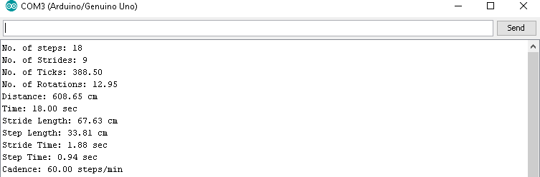

Figure 4.5.13(c): Observed Gait Parameters of Aged Subject XIII

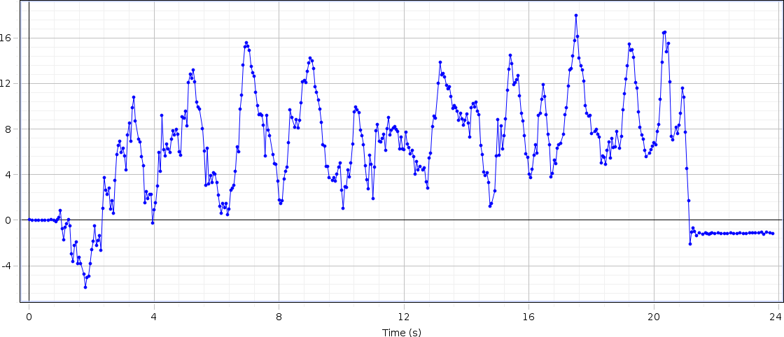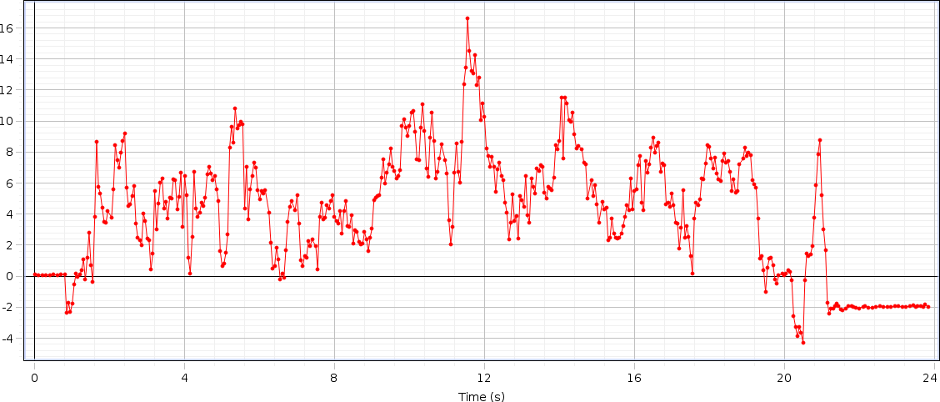

# DATA OF SUBJECT -XIV

## Left Hand Force

Figure 4.5.14(a): Graph of Left Hand Force of Aged Subject XIV

## Right Hand Force

Figure 4.5.14(b): Graph of Right Hand Force of Aged Subject XIV

Table 4.5.14: Data of Aged Subject XIV

|  |  |  |  |  |  |  |  |  |  |
| --- | --- | --- | --- | --- | --- | --- | --- | --- | --- |
| S.no | Steps | Time  (sec) | Distance  (meter) | Step  Time | Step  Length | Stride  Time | Stride  Length | Cadence | Velocity |
| 14 | 22 | 17 | 6.25 | 0.84 | 0.2841 | 1.67 | 0.5683 | 77.65 | 0.3676 |

## Analysis

The rise and drop of strengths in the graph appears upper limb strengths amid taking care of inactive rollator utilized for gait by healthy genomic person. The maximum rise up at F1 is 18N (this force is applied from left hand of the subject), at F2 the maximum rise up is of 17N (this force is applied from right hand of the subject). The change of both forces are different for every single individual according to their age, muscle strength and walking abilities of the subject. The force result comes from the patients who are suffering from diseases like Osteoporosis, Parkinson’s etc. are diverse. Because of the design of our rollator the force is bit different from normal subject (who are not affected from any disease or disability) but not showing a major difference in the graph because their wheels help them to move easily without applying force on the handle bars. Subsequently, it is demonstrated that time inversely proportional to velocity.

## Parameters

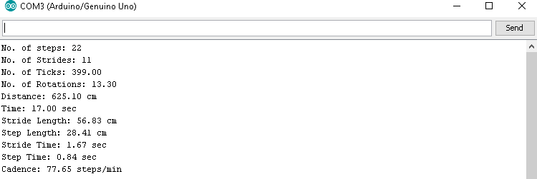

Figure 4.5.14(c): Observed Gait Parameters of Aged Subject XIV

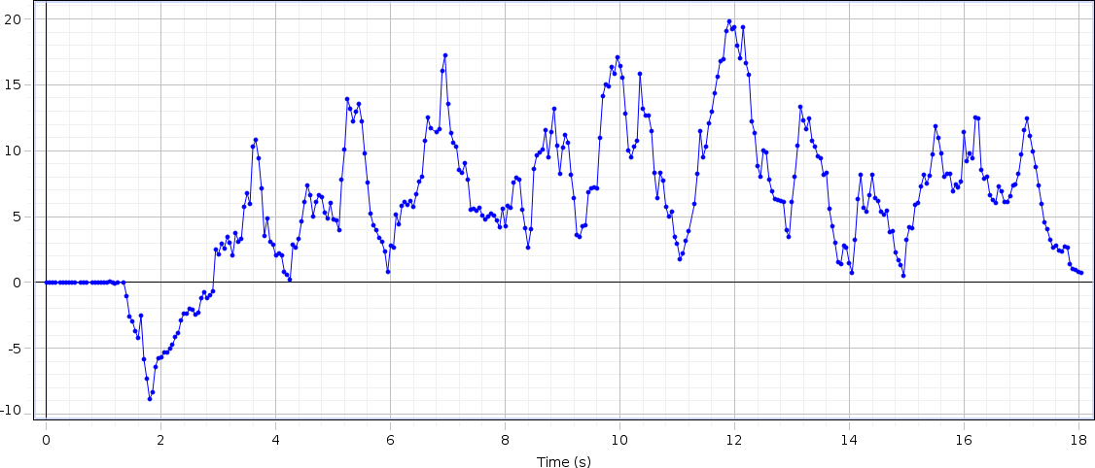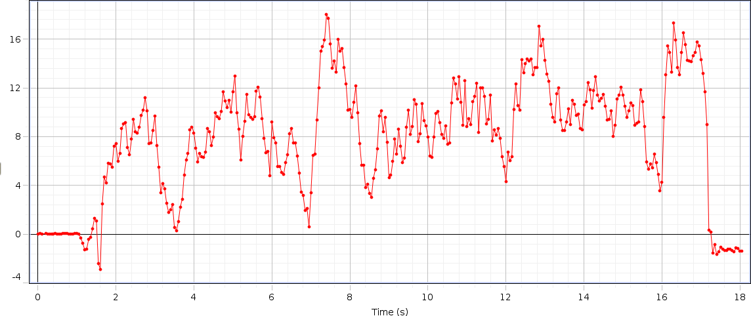

# DATA OF SUBJECT -XV

## Left Hand Force

Figure 4.5.15(a): Graph of Left Hand Force of Aged Subject XV

## Right Hand Force

Figure 4.5.15(b): Graph of Right Hand Force of Aged Subject XV

Table 4.5.15: Data of Aged Subject XV

|  |  |  |  |  |  |  |  |  |  |
| --- | --- | --- | --- | --- | --- | --- | --- | --- | --- |
| S.no | Steps | Time  (sec) | Distance  (meter) | Step  Time | Step  Length | Stride  Time | Stride  Length | Cadence | Velocity |
| 15 | 18 | 14 | 6.44 | 1.28 | 0.3582 | 2.56 | 0.7165 | 77.14 | 0.46 |

## Analysis

The rise and drop of strengths in the graph appears upper limb strengths amid taking care of inactive rollator utilized for gait by healthy genomic person. The maximum rise up at F1 is 20N (this force is applied from left hand of the subject), at F2 the maximum rise up is of 18N (this force is applied from right hand of the subject). The change of both forces are different for every single individual according to their age, muscle strength and walking abilities of the subject. The force result comes from the patients who are suffering from diseases like Osteoporosis, Parkinson’s etc. are diverse. Because of the design of our rollator the force is bit different from normal subject (who are not affected from any disease or disability) but not showing a major difference in the graph because their wheels help them to move easily without applying force on the handle bars. Subsequently, it is demonstrated that time inversely proportional to velocity.

## Parameters

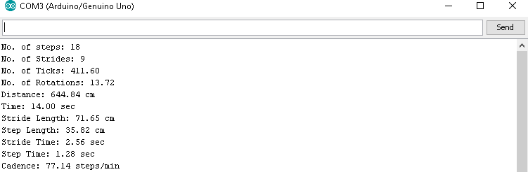

Figure 4.5.15(c): Observed Gait Parameters of Aged Subject XV

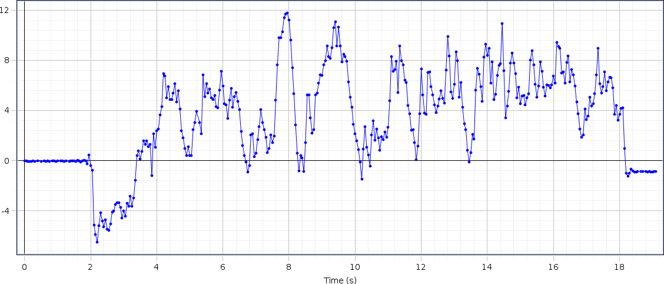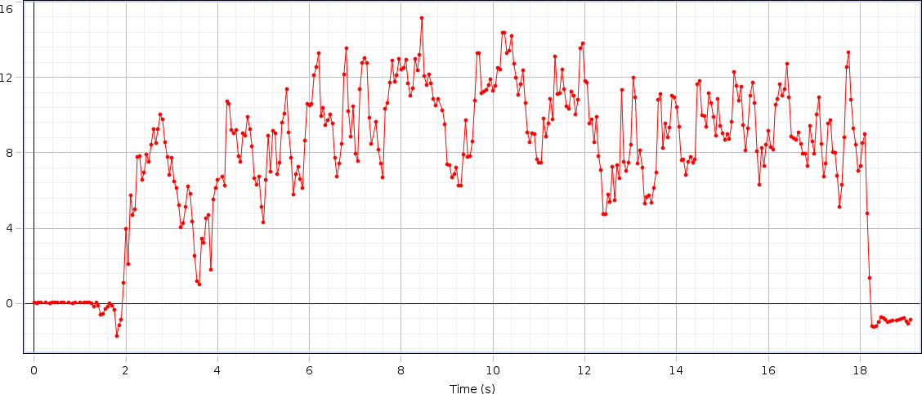

# DATA OF SUBJECT -XVI

## Left Hand Force

Figure 4.5.16(a): Graph of Left Hand Force of Aged Subject XVI

## Right Hand Force

Figure 4.5.16(b): Graph of Right Hand Force of Aged Subject XVI

Table 4.5.16: Data of Aged Subject XVI

|  |  |  |  |  |  |  |  |  |  |
| --- | --- | --- | --- | --- | --- | --- | --- | --- | --- |
| S.no | Steps | Time  (sec) | Distance  (meter) | Step  Time | Step  Length | Stride  Time | Stride  Length | Cadence | Velocity |
| 16 | 20 | 15 | 5.95 | 0.99 | 0.2977 | 1.98 | 0.5955 | 80 | 0.3966 |

## Analysis

The rise and drop of strengths in the graph appears upper limb strengths amid taking care of inactive rollator utilized for gait by healthy genomic person. The maximum rise up at F1 is 13.5N (this force is applied from left hand of the subject), at F2 the maximum rise up is of 15N (this force is applied from right hand of the subject). The change of both forces are different for every single individual according to their age, muscle strength and walking abilities of the subject. The force result comes from the patients who are suffering from diseases like Osteoporosis, Parkinson’s etc. are diverse. Because of the design of our rollator the force is bit different from normal subject (who are not affected from any disease or disability) but not showing a major difference in the graph because their wheels help them to move easily without applying force on the handle bars. Subsequently, it is demonstrated that time inversely proportional to velocity.

## Parameters

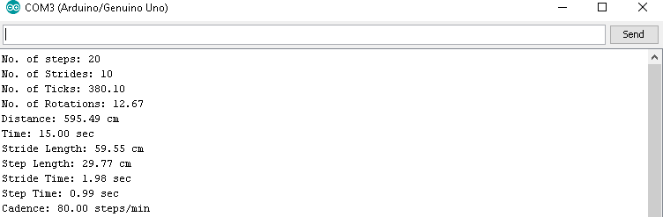

Figure 4.5.16(c): Observed Gait Parameters of Aged Subject XVI

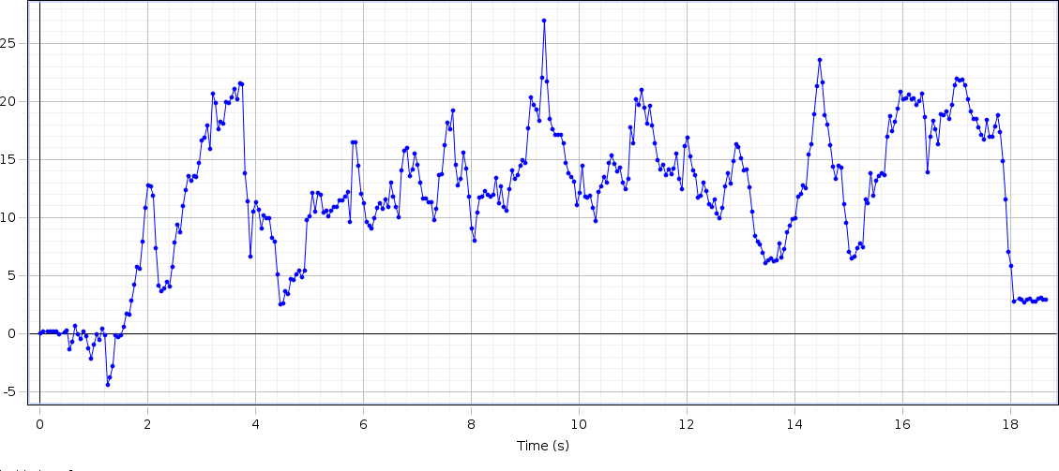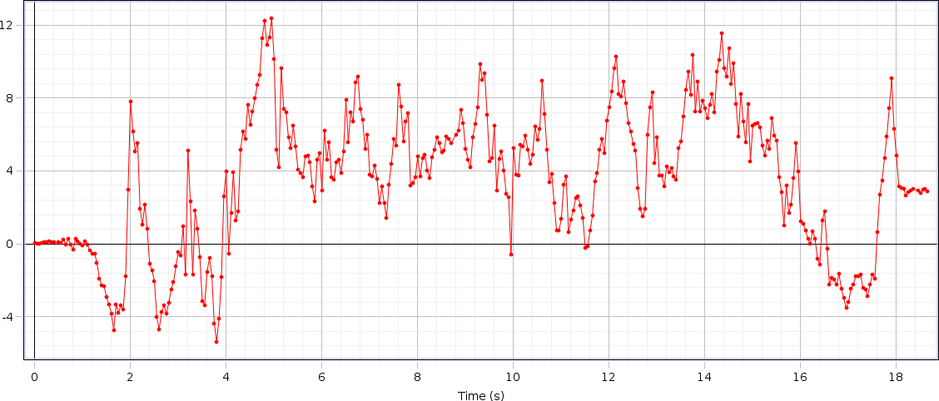

# DATA OF SUBJECT -XVII

## Left Hand Force

Figure 4.5.17(a): Graph of Left Hand Force of Aged Subject XVII

## Right Hand Force

Figure 4.5.17(b): Graph of Right Hand Force of Aged Subject XVII

Table 4.5.17: Data of Aged Subject XVII

|  |  |  |  |  |  |  |  |  |  |
| --- | --- | --- | --- | --- | --- | --- | --- | --- | --- |
| S.no | Steps | Time  (sec) | Distance  (meter) | Step  Time | Step  Length | Stride  Time | Stride  Length | Cadence | Velocity |
| 17 | 20 | 15 | 6.11 | 1.02 | 0.3060 | 2.04 | 0.6119 | 80 | 0.4073 |

## Analysis

The rise and drop of strengths in the graph appears upper limb strengths amid taking care of inactive rollator utilized for gait by healthy genomic person. The maximum rise up at F1 is 27N (this force is applied from left hand of the subject), at F2 the maximum rise up is of 13N (this force is applied from right hand of the subject). The change of both forces are different for every single individual according to their age, muscle strength and walking abilities of the subject. The force result comes from the patients who are suffering from diseases like Osteoporosis, Parkinson’s etc. are diverse. Because of the design of our rollator the force is bit different from normal subject (who are not affected from any disease or disability) but not showing a major difference in the graph because their wheels help them to move easily without applying force on the handle bars. Subsequently, it is demonstrated that time inversely proportional to velocity.

## Parameters

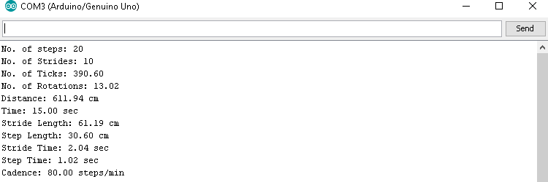

Figure 4.5.17(c): Observed Gait Parameters of Aged Subject XVII

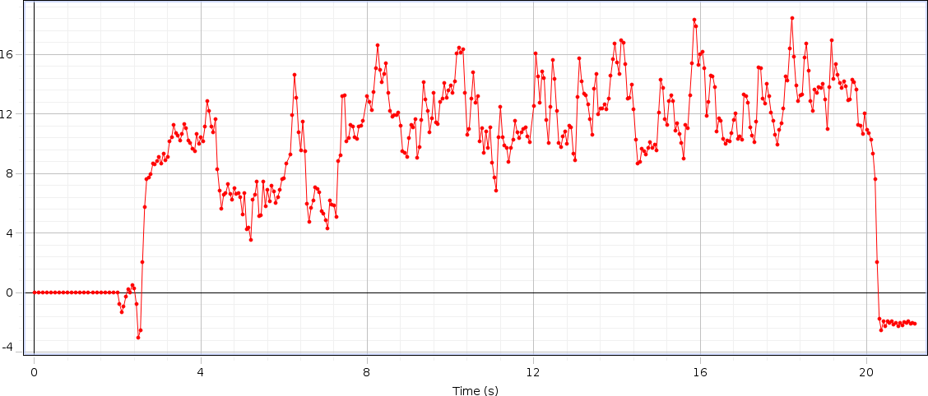

# DATA OF SUBJECT -XVIII

## Left Hand Force

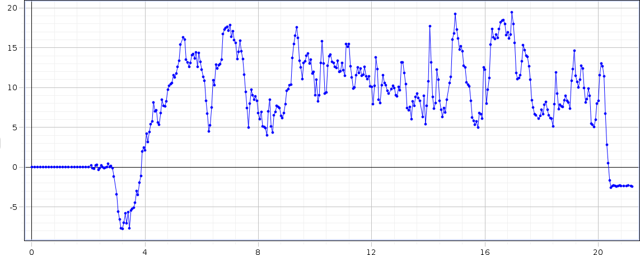

Figure 4.5.18(a): Graph of Left Hand Force of Aged Subject XVIII

## Right Hand Force

Figure 4.5.18(b): Graph of Right Hand Force of Aged Subject XVIII

Table 4.5.18: Data of Aged Subject XVIII

|  |  |  |  |  |  |  |  |  |  |
| --- | --- | --- | --- | --- | --- | --- | --- | --- | --- |
| S.no | Steps | Time  (sec) | Distance  (meter) | Step  Time | Step  Length | Stride  Time | Stride  Length | Cadence | Velocity |
| 18 | 20 | 16 | 5.85 | 0.92 | 0.2928 | 1.83 | 0.5856 | 75 | 0.3656 |

## Analysis

The rise and drop of strengths in the graph appears upper limb strengths amid taking care of inactive rollator utilized for gait by healthy genomic person. The maximum rise up at F1 is 19N (this force is applied from left hand of the subject), at F2 the maximum rise up is of 18N (this force is applied from right hand of the subject). The change of both forces are different for every single individual according to their age, muscle strength and walking abilities of the subject. The force result comes from the patients who are suffering from diseases like Osteoporosis, Parkinson’s etc. are diverse. Because of the design of our rollator the force is bit different from normal subject (who are not affected from any disease or disability) but not showing a major difference in the graph because their wheels help them to move easily without applying force on the handle bars. Subsequently, it is demonstrated that time inversely proportional to velocity.

## Parameters

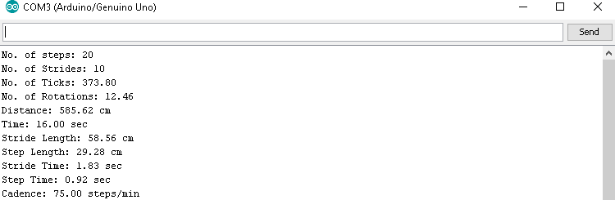

Figure 4.5.18(c): Observed Gait Parameters of Aged Subject XVIII

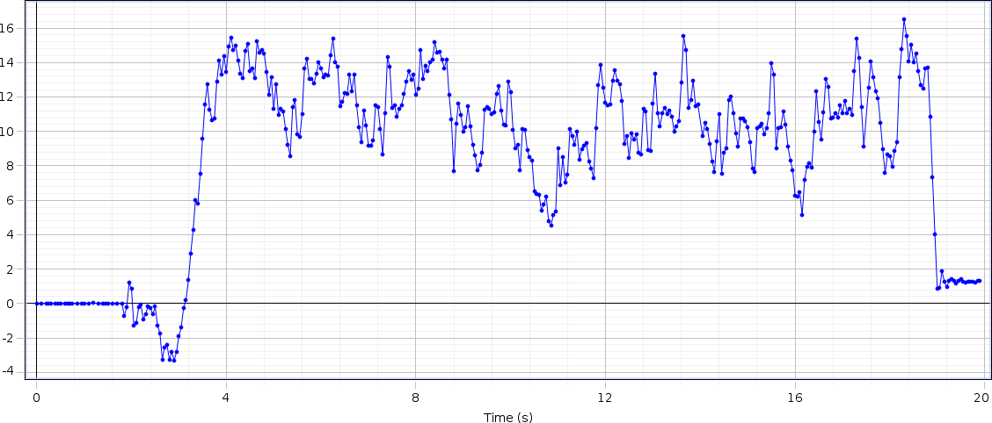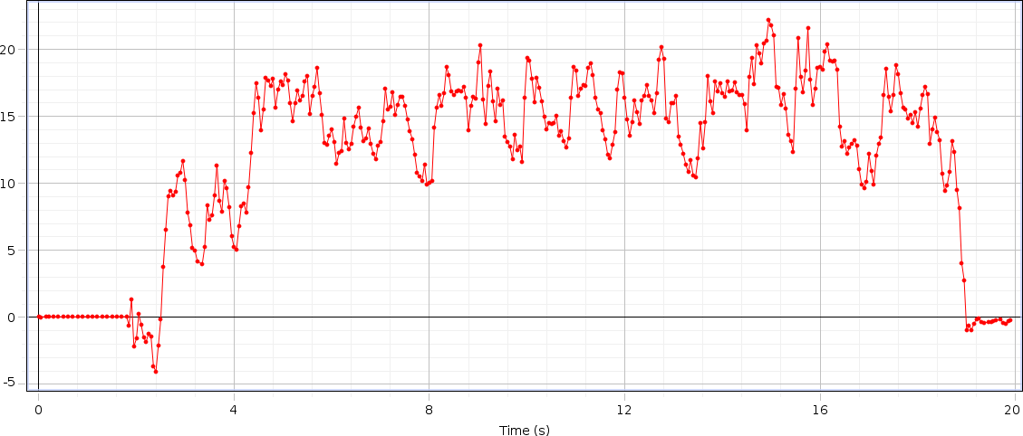

# DATA OF SUBJECT -XIX

## Left Hand Force

Figure 4.5.19(a): Graph of Left Hand Force of Aged Subject XIX

## Right Hand Force

Figure 4.5.19(b): Graph of Right Hand Force of Aged Subject XIX

Table 4.5.19: Data of Aged Subject XIX

|  |  |  |  |  |  |  |  |  |  |
| --- | --- | --- | --- | --- | --- | --- | --- | --- | --- |
| S.no | Steps | Time  (sec) | Distance  (meter) | Step  Time | Step  Length | Stride  Time | Stride  Length | Cadence | Velocity |
| 19 | 18 | 16 | 6.11 | 1.06 | 0.34 | 2.12 | 0.68 | 67.50 | 0.3818 |

## Analysis

The rise and drop of strengths in the graph appears upper limb strengths amid taking care of inactive rollator utilized for gait by healthy genomic person. The maximum rise up at F1 is 18N (this force is applied from left hand of the subject), at F2 the maximum rise up is of 23N (this force is applied from right hand of the subject). The change of both forces are different for every single individual according to their age, muscle strength and walking abilities of the subject. The force result comes from the patients who are suffering from diseases like Osteoporosis, Parkinson’s etc. are diverse. Because of the design of our rollator the force is bit different from normal subject (who are not affected from any disease or disability) but not showing a major difference in the graph because their wheels help them to move easily without applying force on the handle bars. Subsequently, it is demonstrated that time inversely proportional to velocity.

## Parameters

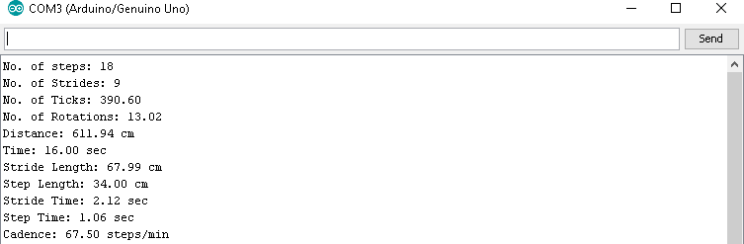

Figure 4.5.19(c): Observed Gait Parameters of Aged Subject XIX

# DATA OF SUBJECT -XX

## Left Hand Force

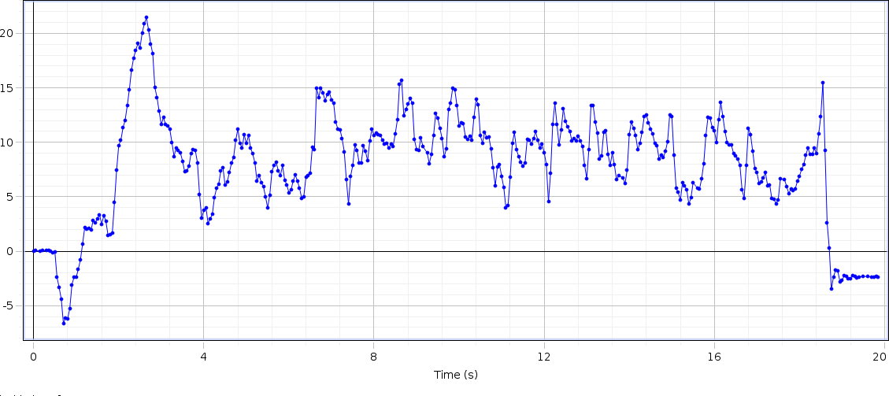

Figure 4.5.20(a): Graph of Left Hand Force of Aged Subject XX

## Right Hand Force

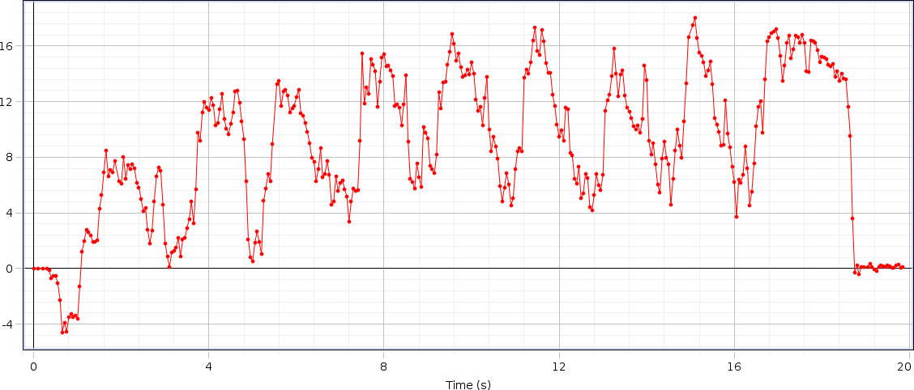

Figure 4.5.20(b): Graph of Right Hand Force of Aged Subject XX

Table 4.5.20: Data of Aged Subject XX

|  |  |  |  |  |  |  |  |  |  |
| --- | --- | --- | --- | --- | --- | --- | --- | --- | --- |
| S.no | Steps | Time  (sec) | Distance  (meter) | Step  Time | Step  Length | Stride  Time | Stride  Length | Cadence | Velocity |
| 20 | 18 | 17 | 6.07 | 01 | 0.3384 | 1.99 | 0.6768 | 63.53 | 0.3570 |

## Analysis

The rise and drop of strengths in the graph appears upper limb strengths amid taking care of inactive rollator utilized for gait by healthy genomic person. The maximum rise up at F1 is 22N (this force is applied from left hand of the subject), at F2 the maximum rise up is of 18N (this force is applied from right hand of the subject). The change of both forces are different for every single individual according to their age, muscle strength and walking abilities of the subject. The force result comes from the patients who are suffering from diseases like Osteoporosis, Parkinson’s etc. are diverse. Because of the design of our rollator the force is bit different from normal subject (who are not affected from any disease or disability) but not showing a major difference in the graph because their wheels help them to move easily without applying force on the handle bars. Subsequently, it is demonstrated that time inversely proportional to velocity.

## Parameters

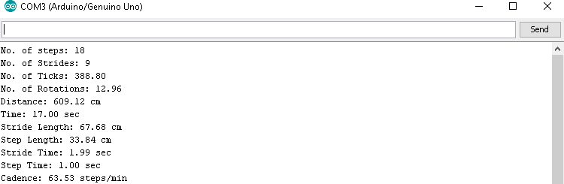

Figure 4.5.20(c): Observed Gait Parameters of Aged Subject XX

# DATA AND ANALYSIS OF AMPUTATED SUBJECTS

The 05 figures with two part (a) and (b) contains the graph of amputated subject these subjects have amputation in left leg and they ages from 20 to 40 years, similarly the first part is representation of forces applied from right and left hand and the second part is the value of observed spatiotemporal parameters on Arduino software which are written in tabular form.

The analysis of data of all subjects are performed individually which is mentioned with details along with the table of data collected of each subject.

# DATA OF SUBJECT-I

## Left Hand Force

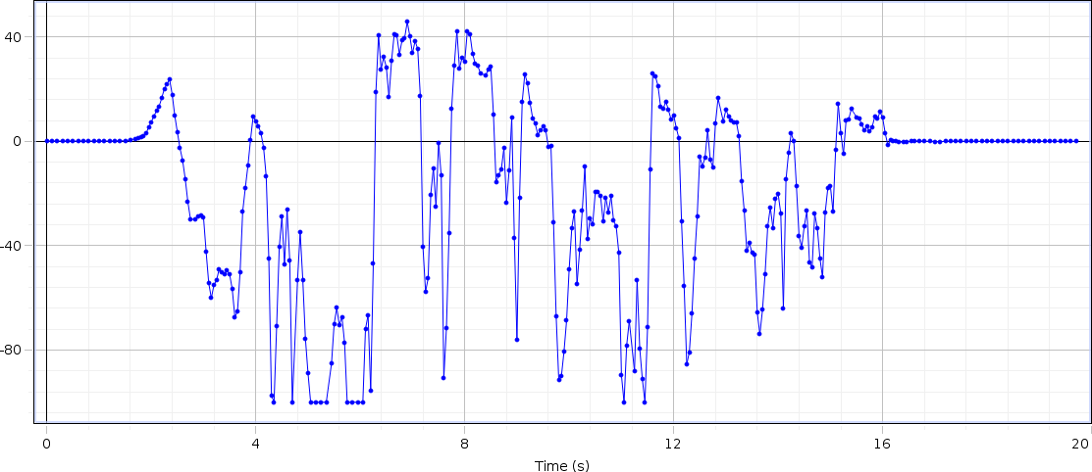

Figure 4.6.1(a): Graph of Left Hand Force of Amputated Subject I

## Right Hand Force

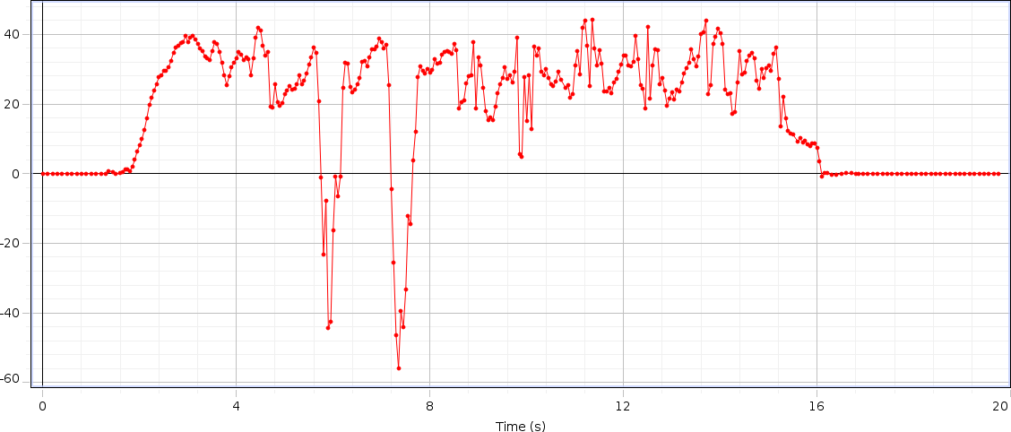

Figure 4.6.1(b): Graph of Right Hand Force of Amputated Subject I

Table 4.6.1: Data of Amputated Subject I

|  |  |  |  |  |  |  |  |  |  |
| --- | --- | --- | --- | --- | --- | --- | --- | --- | --- |
| S.no | Steps | Time  (sec) | Distance  (meter) | Step  Time | Step  Length | Stride  Time | Stride  Length | Cadence | Velocity |
| 01 | 20 | 13 | 5.44 | 0.65 | 0.2723 | 1.30 | 0.5456 | 92.31 | 0.418 |

## Analysis

The rise and drop of strengths in the graph appears upper limb strengths amid taking care of inactive rollator utilized for gait by amputated person. The maximum rise up at F1 is 48N (force applied from the left hand side), at F2 the maximum rise up is of 44N (force applied from the right hand side). In both right and left hand the graph is showing negative peaks too, this is due to the patient’s left leg is amputated and he pull the handle after every step. The change of both forces are different for every single individual according to their age, muscle strength and walking abilities of the subject, the force result comes from the subject. Because of the design of our rollator the force is bit different from abnormal subject (who are affected from any disease or disability) and showing a major difference in the graph. Subsequently, it is demonstrated that time inversely proportional to velocity.

## Parameters

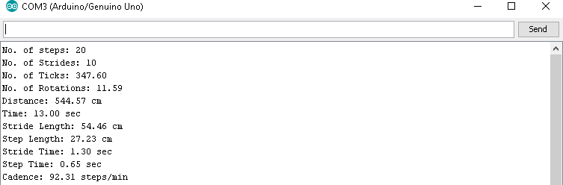

Figure 4.6.1(c): Observed Gait Parameters of Amputated Subject I

# DATA OF SUBJECT-II

## Left Hand Force

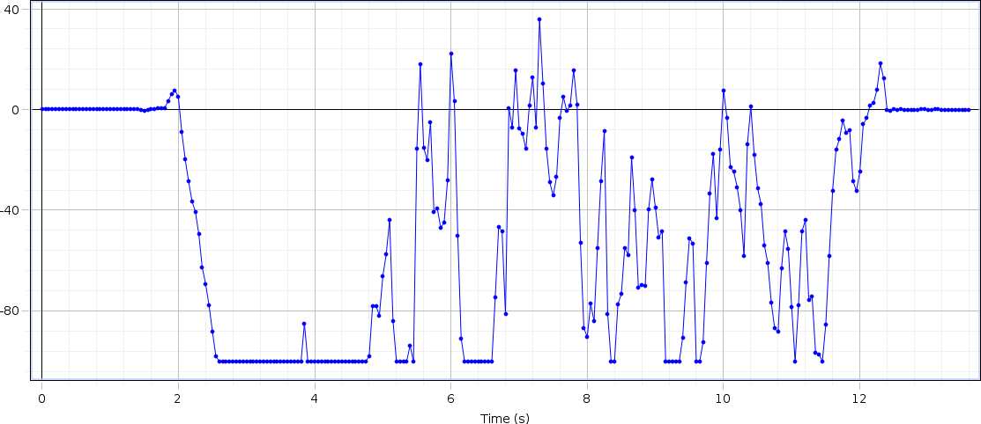

Figure 4.6.2(a): Graph of Left Hand Force of Amputated Subject II

## Right Hand Force

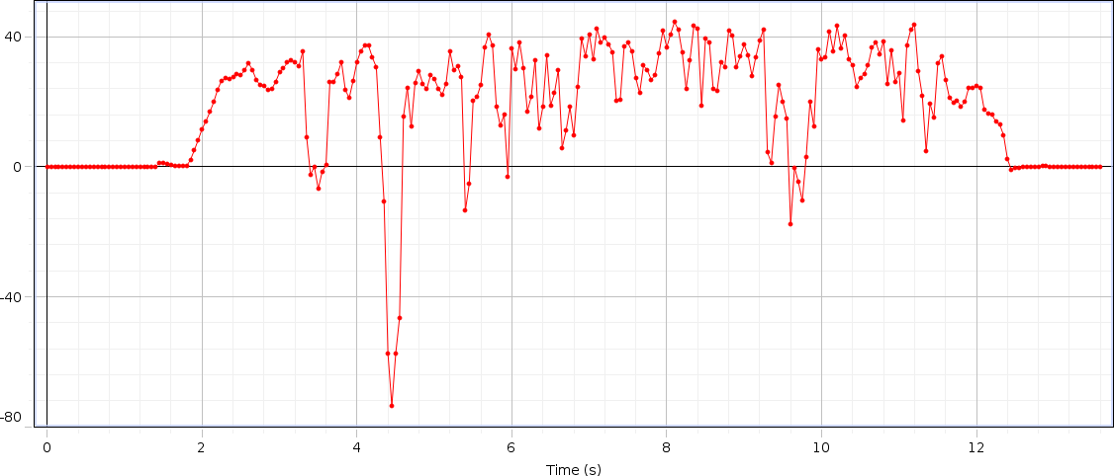

Figure 4.6.2(b): Graph of Right Hand Force of Amputated Subject II

Table 4.6.2: Data of Amputated Subject II

|  |  |  |  |  |  |  |  |  |  |
| --- | --- | --- | --- | --- | --- | --- | --- | --- | --- |
| S.no | Steps | Time (sec) | Distance (meter) | Step Time | Step Length | Stride Time | Stride Length | Cadence | Velocity |
| 02 | 18 | 16 | 5.856 | 1.02 | 0.3253 | 2.03 | 65.07 | 0.675 | 0.366 |

## Analysis

The rise and drop of strengths in the graph appears upper limb strengths amid taking care of inactive rollator utilized for gait by amputated person. The maximum rise up at F1 is 38N (force applied from the left hand side), at F2 the maximum rise up is of 43N (force applied from the right hand side). In both right and left hand the graph is showing negative peaks too, this is due to the patient’s left leg is amputated and he pull the handle after every step. The change of both forces are different for every single individual according to their age, muscle strength and walking abilities of the subject, the force result comes from the subject. Because of the design of our rollator the force is bit different from abnormal subject (who are affected from any disease or disability) and showing a major difference in the graph. Subsequently, it is demonstrated that time inversely proportional to velocity.

## Parameters

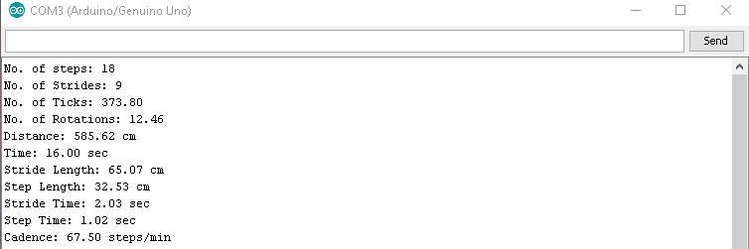

Figure 4.6.2(c): Observed Gait Parameters of Amputated Subject II

# DATA OF SUBJECT-III

## Left Hand Force

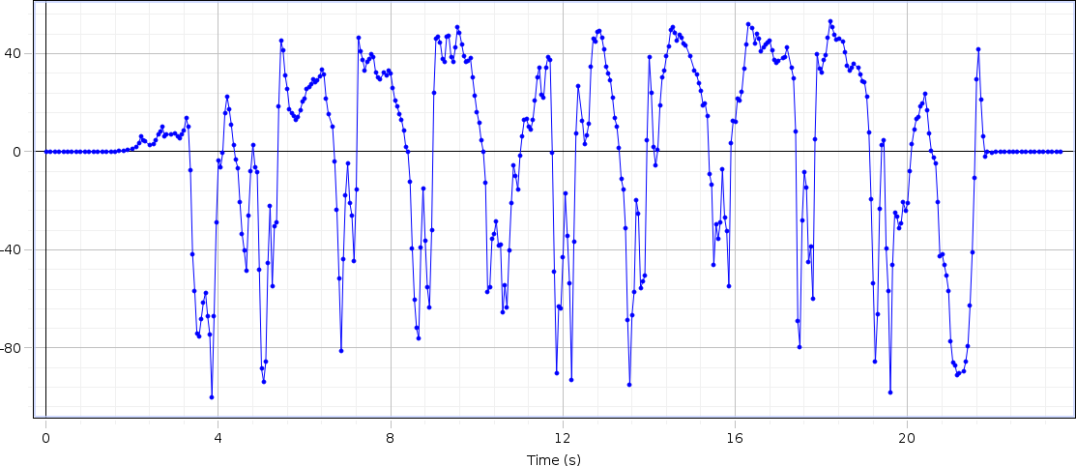

Figure 4.6.3(a): Graph of Left Hand Force of Amputated Subject III

## Right Hand Force

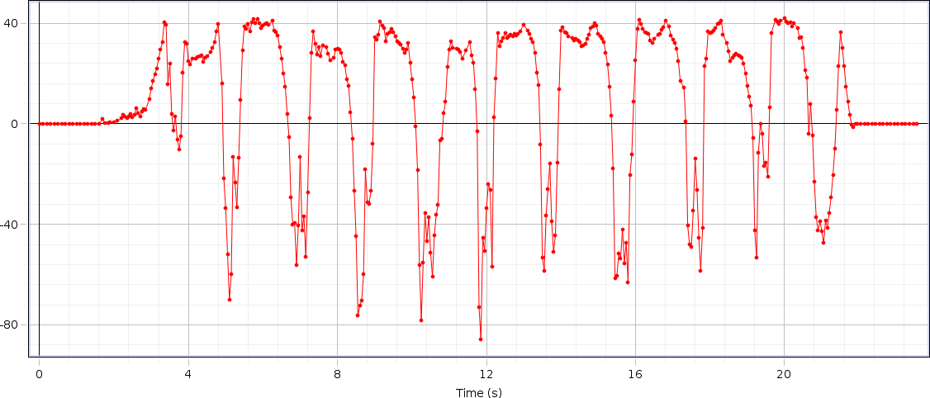

Figure 4.6.3(b): Graph of Right Hand Force of Amputated Subject III

Table 4.6.3: Data of Amputated Subject III

|  |  |  |  |  |  |  |  |  |  |
| --- | --- | --- | --- | --- | --- | --- | --- | --- | --- |
| S.no | Steps | Time  (sec) | Distance  (meter) | Step  Time | Step  Length | Stride  Time | Stride  Length | Cadence | Velocity |
| 03 | 24 | 17 | 5.99 | 0.71 | 0.249 | 1.42 | 0.499 | 84.71 | 0.352 |

## Analysis

The rise and drop of strengths in the graph appears upper limb strengths amid taking care of inactive rollator utilized for gait by amputated person. The maximum rise up at F1 is 52N (force applied from the left hand side), at F2 the maximum rise up is of 42N (force applied from the right hand side). In both right and left hand the graph is showing negative peaks too, this is due to the patient’s left leg is amputated and he pull the handle after every step. The change of both forces are different for every single individual according to their age, muscle strength and walking abilities of the subject, the force result comes from the subject. Because of the design of our rollator the force is bit different from abnormal subject (who are affected from any disease or disability) and showing a major difference in the graph. Subsequently, it is demonstrated that time inversely proportional to velocity.

## Parameters

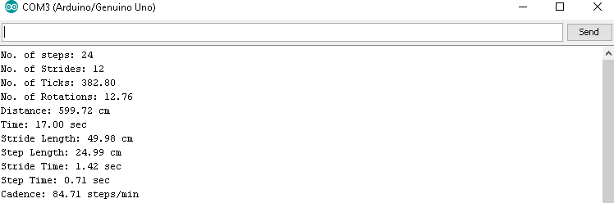

Figure 4.6.3(c): Observed Gait Parameters of Amputated Subject III

# DATA OF SUBJECT-IV

## Left Hand Force

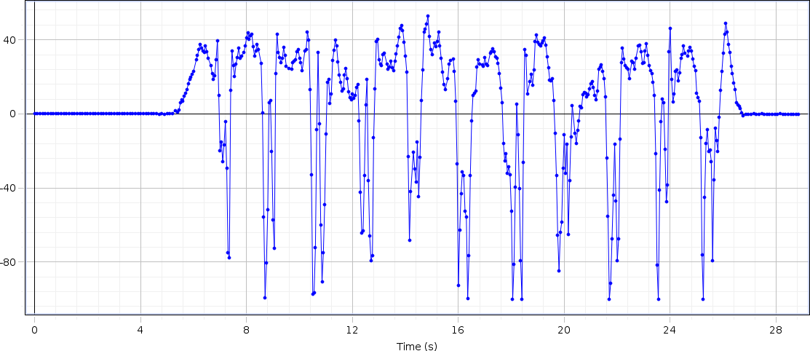

Figure 4.6.4(a): Graph of Left Hand Force of Amputated Subject IV

## Right Hand Force

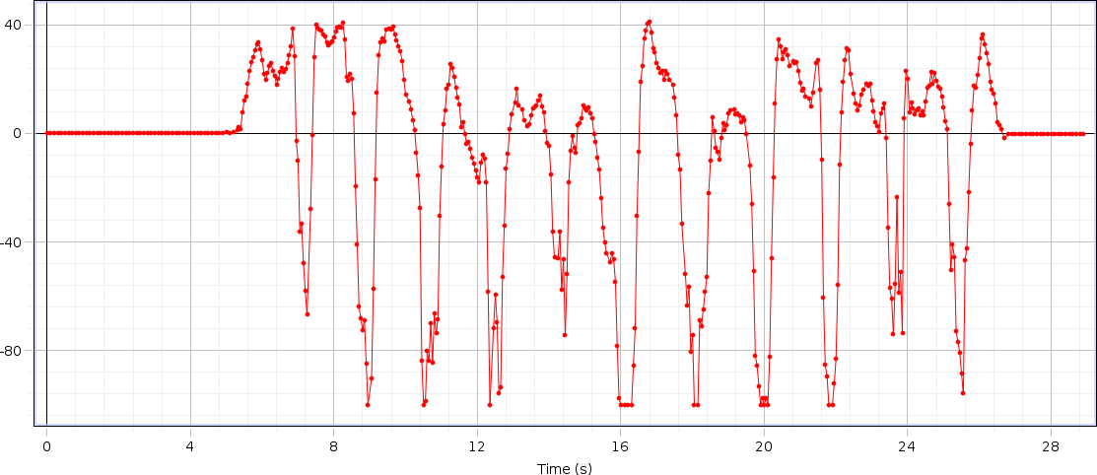

Figure 4.6.4(b): Graph of Right Hand Force of Amputated Subject IV

Table 4.6.4: Data of Amputated Subject IV

|  |  |  |  |  |  |  |  |  |  |
| --- | --- | --- | --- | --- | --- | --- | --- | --- | --- |
| S.no | Steps | Time  (sec) | Distance  (meter) | Step  Time | Step  Length | Stride  Time | Stride  Length | Cadence | Velocity |
| 04 | 24 | 19 | 6.135 | 0.79 | 0.255 | 1.58 | 0.511 | 75.79 | 0.322 |

## Analysis

The rise and drop of strengths in the graph appears upper limb strengths amid taking care of inactive rollator utilized for gait by amputated person. The maximum rise up at F1 is 53N (force applied from the left hand side), at F2 the maximum rise up is of 41N (force applied from the right hand side). In both right and left hand the graph is showing negative peaks too, this is due to the patient’s left leg is amputated and he pull the handle after every step. The change of both forces are different for every single individual according to their age, muscle strength and walking abilities of the subject, the force result comes from the subject. Because of the design of our rollator the force is bit different from abnormal subject (who are affected from any disease or disability) and showing a major difference in the graph. Subsequently, it is demonstrated that time inversely proportional to velocity.

## Parameters

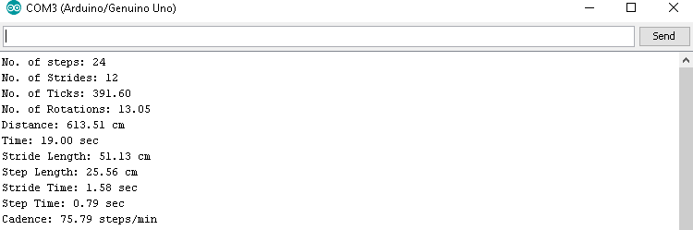

Figure 4.6.4(c): Observed Gait Parameters of Amputated Subject IV

# DATA OF SUBJECT-V

## Left Hand Force

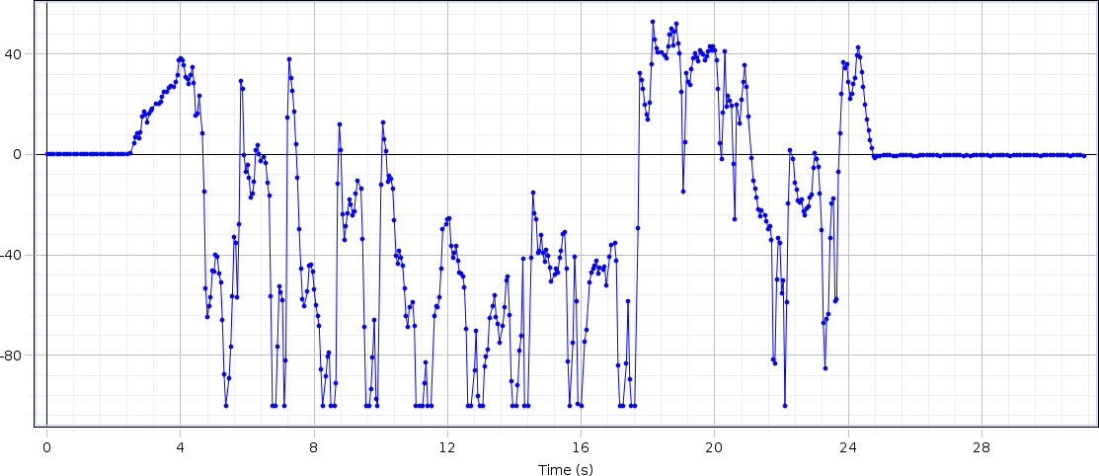

Figure 4.6.5(a): Graph of Left Hand Force of Amputated Subject V

## Right Hand Force

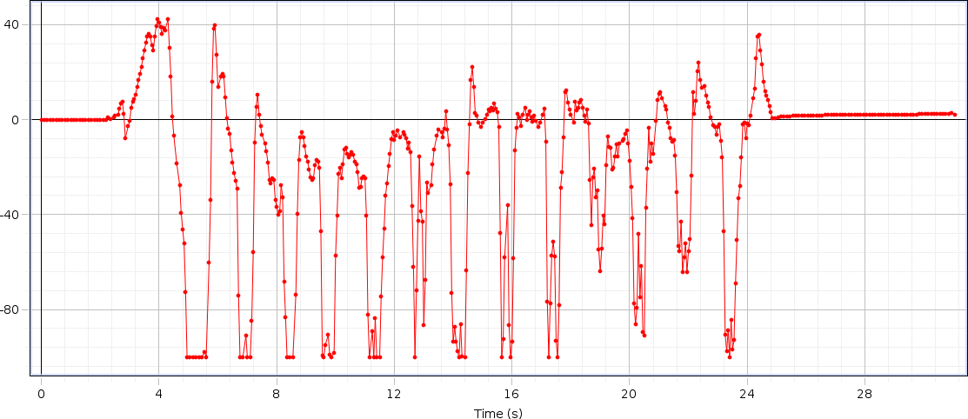

Figure 4.6.5(b): Graph of Right Hand Force of Amputated Subject V

Table 4.6.5: Data of Amputated Subject V

|  |  |  |  |  |  |  |  |  |  |
| --- | --- | --- | --- | --- | --- | --- | --- | --- | --- |
| S.no | Steps | Time  (sec) | Distance  (meter) | Step  Time | Step  Length | Stride  Time | Stride  Length | Cadence | Velocity |
| 05 | 26 | 20 | 6.307 | 0.77 | 0.242 | 1.54 | 0.485 | 78 | 0.315 |

## Analysis

The rise and drop of strengths in the graph appears upper limb strengths amid taking care of inactive rollator utilized for gait by amputated person. The maximum rise up at F1 is 54N (force applied from the left hand side), at F2 the maximum rise up is of 41N (force applied from the right hand side). In both right and left hand the graph is showing negative peaks too, this is due to the patient’s left leg is amputated and he pull the handle after every step. The change of both forces are different for every single individual according to their age, muscle strength and walking abilities of the subject, the force result comes from the subject. Because of the design of our rollator the force is bit different from abnormal subject (who are affected from any disease or disability) and showing a major difference in the graph. Subsequently, it is demonstrated that time inversely proportional to velocity.

## Parameters

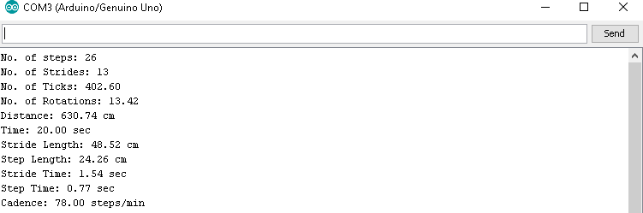

Figure 4.6.5(c): Observed Gait Parameters of Amputated Subject V

# COMPARATIVE STUDY

For comparing the results and observing the difference between healthy and elderly aged subjects, two separate tables are created to understand the patient’s walking condition. It was necessary to measure the gait parameters of subjects because only the measurement of force cannot specify the condition of patients therefore we also related other parameters like total steps and time taken by the subject and its velocity to understand the relationship, and we are taking these parameters by the help of sensors which we have placed in the rollator. The differences in data of both groups are shown in given two tables.

In previous project of 2018 they have used static walker and uses only force sensors in it and all parameters were calculated manually. Comparing to that it is easier to operate and require only one person for the data collection because it calculate automatically all parameters through the sensors.

## Table of Adult and Healthy Subjects

Table 4.7.1: Data of 20 Adult Healthy Subjects

|  |  |  |  |  |  |  |  |  |  |  |
| --- | --- | --- | --- | --- | --- | --- | --- | --- | --- | --- |
| **S.**  **No.** | **Age**  **(Yrs)** | **Steps** | **Time**  **(sec)** | **Distance**  **(m)** | **Stride**  **Length** | **Step**  **length** | **Stride**  **Time** | **Step**  **Time** | **Cadence**  **(steps/min)** | **Velocity**  **(m/s)** |
|  |  |  |  |  |  |  |  |  |  |  |
| 1 | 25 | 14 | 10 | 5.87 | 0.839 | 0.419 | 1.43 | 0.71 | 84 | 0.587 |
| 2 | 26 | 18 | 10 | 6.11 | 0.678 | 0.339 | 1.11 | 0.56 | 108 | 0.611 |
| 3 | 22 | 16 | 11 | 5.83 | 0.729 | 0.364 | 1.37 | 0.69 | 87.27 | 0.53 |
| 4 | 22 | 18 | 11 | 6.22 | 0.691 | 0.346 | 1.22 | 0.61 | 98.18 | 0.565 |
| 5 | 23 | 20 | 12 | 6.38 | 0.638 | 0.319 | 1.2 | 0.6 | 100 | 0.531 |
| 6 | 21 | 14 | 9 | 6.07 | 0.867 | 0.433 | 1.29 | 0.64 | 93.33 | 0.674 |
| 7 | 20 | 16 | 10 | 6.61 | 0.827 | 0.413 | 1.25 | 0.63 | 96 | 0.661 |
| 8 | 23 | 14 | 10 | 5.82 | 0.832 | 0.416 | 1.43 | 0.71 | 84 | 0.582 |
| 9 | 20 | 16 | 9 | 5.58 | 0.697 | 0.349 | 1.12 | 0.56 | 106.67 | 0.62 |
| 10 | 24 | 14 | 9 | 6.58 | 0.94 | 0.47 | 1.29 | 0.64 | 93.33 | 0.731 |
| 11 | 23 | 16 | 10 | 5.87 | 0.734 | 0.367 | 1.25 | 0.63 | 96 | 0.587 |
| 12 | 25 | 14 | 10 | 6.38 | 0.912 | 0.456 | 1.43 | 0.71 | 84 | 0.638 |
| 13 | 25 | 14 | 10 | 6.5 | 0.928 | 0.464 | 1.43 | 0.71 | 84 | 0.65 |
| 14 | 23 | 16 | 11 | 6.02 | 0.752 | 0.376 | 1.37 | 0.69 | 87.27 | 0.547 |
| 15 | 20 | 16 | 10 | 5.79 | 0.724 | 0.362 | 1.25 | 0.63 | 96 | 0.579 |
| 16 | 19 | 12 | 8 | 5.91 | 0.985 | 0.492 | 1.33 | 0.67 | 90 | 0.738 |
| 17 | 21 | 16 | 9 | 6.42 | 0.802 | 0.401 | 1.12 | 0.56 | 106.67 | 0.713 |
| 18 | 24 | 18 | 11 | 6.26 | 0.696 | 0.348 | 1.22 | 0.61 | 98.18 | 0.569 |
| 19 | 20 | 18 | 10 | 5.97 | 0.664 | 0.332 | 1.11 | 0.56 | 108 | 0.597 |
| 20 | 22 | 14 | 10 | 6.05 | 0.864 | 0.432 | 1.43 | 0.71 | 84 | 0.605 |

## Table of Elderly Aged Subjects

Table 4.8.2: Data of 20 Elderly Aged Subjects

|  |  |  |  |  |  |  |  |  |  |  |
| --- | --- | --- | --- | --- | --- | --- | --- | --- | --- | --- |
| **S.**  **No.** | **Age**  **(Yrs)** | **Steps** | **Time**  **(sec)** | **Distance**  **(m)** | **Stride**  **Length** | **Step**  **length** | **Stride**  **Time** | **Step**  **Time** | **Cadence**  **(steps/min)** | **Velocity**  **(m/s)** |
|  |  |  |  |  |  |  |  |  |  |  |
| 1 | 45 | 20 | 17 | 5.79 | 0.579 | 0.289 | 1.7 | 0.85 | 70.59 | 0.340 |
| 2 | 52 | 14 | 13 | 6.02 | 0.860 | 0.430 | 3.31 | 1.65 | 64.62 | 0.463 |
| 3 | 63 | 20 | 17 | 6.15 | 0.615 | 0.307 | 1.81 | 0.9 | 70.59 | 0.361 |
| 4 | 61 | 24 | 21 | 5.82 | 0.485 | 0.242 | 1.16 | 0.58 | 68.57 | 0.277 |
| 5 | 53 | 16 | 14 | 6.11 | 0.764 | 0.382 | 2.73 | 1.37 | 68.57 | 0.436 |
| 6 | 64 | 16 | 18 | 5.82 | 0.727 | 0.364 | 2.02 | 1.01 | 53.33 | 0.323 |
| 7 | 49 | 18 | 16 | 5.85 | 0.650 | 0.325 | 2.03 | 1.02 | 67.5 | 0.365 |
| 8 | 56 | 20 | 16 | 6.29 | 0.629 | 0.314 | 1.97 | 0.98 | 75 | 0.393 |
| 9 | 59 | 20 | 16 | 5.7 | 0.570 | 0.285 | 1.78 | 0.89 | 75 | 0.356 |
| 10 | 62 | 18 | 17 | 6.15 | 0.683 | 0.341 | 2.01 | 1.01 | 63.53 | 0.361 |
| 11 | 64 | 28 | 26 | 6.25 | 0.446 | 0.223 | 0.86 | 0.43 | 64.62 | 0.240 |
| 12 | 63 | 22 | 20 | 5.69 | 0.517 | 0.258 | 1.29 | 0.65 | 66 | 0.284 |
| 13 | 57 | 18 | 18 | 6.08 | 0.676 | 0.338 | 1.88 | 0.94 | 60 | 0.337 |
| 14 | 54 | 22 | 17 | 6.25 | 0.568 | 0.284 | 1.67 | 0.84 | 77.65 | 0.367 |
| 15 | 57 | 18 | 14 | 6.44 | 0.716 | 0.358 | 2.56 | 1.28 | 77.14 | 0.46 |
| 16 | 61 | 20 | 15 | 5.95 | 0.595 | 0.297 | 1.98 | 0.99 | 80 | 0.396 |
| 17 | 57 | 20 | 15 | 6.11 | 0.611 | 0.306 | 2.04 | 1.02 | 80 | 0.407 |
| 18 | 53 | 20 | 16 | 5.85 | 0.585 | 0.292 | 1.83 | 0.92 | 75 | 0.365 |
| 19 | 62 | 18 | 16 | 6.11 | 0.68 | 0.34 | 2.12 | 1.06 | 67.5 | 0.381 |
| 20 | 60 | 18 | 17 | 6.07 | 0.676 | 0.338 | 1.99 | 1.0 | 63.53 | 0.357 |

## Table of Amputated Subjects

Table 4.8.3: Data of Amputated Subjects

|  |  |  |  |  |  |  |  |  |  |  |
| --- | --- | --- | --- | --- | --- | --- | --- | --- | --- | --- |
| **S.**  **No.** | **Age**  **(Yrs)** | **Steps** | **Time**  **(sec)** | **Distance**  **(m)** | **Stride**  **Length** | **Step**  **length** | **Stride**  **Time** | **Step**  **Time** | **Cadence**  **(steps/min)** | **Velocity**  **(m/s)** |
|  |  |  |  |  |  |  |  |  |  |  |
| 1 | 24 | 20 | 13 | 5.44 | 0.544 | 0.272 | 1.30 | 0.65 | 92.31 | 0.418 |
| 2 | 27 | 18 | 16 | 5.85 | 0.65 | 0.325 | 2.03 | 1.02 | 67.50 | 0.365 |
| 3 | 25 | 24 | 17 | 5.99 | 0.499 | 0.249 | 1.42 | 0.71 | 84.71 | 0.352 |
| 4 | 28 | 24 | 19 | 6.13 | 0.511 | 0.255 | 1.58 | 0.79 | 75.79 | 0.322 |
| 5 | 24 | 26 | 20 | 6.30 | 0.485 | 0.242 | 1.54 | 0.77 | 78 | 0.315 |

# CONCLUSION

***Chapter 5***

* 1. **CONCLUSION**

All the objectives which we have discussed in the chapters are showing that the prototype is designed in particular manner that can performs all the tasks properly and give results in very much accurate manner. The analysis of gait pattern has been completed properly along with the data storage in the software. Secondly, it is specially designed as non-wearable prototype to analyze the force and spatiotemporal gait parameters. Third it is a human friendly device, the patient can use it in everyday life.

This prototype will help the aged patients who are not able to walk without any support this will also provide support and less force from the patient would be required to handle the rollator, further more advancements from paramedic staff and engineer will lead this device to perform complete gait analysis in future to save patients from the burden of sensors.

# FUTURE WORK

In the future we will try to convert data wirelessly by using Bluetooth module to get the results of forces in a laptop and a LCD on a rollator which will show all the parameters on LCD.

We can also measure the trajectory of rollator by using another encoder in a front movable wheel in result it helps to analyze the patient’s gait more accurately.

# APPENDICES

## Source Code for Calculating Gait Parameters

#define encoder0PinA 2 // CLK #define encoder0PinB 4 // DT

float StrideLength=0; float StepLength=0; float StrideTime=0; float StepTime=0; float Cadence=0;

float TotalDistance=0; char input;

int counter = 0; float co = 0;

int newcounter = 0;

int previouscounter = 0; int aState;

int aLastState;

unsigned long previousTime = 0; unsigned long previousMillis = 0; unsigned long previousMillis1 = 0; unsigned long previousMillis2 = 0; const long interval = 1000;

const long interval1 = 20; const long interval2 = 20; float seconds;

const int trigPin = 9; const int echoPin = 10;

int strides=0; int steps=0; int old=0; long duration; int distance;

void setup() {

pinMode (encoder0PinA,INPUT); pinMode (encoder0PinB,INPUT);

pinMode(trigPin, OUTPUT); // Sets the trigPin as an Output pinMode(echoPin, INPUT); // Sets the echoPin as an Input Serial.begin (9600);

aLastState = digitalRead(encoder0PinA);

}

void loop() {

unsigned long currentMillis2 = millis();

if (currentMillis2 - previousMillis2 >= interval2) { previousMillis2 = currentMillis2;

digitalWrite(trigPin, LOW); delayMicroseconds(20); digitalWrite(trigPin, HIGH); delayMicroseconds(90); digitalWrite(trigPin, LOW); duration = pulseIn(echoPin, HIGH); distance= duration*0.034/2;

//Serial.print("Distance: ");

//Serial.println(distance);

unsigned long currentMillis1 = millis(); if (distance > 20 || old==1)

{

if (currentMillis1 - previousMillis1 >= interval1) { previousMillis1 = currentMillis1; digitalWrite(trigPin, LOW); delayMicroseconds(20);

digitalWrite(trigPin, HIGH); delayMicroseconds(90); digitalWrite(trigPin, LOW); duration = pulseIn(echoPin, HIGH); distance= duration*0.034/2;

//Serial.print("Distance: ");

//Serial.println(distance); old=1;

if (distance < 20 & old==1)

{

strides++; old=0;

}

}

}

unsigned long currentMillis = millis(); aState = digitalRead(encoder0PinA); if (aState != aLastState){

if (digitalRead(encoder0PinB) != aState) { counter --;

} else { counter ++;

}

co=counter*2.1; TotalDistance = ((47*co)/30);

if (counter > 0 & counter != newcounter)

{

if (currentMillis - previousMillis >= interval) { previousMillis = currentMillis;

newcounter = counter; seconds = seconds +1;

}

}

}

aLastState = aState;

StrideLength = TotalDistance/strides; StepLength = StrideLength/2; StrideTime = StepLength/seconds; StepTime = StrideTime/2;

Cadence = ((strides*2)/seconds)*60;

if(Serial.available()){ input = Serial.read();

Serial.print("No. of steps: "); steps=strides*2; Serial.println(steps); Serial.print("No. of Strides: "); Serial.println(strides); Serial.print("No. of Ticks: "); Serial.println(co); Serial.print("No. of Rotations: "); Serial.println(co/30); Serial.print("Distance: "); Serial.print( TotalDistance); Serial.println(" cm");

Serial.print("Time: "); Serial.print(seconds); Serial.println(" sec");

Serial.print("Stride Length: "); Serial.print(StrideLength); Serial.println(" cm"); Serial.print("Step Length: "); Serial.print(StepLength); Serial.println(" cm"); Serial.print("Stride Time: "); Serial.print(StrideTime); Serial.println(" sec"); Serial.print("Step Time: "); Serial.print(StepTime); Serial.println(" sec"); Serial.print("Cadence: "); Serial.print(Cadence); Serial.println(" steps/min\n\n");

}

}

}

# REFERENCES

1. Cyril Joly, Claire Dune, Philippe Gorce, Patrick Rives. Feet and legs tracking using a smart rollator equipped with a Kinect. Workshop on "Assistance and Service Robotics in a Human Environment" in conjonction with IEEE/RSJ Int.

Conf. on Int. Rob. and Sys. (IROS), Nov 2013, Tokyo, Japan. ⟨hal-00921273⟩

1. Martins, M. M., Santos, C. P., Frizera-Neto, A., & Ceres, R. (2012). Assistive mobility devices focusing on Smart Walkers: Classification and review. Robotics and Autonomous Systems, 60(4), 548–562. doi:10.1016/j.robot.2011.11.015
2. K. E. Webster, J. E. Wittwer, and J. A. Feller, "Quantitative gait analysis after medial unicompartmental knee arthroplasty for osteoarthritis," The Journal of Arthroplasty, vol. 18, pp. 751-759, 2003/09/01/ 2003.
3. M. Švehlík, E. B. Zwick, G. Steinwender, W. E. Linhart, P. Schwingenschuh, P. Katschnig, et al., "Gait Analysis in Patients With Parkinson's Disease Off Dopaminergic Therapy," Archives of Physical Medicine and Rehabilitation, vol. 90, pp. 1880-1886, 2009/11/01/ 2009.
4. O. Sofuwa, A. Nieuwboer, K. Desloovere, A.-M. Willems, F. Chavret, and I. Jonkers, "Quantitative Gait Analysis in Parkinson’s Disease: Comparison With a Healthy Control Group," Archives of Physical Medicine and Rehabilitation, vol. 86, pp. 1007-1013, 2005/05/01/ 2005.
5. J. A. McClelland, K. E. Webster, and J. A. Feller, "Gait analysis of patients following total knee replacement: A systematic review," The Knee, vol. 14, pp. 253-263, 2007/08/01/ 2007.
6. R. Bausà, A. Dalmau, J. Barrachina, and M. F. Peydro, "Kinetic gait analysis in sequels of hindfoot injuries: Preliminary results," Foot and Ankle Surgery, vol. 13, pp. 63-66, 2007/01/01/ 2007.
7. Brose, S. W., Weber, D. J., Salatin, B. A., Grindle, G. G., Wang, H., Vazquez,

J. J., & Cooper, R. A. (2010). The Role of Assistive Robotics in the Lives of

Persons with Disability. American Journal of Physical Medicine & Rehabilitation, 89(6), 509–521. doi:10.1097/phm.0b013e3181cf569b

1. J. R. Merory, J. E. Wittwer, C. C. Rowe, and K. E. Webster, "Quantitative gait analysis in patients with dementia with Lewy bodies and Alzheimer's disease," Gait & Posture, vol. 26, pp. 414-419, 2007/09/01/ 2007.
2. Ballesteros, J., Urdiales, C., Martinez, A. B., & Tirado, M. (2015). Gait analysis for challenged users based on a rollator equipped with force sensors. 2015 IEEE/RSJ International Conference on Intelligent Robots and Systems (IROS). doi:10.1109/iros.2015.7354169
3. C. Prakash, R. Kumar, N. Mittal, and G. Raj, "Vision based Identification of Joint Coordinates for Marker-less Gait Analysis," Procedia Computer Science, vol. 132, pp. 68-75, 2018/01/01/ 2018.
4. N. M. Mueske, S. Õunpuu, D. D. Ryan, B. S. Healy, J. Thomson, P. Choi, et al., "Impact of gait analysis on pathology identification and surgical recommendations in children with spina bifida," Gait & Posture, vol. 67, pp. 128-132, 2019/01/01/ 2019.
5. W.-L. Wu, F.-C. Su, Y.-M. Cheng, P.-J. Huang, Y.-L. Chou, and C.-K. Chou, "Gait analysis after ankle arthrodesis," Gait & Posture, vol. 11, pp. 54-61, 2000/02/01/ 2000.